Evaluating multi-disease interventions

by

Shannon M. Gross

to obtain the degree of

**MASTER OF SCIENCE IN ENGINEERING AND POLICY ANALYSIS**

at the Delft University of Technology, Faculty of Technology, Policy and Management

To be defended in public on August 27, 2019

Student number: 4735048

Chairperson: Prof. dr. B.A. (Bartel) Van de Walle

First Supervisor: Dr.ir. J.H. (Jan) Kwakkel

Second Supervisor: Dr.ir. I. (Igor) Nikolic

An electronic version of this thesis is available at <http://repository.tudelft.nl>

Associated code and models are available at <https://github.com/shannongross/multi_disease_model>



Acknowledgements

Thousands of children die from diarrhea every day, despite it being entirely preventable. This thesis is dedicated to the individuals suffering unnecessarily from avoidable causes, as well as to the men and women who work in unappealing situations – in messy cholera wards or emptying latrine pits - to alleviate this burden. Diseases of poverty present a grand challenge that cannot be solved by any one person or technology. By following the Gates Foundation’s motto of “impatient optimism,” this thesis is a call to use the imperfect knowledge we have available to do more, now.

Executive Summary

Low-income countries struggle to cope with enormous public health burdens caused by a variety of infectious diseases. While many of these “diseases of poverty” have been well-studied, there remains a large disconnect between the clinical research community and the way that decisions are made affecting their transmission in real life. For policymakers with finite resources, any decision to invest in an intervention against one disease as also an implicit decision to *not* invest in controlling another disease.

This thesis used a multi-disease perspective to find interventions that work in an integrated and robust manner with the intent of supporting policymakers to develop cost-justifiable strategies. Particularly in development programs, limited resources mean that policymakers cannot afford to handle each disease in isolation. Policymakers must consider how investing in one public health strategy takes away from another, and what that ultimately means for the population. In this thesis, a novel multi-disease model is developed to show how exploratory modeling can be used to support the development of holistic public health policies.

The main research question addressed here is: “**How can a multi-disease model be used to support the design of robust, integrated strategies for achieving many public health objectives?**” The research question is answered using a case study about the spread of four gastroenteric pathogens in Uganda (Rotavirus, *Ascaris lumbricoides*, C*ryptosporidium*, and *Escherichia coli*). These pathogens have little in common from a biological or clinical perspective; however, they are all spread in the environment because of insufficiencies in water, sanitation, and hygiene (WASH) conditions. Therefore, there is a great deal of overlap in the policy levers that could be used to decrease their transmission. The target audience of this research include those who work on development projects in low-income settings (especially in WASH) as well as to the public health modelling community at large.

This thesis adopts an exploratory modeling and analysis approach in order to create a multi-disease model and evaluate its findings in the presence of large data gaps. This approach is different than what has traditionally been performed in disease modeling. A literature review emphasizes this difference by discussing the state-of-the-art surrounding multi-disease modeling for policy support. To address the research gaps identified in the literature review, an analytic framework synthesizes exploratory modeling theories in a manner that is useful for public health policy support.

This research delivers a multi-disease model for evaluating the performance of various public health interventions under deep uncertainty, which to the author’s knowledge has not yet been performed. The model is created using system dynamics software to extend the Susceptible-Infectious-Susceptible (SIS) model widely used in epidemiology. Python programming enhances the model by testing how policy recommendations vary based on a decision maker’s interpretation of the policy objectives.

Many-Objective Robust Decision Making (MORDM) techniques explore the assumptions and uncertainties used to build the model. MORDM incorporates the use of a many-objective evolutionary algorithm to find promising policy alternatives. This approach enables the subjective preferences and deep uncertainties present in a complex public health system to be systematically explored in a manner that is informative for policy debate. By using MORDM, this thesis contributes an original application of *a posteriori* preferential elicitation to the domain of infectious diseases and WASH.

##### Summary of Model Results

Model formulations that focus on developing control strategies against the spread of an individual pathogen produce different recommendations than model formulations which take more than one infection into account, even if the pathogens share many of the same intervention strategies.

A single-disease problem formulation that focused on the alleviating the burden of rotavirus in children tends to recommend policies that emphasize vaccination and treatment. These are effective measures at reducing rotavirus-related morbidity and mortality, although they can be rather expensive to maintain indefinitely. An ascariasis-focused problem perspective recommends that programs to delivery albendazole through mass drug administration programs to youth. Like the rotavirus problem formulation, improvements to sanitation infrastructure are also favorable but slightly less so due to the high upfront costs.

A long-term problem formulation inclusive of all four gastroenteric pathogens suggests that sanitation improvement as the most robust policy alternative. Had policymakers operated in silos, one with a rotavirus perspective and one with an ascariasis perspective, it could lead to the development of two separate programs. The multi-disease formulation is advantageous for finding integrated solutions that work well across different pathogens, ideally to reduce wasted resources.

The thesis findings suggest the following:

1. Where information is deeply uncertain or there are severe data gaps, traditional methods of quantitative modeling that focus on probability or risk are impracticable. Public health modelers may provide more policy-relevant support by adopting a systems approach and exploring (rather than assuming away) critical uncertainties.
2. In deeply uncertain systems, it is advantageous to analyze different problem formulations in order to avoid a single perspective of the “optimal” solution. By not relying on one party’s assumptions or views of an issue, exploratory approaches may be more appropriate to addressing contentious issues.
3. Using a broad (and interdisciplinary) system boundary can help to prevent policy recommendations from being constrained early on.
4. Finally, the existing terminology used to discuss more than one pathogen must be improved in order to facilitate wider adoption of multi-disease evaluations.

Multi-disease modelling that incorporates exploratory technique shows promise for supporting low-income countries in making strategic decisions about how to prioritize scarce resources. By looking at how an intervention impacts multiple health threats, a more holistic picture can be provided to the decision maker of how the intervention influences their key objectives.

##### Policy Recommendations

The following policy recommendations are proposed for Uganda:

1. Ugandan policymakers should guard against a critical vulnerability in its new rotavirus vaccination program by improving the reliability of vaccine cold chain and supply systems.
2. Where the goal is to improve population health, sanitation initiatives ought to be emphasized in national planning as much as water supply or water quality programs are.
3. Hygiene campaigns are potentially powerful and cost-effective strategies for improving public health. There is an urgent need for increased study in this area. Exploratory models may be a useful tool to study such policies where traditional methods are too expensive and invasive.

Exploratory modeling presents many opportunities to enrich policy support, which to date has been relatively overlooked in the public health sector. Exploratory modeling techniques can be used to build a multi-disease model, which (due to confounding) would be questionable using predictive methods. Through sensitivity analysis and exploration, researchers can gain a better understanding of which factors are most important to the outcomes. Data collection efforts can focus only on gathering information on the most important factors, rather than trying to collect data on everything. Finally, exploratory models are more appropriate for helping decision makers learn about the system and different strategic options, rather than models that use big assumptions to prescribe a single solution.

Table of Contents

1 Research Formulation 1

1.1 Reasons for multi-disease modelling 1

1.2 Present Main Research Question 11

2 Literature Review 13

2.1 Four research themes related to multi-disease modelling 14

2.2 Existing multi-disease model example 16

2.3 Research Gap 16

3 Methodology 18

3.1 Description of thesis methodology 18

3.2 Justification of Methods 20

3.3 Methodology conclusion 23

4 Exploratory Policy Modelling Framework 24

4.1 Foundation 1 25

4.2 Foundation 2 26

4.3 Foundation 3 27

4.4 Foundation 4 27

4.5 Foundation 5 28

4.6 Framework presentation 29

5 Multi-Disease Model Presentation 30

5.1 Case Study Introduction 31

5.2 Model Conceptualization 33

5.3 Data Gathering 40

5.4 Model Formalization 42

5.5 Verification and validation 49

5.6 Model Results 51

5.7 Model Development Conclusion 55

6 Many-Objective Experimentation 56

6.1 Operationalize the Problem Formulations 57

6.2 Search for candidate interventions 66

6.3 Stress-test candidate interventions 69

6.4 Identify vulnerabilities 80

7 Discussion 84

7.1 Implications for public health policy modelling 85

7.2 Implications for international health development strategies 87

7.3 Policy recommendations for Uganda 89

7.4 Revisit Research Questions 91

7.5 Reflection on Approach 95

7.6 Research Extensions 97

8 Conclusion 98

Appendix A – D 100

A. Disease-specific information 101

B. Software Implementation and Data 106

C. Experimental Design 107

D. Literature Review Process 114

REFERENCES 116

List of Tables

Table 1: Overview of Gastroenteric Pathogens Considered 32

Table 2: Summary of XLRM Framework 33

Table 3: Description of Policy Levers 34

Table 4: Description of Objectives (M) using four different problem formulations 35

Table 5: Description of Exogenous Uncertainties (X) 37

Table 6: Description of WASH cost estimates used in model parameterization 41

Table 7: Uncertainty values used to create the Reference Scenario 58

Table 8: Parameters and corresponding results from MOEA search 66

Table 10: Implications of research findings for existing health policies in Uganda 89

Table 11: Existing multi-disease models and frameworks from literature 115

List of Figures

Figure 1: Simplified F-diagram. 3

Figure 2: Predictive versus Exploratory modelling 7

Figure 3: Challenges of *a priori* preference elicitation 8

Figure 4: Methods of preference elicitation. 9

Figure 5: Using Evolutionary Algorithms for Policy Analysis. 10

Figure 6: Research Methodology. 19

Figure 7: Foundations of Exploratory Public Health Policy Modeling. 29

Figure 8: Many objectives of public health policymakers. 35

Figure 9: Overview of Conceptual Relationships. 38

Figure 10: System Diagram. 39

Figure 11: Open Defecation Sub-Model. 42

Figure 12: Aging Chain 43

Figure 13: Sanitation Sub-Model. 44

Figure 14: Drinking Water Sub-Model. 45

Figure 15: Hygiene Sub-Model. 46

Figure 16: Vaccination Sub-Model. 47

Figure 17: MDA Sub-Model. 47

Figure 18: ORT Treatment Sub-Model. 48

Figure 19: Infected versus total population. 49

Figure 20: District-level functionality (Kampala shown). 50

Figure 21: Pre-Specified Policy 1 – Groundwater Supply. 51

Figure 22: Pre-Specified Policy 2 – Vaccination. 52

Figure 23: Pre-Specified Policy 3 – Oral Rehydration Therapy (ORT). 53

Figure 24: Pre-Specified Policy 4 – Latrine Program. 53

Figure 25: Pre-Specified Policy 5 – Mass Drug Administration (MDA). 54

Figure 26: Outline of Many-Objective Robust Decision-making (MORDM). 56

Figure 27: Objective tradeoffs for pre-specified policies using PF1. 60

Figure 28: Objective tradeoffs for pre-specified policies using PF2. 61

Figure 29: Objective tradeoffs for pre-specified policies using PF3. 63

Figure 30: Objective tradeoffs for pre-specified policies using PF4. 64

Figure 31: Results of directed search under PF1 (rotavirus in children). 67

Figure 32: Results of directed search under PF4 (multi-disease) 68

Figure 33: Policy recommendations under each problem formulation 71

Figure 34: Robust policies under PF1. 72

Figure 35: Robust policies under PF2 73

Figure 36: Robust policies under PF3 74

Figure 37: Results of PF3 policy option over time. 75

Figure 38: Robust policies under PF4 76

Figure 39: Impact of PF4 recommendation on total gastroenteric infections 77

Figure 40: Recommended policy against rotavirus in children 77

Figure 41: Recommended policy against ascariasis in youth 78

Figure 42: Recommended policy for children in the immediate term 78

Figure 43: Rotavirus in children – High mortality scenarios 81

Figure 44: Rotavirus in children – High morbidity scenarios 81

Figure 45: Ascariasis in youth – High Mortality (and Morbidity) scenarios 82

# Research Formulation

Policymakers who work in the public health sector may rely on the help of quantitative models to support their choice of control strategy against a particular infectious disease. While policymakers have a large number of decision support models to choose from, hardly any of these tools are used to design an intervention strategy that can work well across multiple diseases. This is in part because of the need for large amounts of precise, detailed data and the presence of many unknown or confounding factors, which complicates attempts to make single-disease models, let alone multi-disease models. Is this highly data-intensive and detailed predictive approach necessary to make a good decision about how limited health resources should be allocated against multiple threats? Could the inclusion of multiple pathogens into a single decision support tool change the recommendation of an “optimal” intervention? In the following thesis, a novel multi-disease model is created. Rather than attempting to make a predictive tool to try and foresee a deeply uncertain future, this multi-disease model uses an exploratory approach to systematically evaluate the impacts of uncertain parameters. Many objective optimization techniques are used to find robust intervention strategies that work well for decision-makers who are interested in increasing the impact of their limited resources.

## Reasons for multi-disease modelling

Evidence-based public health policymaking is difficult. One reason for this difficulty is because the “evidence” presented to decision makers is often too specialized to address broad policy concerns. This is especially the case in low-income countries, where evidence to support health policymaking is often lacking or inappropriate (e.g. suggesting overly-technical solutions). Furthermore, low-income countries not only have less resources but a far higher burden of infectious disease than the rest of the world. Policymakers in such settings are pressured to use finite resources to control a large number of different public health issues.

In this thesis, the concept of an **intervention** describes any policy designed to prevent, treat, or mitigate the prevalence and/or intensity of an infectious disease. The current study aims toward designing more integrated interventions, where **integrated** refers to finding one intervention that acts against multiple pathogens. **Pathogens** are the contagious organisms excreted by infected individuals, which can be transmitted to a new person. Pathogens may be viruses, bacteria, or small invertebrate animals such as worms.

Quantitative modelling is useful for simulating the effects of different disease interventions, particularly when testing them in real life would be impractical or unethical. The vast majority of quantitative models, however, are used by researchers to design a control strategy against a single pathogen of interest. Unfortunately, looking at one pathogen in isolation is much less useful from a policy standpoint than it is in a laboratory setting. Policymakers are rarely interested in a single pathogen under narrowly-defined conditions, being charged more broadly with the general health and welfare of their communities. In the real world, isolating one disease from another is difficult because any decision to invest in a particular intervention is also an implicit decision to *not* invest in a different strategy. In order to understand which intervention out of many is most worth investing in, policymakers would need to refer to a large number of different disease models. To meet policy concerns, there is a need for models that evaluate across a wider landscape of public health issues

An important reason for looking at many infectious diseases at once is that there is often a great deal of overlap in control strategies. In other words, an intervention that is effective at decreasing the transmission of one disease may also have the fortunate effect of reducing other (perhaps, seemingly unrelated) diseases as well. It is only by looking from a wider, multi-disease perspective that the full benefits of an intervention can be assessed. This is significant for low-income countries, where the bulk of infectious diseases are spread very similarly or have similar risk factors. In such settings, extreme poverty leads to conditions of poor hygiene, lack of education, unclean water, reduced medical options, and other difficulties. Since these “diseases of poverty” are spread similarly, it is desirable for policymakers operating in low-income conditions to try and find interventions that target as many diseases as possible. To observe and quantify these overlaps in intervention strategies, models which include multiple, similarly-transmitted diseases may be a useful aid.

For this thesis, the term “**multi-disease model**” describes a single model which evaluates how an intervention performs across more than one pathogen. A “multi-disease model” does *not* refer to a general/nonspecific model that can be adapted to different diseases. Nor is it meant for clinical applications, for example co-infection models that study the effects of multiple diseases on a person’s immune system. In this thesis, the multi-disease model is intended to compare the performance of public (not individual-level) intervention strategies at improving population welfare.

To highlight the need for considering multiple, similarly-transmitted diseases when designing public health policies, the remainder of this thesis will be applied to studying a group of fecal-oral diseases common to low-income countries. These diseases are all similarly transmitted due to inadequacies in local water, sanitation, and hygiene (WASH) conditions, which cause fecal pathogens to be passed on to a susceptible host. Diseases related to WASH are an appropriate test case for the multi-disease model because there is a relatively limited set of interventions which are effective at stopping a large variety of different pathogens.

### Interrupting fecal-oral disease transmission

Approximately half of the people living in low-income areas have at least one of the major infections linked to poor water and sanitation conditions, many of which lead to diarrhea (Mulogo et al., 2018). Diarrhea is a particularly severe problem for children because they are vulnerable to the effects of losing excessive amounts of fluids. Muli (2018) estimates that over 2,000 children die from diarrhea each day, and notes that this figure is more than malaria, HIV and measles together – making in the second biggest cause of death for children globally. Interventions aimed to improve water and sanitation conditions can be highly effective at reducing the burden of fecal-oral disease, but even initially successful interventions may be difficult to sustain over long periods of time (Batterman et al., 2009).

Diseases transmitted because of inadequate water, sanitation and hygiene (WASH) are spread via the fecal-oral route, meaning that contaminated food or water or dirty hands enter the mouth. In low-income communities throughout the world where access to a toilet is scarce, the practice of open defecationmay be the norm. **Open defecation** refers to the behavior of relieving oneself in nature instead of using a toilet to defecate. Pathogens contained in human feces are transmitted to the environment when individuals defecate openly (e.g. in a field, stream) where they may be picked up by a new host. Susceptible individuals may come into contact with this infectious environmental reservoir by drinking untreated water, eating unwashed foods, or touching unwashed hands to their mouths (Figure 1).

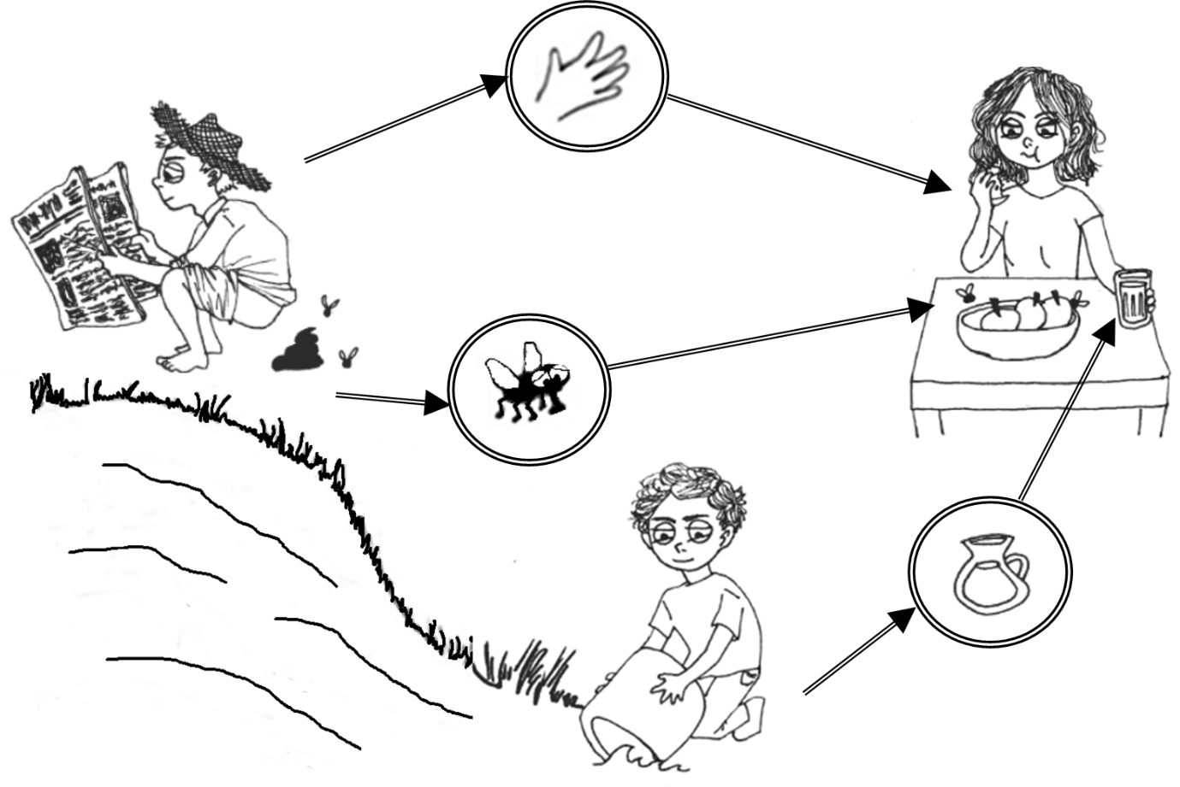

Figure : Simplified F-diagram.

A new host becomes infected when fecal matter is transferred to their mouth via contaminated fingers, flies, or fluids.

Programs by humanitarian and development organizations to reduce the high burden of diarrhea generally focus on improving water, sanitation and hygiene conditions (Musoke et al., 2018). Broadly, intervention strategies to interrupt fecal-oral transmission pathways could be categorized as follows:

* Adequate **Sanitation** can prevent feces from entering the environment where others may be exposed to it. Sanitation facilities must be of sufficient quality to contain infectious feces and keep them separate from drinking water supply, food eaten raw, and flies that can spread fecal matter between surfaces.
* Improved **Water Quality** through a variety of different treatment methods can kill infectious pathogens that are in the water before they are consumed. The appropriate type of water quality treatment depends on the pathogens present.
* Better **Hygiene** (e.g. handwashing, food washing)practicescan interrupt the transmission of fecal pathogens before they are ingested.
* Increasing **Water Supply** can increase the quantity and convenience for people to practice hygienic behaviors.

Each of these intervention strategies are effective at preventing the transmission of many different types of fecal-oral diseases, although the exact extent of the effectiveness depends on pathogen-specific characteristics. While there is a great deal of overlap in the strategies to prevent or control fecal-oral pathogens, it is unlikely that policymakers have the resources to implement all interventions at once. Yet, no guide has been developed as to how interventions from the WASH sector can be strategically optimized for alleviating disease burden.

### Applying systems thinking to disease control

Infectious diseases do not spread in isolation. Instead, pathogens are transmitted through complex mechanisms involving human behaviors and external conditions in the environment. This is one reason for incorporating a range of expertise in policy discussions. Additionally, not all decisions related to public health are performed by those with medical expertise. For instance, financial institutions, donor agencies, or water and sanitation engineers are all examples of influential actors on community health who may not have epidemiological backgrounds. Models that incorporate non-medical domains (or at least, are interpretable by those lacking clinical experience) may be useful in multi-actor policy situations.

To account for complexity and interdisciplinarity, a growing number of researchers are advocating for the application of **systems thinking** to public health issues like WASH (Eisenberg, Trostle, Sorensen, & Shields, 2012; Valcourt, Walters, Will, & Linden, 2019; Xia, Zhou, & Liu, 2017). Systems approaches account for the complex interrelationships between connected sub-systems and encourage the integration of cross-disciplinary knowledge (Rietveld et al., 2016). Such methods move beyond the traditional methods used in disease epidemiology because they work to account for factors such as: economic mechanisms, community effects, social interactions, ecological factors, and other interdependent elements (Eisenberg, Scott, & Porco, 2007).

As stated by Montibeller & Franco (2010), choices surrounding the implementation of a WASH project go beyond just the technical aspects. Policymakers must make important choices (e.g. which diseases to target, which groups of people are highest priority, which intervention method to use) concerning the limited funding they get from constituents or international donors. Whether intended or not, programs commit limited resources that “lock in” development to a certain pathway, which has long-term consequences for public health. In low-income countries, health prioritization occurs on an ad hoc basis and policies are often based on the priorities of donors or on previously-financed programs (Henriksson, Peterson, Waiswa, & Fredriksson, 2019).

There are few tools available to help low-income countries decide which control strategies are the highest priority. Resource prioritization is not so straightforward when one considers the conflicting opinions of decision makers that are likely to occur surrounding which health problems should be tackled first. For instance, is it most important to alleviate an immediate, acute problem or to find sustainable solutions to a long-term issue? Should solutions be sought to be applied equally, to protect the greatest number of people, or equitably, to protect the most vulnerable? Should the focus be on treating community members who are sick so that their conditions do not worsen, or preventing future cohorts from becoming infected in the first place? These value trade-offs are uncomfortable, important characteristics that policymakers must choose between and that laboratory research and quantitative models alone cannot resolve.

### Making decisions under deep uncertainty

Health needs in low-income countries are overwhelming. When it comes to deciding how to best help communities struggling with inadequate water, sanitation and hygiene, policymakers must deal with a great deal of complexity. This complexity imparts a heavy cognitive burden on decision makers as they try to think holistically about the possible performance of each policy option– especially when policies in reality are composed of a large set of sub-options (Montibeller & Franco, 2010). Decision makers can quickly become overwhelmed by the cognitive burden of evaluating a set of interrelated strategic decisions (Montibeller & Franco, 2010). In the face of complexity, decision makers may resort to ignoring or simplifying key parameters of the problem at hand to make it more understandable. Public health problems are often situated within a challenging, multilayered context, thus the decision often ends up being made simply based on “gut feeling" or by following the course of previous actions (Baltussen & Niessen, 2006).

To supplement the limitations of human cognition in non-linear and uncertain situations, quantitative modelling can be a useful aid (J. Kwakkel & Haasnoot, 2018). Models may help policymakers to compare, contrast, and visualize the potential policy performance of different options. Such computational testing not only helps to understand the behavior of the system, but also to make likely tradeoffs between different objectives clear to the decision maker.

Quantitative models including compartment and agent-based models have thrived over the past several decades, making great contributions in our knowledge of infectious diseases (Xia et al., 2017). However, recent studies suggest that the success of models to influence policy debates has been rather limited (Saltelli & Giampietro, 2015). Critics have argued that models often exclude, ignore, or simplify precisely those aspects that make public policy problems so formidable. Furthermore, models often fail to answer many of the key questions asked by policymakers (Victora, Habicht, & Bryce, 2004).

A critical instance of models failing to support policy decisions occurs when the model itself is difficult for policymakers to understand, not only due to the use of technical jargon but due to simplifying assumptions used to create the model. It is unavoidable that any model will contain assumptions that simplify reality, but while the assumptions chosen may be obvious and rational to the modeler, to the policymaker the simplifications may appear to be biased and misguided. Ideally, the modeler and policymaker would build the model together, ensuring that the parameter assumptions are fully understood and agreed upon. However, public health policies are rarely decided by a single actor. In multi-actor policymaking processes – especially where the actors have wildly different worldviews – it may be impossible to achieve consensus on modelling assumptions.

Modelling assumptions are necessary in cases of uncertainty. Uncertain parameters – such as how often people come into contact with infectious material and what proportion of infected individuals are likely to die – cannot be known exactly, but the modeler may use literature estimates and probability distributions to make an acceptable approximation. In some cases, the uncertainty can be reduced through further laboratory experimentation or data collection. In other cases, the uncertain parameter is so unknown that it is irreducible *even if additional data is collected* – greatly increasing the difficulty for modelers and decision makers alike. In multi-actor situations, policymakers may disagree about what values or structures best represent these parameters, leading to a situation of “deep uncertainty.”

**Deep uncertainty**refers to a situation where the various parties to a decision do not know or cannot agree on how the system works; how likely various possible future states of the world are; and how important the various outcomes of interest are (Lempert et al., 2003). Accordingly, deep uncertainty problems are often contentious. From a modeler’s perspective, this means that there are many plausible model structures that could be used; a variety of perspectives on how to formulate the main objectives; and different ideas about what the optimal solution sets are (J. H. Kwakkel, Walker, & Haasnoot, 2016). In situations of deep uncertainty, traditional decision analysis methods may be insufficient to assist decision makers in coming up with strategies to achieve their objectives.

The classic use of modelling to support decision making tries to predict future outcomes with computational simulation, but such approaches are ill-equipped to handle deep uncertainty (J. H. Kwakkel, 2017). If even forming a “best-guess” probability distribution of a particular uncertainty is unsuitable or impossible, then traditional models may be unable to support decision-making. Thus, rather than falsely trying to reduce an irreducible uncertainty – or avoiding creating a model about the topic at all – modelling techniques that are able to systematically *explore* deep uncertainty values are needed.

Predictive modelling tools applied to the public health sector are often unsuitable when transmission parameters are highly uncertain or data are scarce. In light of this, exploratory (rather than predictive) modelling techniques can be used for learning about the behavior of the public health system. **Exploratory modelling** entails investigating the behavior of highly complex and uncertain systems through computational experiments (Bankes, 1993; Bankes et al., 2013). Each model run is an experiment to test how a particular decision would perform if that plausible situation came to pass (J. Kwakkel & Haasnoot, 2018). Exploratory modelling can be a powerful tool for helping public health policymakers gain insights that are important for decision-making, even when the situation is highly complex and deeply uncertain (Figure 2). Unfortunately, exploratory modelling has been little applied to public health issues to date.

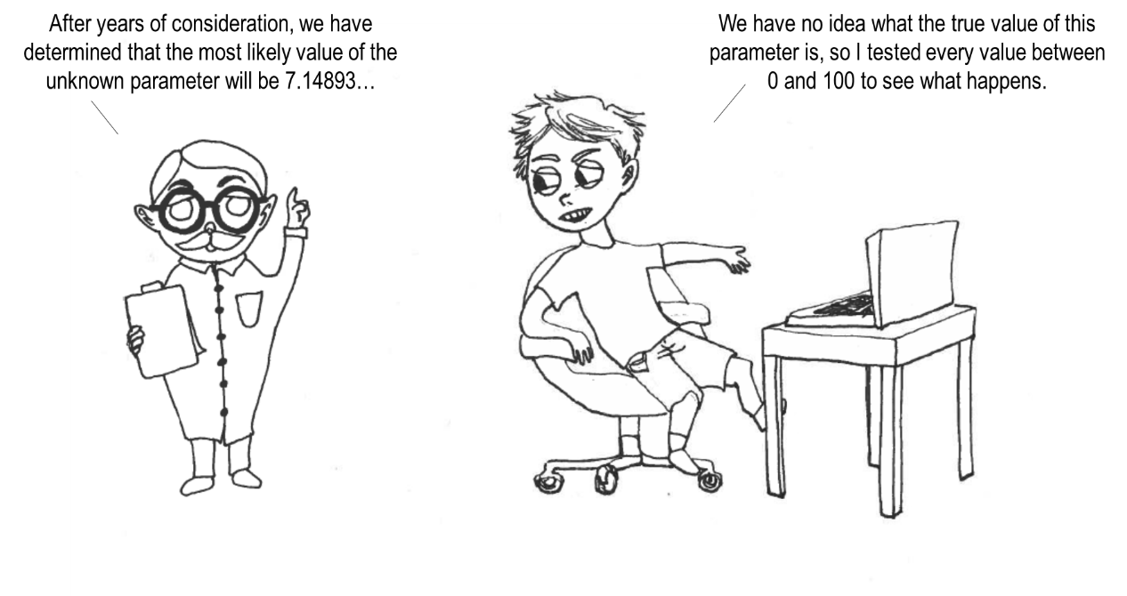

Figure : Predictive versus Exploratory modelling

### Robust Decision Making

The objective of an exploratory model is not to predict the future. Instead, the goal is to find **robust** solutions that perform satisfactorily across a wide range of plausible future states of the world. Decision support methods that seek robust solutions are concerned with finding options that perform reasonably well in as large a set of scenarios as possible, rather than trying to find the optimal policy for a few well-known cases (J. H. Kwakkel et al., 2016).

Robustness is a useful metric because it identifies policies that are both high-performing and also relatively insensitive to future external changes, or “scenarios” (Lempert, Groves, Popper, & Bankes, 2006). **Scenarios** are easy-to-understand descriptions of possible future situations and are an effective tool for helping decision makers understand the resiliency of their policy ideas. Decision support models that use scenarios (rather than probabilistic forecasts) to discuss deep uncertainty helps decision makers to think about a broader range of possibilities, ultimately encouraging more robust policy choices (Gong et al., 2017).

Scenarios tend to encourage decision makers to consider situations that may be less likely to occur but would have extreme implications on policy performance. Such scenarios are commonly overlooked by decision makers (possibly because they have never occurred before) but that does not mean they are inconsequential (Gong et al., 2017). Ultimately, policymakers would prefer to develop a strategy that can to do well not only in the most probable future scenario, but under extreme worst-case scenarios as well. In this way, policymakers can feel assured that their investment is likely to succeed.

Decision frameworks that consider robustness are useful for identifying important vulnerabilities in potentially promising policy options. One technique for identifying vulnerabilities is to use a computational process of **scenario discovery**, which can be used to prepare decision makers for how their proposed policies may perform if unexpected future situations unfold (Morecroft, 2015). To date, decision analytic frameworks that incorporate robustness have not been used to inform policy debate against multiple diseases. However, such approaches have great potential for identifying interventions that could work well against many pathogens of interest, despite data gaps and uncertainties.

### Preference elicitation in many-objective problems

At its most basic level, exploratory modelling consists of systematically changing model values and analyzing how a particular outcome of interest is affected. There are a wide range of ways a modeler could do this, which need not be very sophisticated. However, modelling becomes much more complicated when the decision maker is weighing *more than one objective*. Traditionally, many-objective decision problems are simplified by aggregating the objectives into a single “utility function,” which turns the issue back into a relatively easy-to-solve optimization problem. However, there are significant drawbacks to using a utility function. First of all, they can be extremely difficult to make because the decision maker must have a thorough understanding of exactly what they want to achieve in order to come up with a function that captures it. In multi-actor situations, all of the stakeholders need to agree on the same function before it can be used.

Another challenge to solving multi-objective optimization problems occurs when the rise in performance of one objective comes at the expense of another. When objectives conflict, it is impossible to find a single solution that yields ideal performance, instead requiring one or more of the objectives to be compromised. Because utility functions tend to hide what is going on behind-the-scenes, recent algorithmic approaches have sought to keep objectives disaggregated to clarify these tradeoffs. **Many-objective** **optimization** techniques are useful for highlighting the tradeoffs that occur among conflicting objectives, as opposed to aggregated performance measures which tend to hide such deviations and conflicts(Kasprzyk, Nataraj, Reed, & Lempert, 2013).

Inevitably, decision makers are forced to state their preferences over many conflicting objectives. It is up to the decision maker to think about which objectives can be compromised and which tradeoffs are acceptable. Such tradeoffs are especially challenging in the high-stakes domain of health and development where it can feel uncomfortable or unethical to prefer one objective over another (Figure 3).

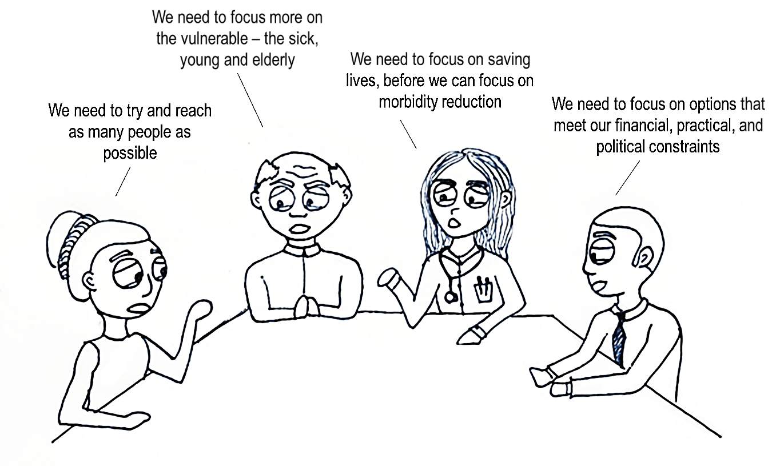

Figure : Challenges of *a priori* preference elicitation

Choosing between these stylized statements helps to illustrate how uncomfortable eliciting preferences can feel to the decision maker when forced to make high-stakes tradeoffs. Still, without a clear understanding of how objectives should be weighed or prioritized, the analyst is unable to optimize for “the most important” objective. It is critical that decision makers are aware that tradeoffs exist and that they decide whether these tradeoffs are acceptable or not – there may be situations where it is not ethical to have low scores on one criterion but high scores on another (Baltussen & Niessen, 2006). Preferences will vary among stakeholders and achieving consensus is difficult – especially for deep uncertainty problems.

Traditional decision support models ask the decision maker to describe their preferences and the best solution is then determined. However, ***a priori*** methods of preference elicitation assume that decision makers have a good understanding of: their own preferences; how feasible their objectives are; and the interdependencies between their objectives. It is unlikely that these assumptions hold for deeply uncertain problems, when decision makers may not understand how the preferences they initially describe affect the solutions that are later presented to them. Also, it is challenging for a decision maker to think about preferences before seeing possible solution sets. Therefore, not only are preferences difficult to elicit *a priori* for deeply uncertain problems, such methods likely also lead the decision maker to miss potentially better solutions.

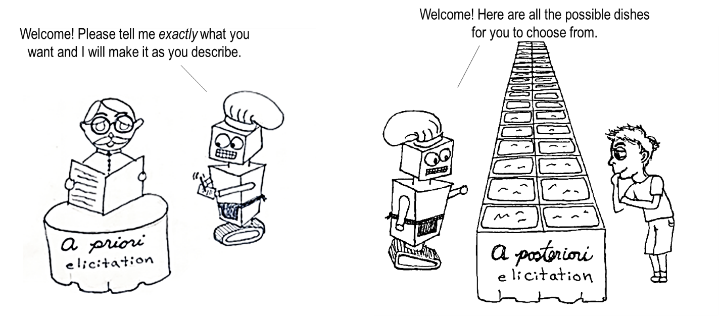

Figure : Methods of preference elicitation.

Decision preferences may be incorporated into a quantitative model upfront (*a priori*) or after computing all possible solutions (*a posteriori*). The latter is particularly useful when decision makers do not know exactly what they want until they see potential solutions, such as when eating at a buffet.

To address the shortcomings of upfront preference elicitation, ***a posteriori*** methodsseek to wait until the end of the analysis before incorporating decision maker preferences. Using *a posteriori* (also known as “generate-first-choose-later”) methods are advantageous because a wide range of optimal solutions are computed first, and then the decision maker is asked to select their preferred solution (Figure 4). A disadvantage is that many-objective *a posteriori* optimization requires much more computationally expensive calculations. To the author’s knowledge these advanced computational techniques have not yet been applied to policy support in the public health sector. However, with machine learning techniques increasingly being applied to supporting health problems such applications are likely to become more mainstream in the near future.

While there are a number of methods for solving many-objective policy problems, perhaps one of the most promising is an emerging method known as **Many-Objective Robust Decision Making (MORDM)**, which incorporates *a posteriori* support. To meet the challenges of optimizing over conflicting objectives, MORDM uses **Many-Objective Evolutionary Algorithms (MOEAs)** to find high-performing solutions. By mimicking Darwinian genetic processes, MOEAs compute promising solution sets using biologically inspired “reproduction,” “mutation,” and “selection” operators (A. Coello Coello, A. Van Veldhuizen, & B. Lamont, 2007). They have risen in popularity in recent years due to increased computational power that enables their application to a wide variety of extremely high-dimensional and irregular problems (Kasprzyk et al., 2013). Accordingly, the potential of evolutionary algorithms presents exciting opportunities for policy analysis in the public health sector.

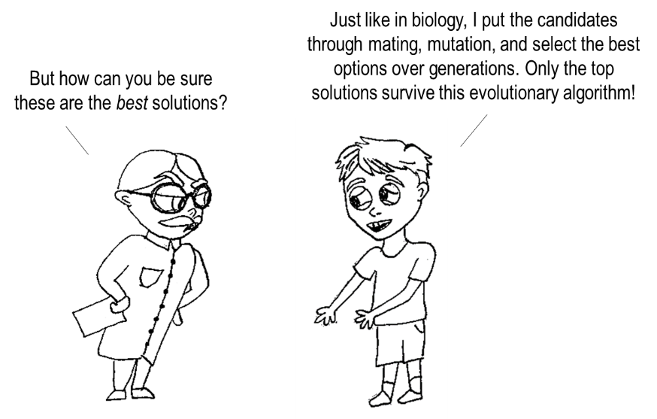

Figure : Using Evolutionary Algorithms for Policy Analysis.

This section introduced the topic of fecal-oral disease transmission in low-income settings as well as background on concepts related to exploratory modeling and analysis. The following section presents the main research question and overall objective of this thesis. This is followed by a presentation of five sub-questions to structure the remainder of this thesis as well as corresponding methods used to answer them.

## Present Main Research Question

Decision makers in low-income countries face enormous public health challenges that must be combatted using finite resources. As such, the following body of research develops a multi-disease model as a proof of concept for supporting policymakers in understanding how different public health investments may affect their long-term strategic goals. The **overall aim** of this thesis is to identify robust policy options for combatting multiple infectious diseases under conditions of deep uncertainty. The main research questionaddressed here is:

**Main Research Question**

**How can a multi-disease model be used to support the design of robust, integrated strategies for achieving many public health objectives?**

The research question is addressed using a specific case study concerning the spread of four gastroenteric pathogens in Uganda. The **target audience** of this thesis includes stakeholders that make or support decisions surrounding the use of public health resources, especially in low-income settings. The model is of interest to those who are interested in using limited public health investments efficiently (i.e. by choosing strategies that work well across a wide range of diseases). More detail on the overall research methodology is provided in Chapter 3.

### Sub-research questions and methods

To address the main research question, five sub-questions are used to structure this thesis:

**Sub-Research Question 1**

How do existing models support policy decisions against multiple public health threats?

Chapter 2 addresses this question through a Literature Review of contemporary disease modeling practices. The purpose of this review is to gain an understanding of the way that quantitative models are currently used to evaluate strategies that work against more than one public health issue. This chapter outlines the research gap surrounding public health modeling and make the case for an exploratory multi-disease model.

**Sub-Research Question 2**

What foundations of exploratory modeling are useful to support public health policymaking under deep uncertainty?

Chapter 4 provides an analytic framework for exploratory public health policy modelers. The gaps identified in the literature review are addressed by organizing some key principles of exploratory modeling in a manner that can readily applied to a wide range of complex public health issues.

**Sub-Research Question 3**

How can the transmission of multiple infectious diseases be included in a single model in order to compare the performance of different interventions on policy objectives?

In Chapter 5, a multi-disease model evaluates policy performance against many objectives of decision makers. The multi-disease model is designed using systems dynamics techniques in order to capture the interconnected factors related to the spread of infectious pathogens. Further justification for using system dynamics methods is provided in Chapter 3 (Methodology).

**Sub-Research Question 4**

What does using different problem formulations reveal about the tradeoffs between many objectives?

This question is addressed in the beginning of Chapter 6: Many-Objective Experimentation. This section investigates how different problem formulations ultimately influence performance outcomes. The implications of this subjectivity in problem formulation are evaluated for their impact on objective tradeoffs.

**Sub-Research Question 5**

Under what plausible future states of the world are the robust policy options vulnerable?

In Chapter 6, Multi-Objective Robust Decision-Making (MORDM) techniques analyze key system factors and scenarios that ultimately affect the objectives. The goal is to find a set of robust policy plans and then to understand what conditions lead these policies to perform poorly. Additional justification for using MORDM as the analytical approach is given in Chapter 3 (Methodology).

##### Concluding remarks on research formulation

This chapter provided the reader with an introduction to the topic of disease modelling for policy analysis. Background on applying exploratory modelling and analysis techniques to deeply uncertain problems was given.

The remainder of this thesis is organized as follows. In Chapter 2, a literature review discusses the research gap surrounding multi-disease policy support. Justification for the chosen methodology is detailed in Chapter 3. In Chapter 4, an analytical framework for exploratory public health policy modelling is developed. The foundations of this framework are subsequently applied through the remainder of the thesis, which includes the development of a multi-disease model in Chapter 5 and the many-objective exploration in Chapter 6. The high-level policy implications of the framework, model, and analysis, are discussed in Chapter 7. In the appendices, the reader may find more detail on the infectious diseases used in this case study.

# Literature Review

The following chapter examines the use of quantitative modelling for supporting policy considerations across more than one disease at a time. Specifically, this review addresses the question: **(Sub-RQ1):** “**How do existing models support policy decisions against multiple public health threats?**” Relevant articles were selected based on if the model considered multiple diseases or multiple transmission pathways in their evaluation of intervention performance. Article abstracts were scanned for relation to the topic of public health intervention planning. Importantly, clinical co-infection studies were discarded, since the scope concerns population-level decision support. A full description of the literature review process, keywords, and a summary of search results is provided in the appendices.

Few examples of models to support policymaking against many infectious diseases were found in the literature search. Instead, a number of articles showed themes that were closely *related to* the notion of a multi-disease model. In the next section, these related themes are presented and critiqued. A single example of an existing multi-disease tool known as LiST is also discussed for its appropriateness in supporting policy design. Finally, the review concludes with a discussion of the knowledge gap and path forward.

## Four research themes related to multi-disease modelling

In this thesis, the notion of a “multi-disease model” is to have one tool that contains transmission information for many different pathogens that can be used to evaluate different policy options. In searching through literature, four ideas that were similar to (but not the same thing as) a multi-disease model were found, which are described here briefly. These related ideas are: (1) *generalizable models*, (2) *multi-disease databases,* (3) *connecting frameworks,* and (4) *group models*. These concepts closely resemble a multi-disease decision support model, but on their own are insufficient for supporting policymakers to understand the effects of different public health interventions.

##### (1) Generalizable models

The first theme that emerged during the literature search for multi-disease models were nonspecific models that could be customized to fit various pathogens (i.e. a “generalizable model”). A highly sophisticated example of a generalizable modelis the Epidemiological Modelling software (EMOD), which is a code structure that can be re-configured to represent many different diseases. It is a multi-disease model in the sense that the code can be modified for different pathogens; but the code was not created for the purpose of modelling many diseases at the same time.

A potential barrier to EMOD being widely extended towards multiple diseases is that the code requires a great deal of data and model fitting to work, which makes it less suitable for low-income countries where diseases are prevalent but information is scarce. Bershteyn et al. (2018) admit that EMOD is less suited for use where there is little data, since it can require a great deal of configuration and parameterization. Thus, while EMOD has the potential to be extended to a multi-disease decision support tool, it is more appropriate for illnesses where detailed information (preferably stratified by age and location) is available (Bershteyn et al., 2018).

##### (2) Multi-disease databases

A second concept related to integrated intervention planning found in the literature search is that of a “multi-disease database.” For example, Eisen et al. (2011) present a software for managing the information about multiple vector-borne diseases, which is currently able to record data on dengue fever and malaria. The program can be used to keep track of data about the prevalence and burden of different diseases in a population (Eisen et al., 2011). This is another useful tool that supplements – but does not replace – the need for multi-disease models in program design.

##### (3) Connecting frameworks

A third related concept to multi-disease modelling is the idea of building “connecting frameworks” that link different models together. This is the notion behind the Framework for Infectious Disease Analysis (FIDA), which aims to facilitate the sharing of model information in order to improve its consistency and ease-of-use (Erraguntla, Zapletal, & Lawley, 2017). By sharing model parameters and structures across different applications, FIDA seeks to improve the coherence and validity between models (Erraguntla et al., 2017). A key tenant of FIDA is that many different methods can be used to model and analyze the same disease, depending on the application, and there should be a framework which can handle and interpret these different methods (Erraguntla et al., 2017). For instance, FIDA could take the output from a compartment model and use it to parameterize the inputs to an agent-based model (Erraguntla et al., 2017). While FIDA is a useful method which promotes the easy linking of different disease models, it is not itself a multi-disease intervention planning tool.

##### (4) Group models

Finally, the most common way that multiple diseases are dealt with in literature is by aggregating them under a category. Hence, a “group model” refers to methods that aggregate diseases together and then treats them the same way. One of the most common examples of this in the WASH sector is the use of “diarrheal disease” to encompass a wide variety of pathogens. The problem with this “grouping” from an intervention standpoint is that while diarrhea-causing pathogens share many similarities, they are not the same. Accordingly, control strategies targeted towards stopping “diarrheal diseases” will vary in effectiveness depending on the actual mix of pathogens present. Discussing these health problems using a general category may be easier for decision makers to understand but has the unfortunate side effect of hiding important information.

Groups of infectious diseases are often clustered according to scientific taxonomy or clinical symptoms, which is useful for purposes of diagnosis and treatment but is less useful when discussing environmental drivers behind disease transmission (Eisenberg, Desai, et al., 2007). Many of the most pressing infectious pathogens related to WASH systems do not share the same symptoms or scientific taxonomy, making it difficult to classify them together under a common moniker. In 1972, White et al. tried to address this problem by creating the **Bradley Classification** system of the following groups of disease: “water-borne,” “water-washed,” “water-based” and “water-related” (Bartram & Hunter, 2015). Along with the term “diarrheal disease,” the Bradley Classification system remains the predominant way of discussing multiple diseases in WASH programming.

Even for WASH experts, however, the delineation between the different Bradley Classifications is head-scratching. For instance, the vast majority of water-borne diseases can also be considered water-washed. Additionally, some pathogens classified as water-borne such as rotavirus are unlikely to be controlled only by improving water quality, requiring other interventions as well (Kraay et al., 2018). While the Bradley Classification system remains the most widely-used set of terminology, it is questionable how useful it is for supporting policy evaluations. The complexity behind environmental change means that relevant disease categorization schemes from a prevention or policy standpoint have remained elusive (Eisenberg, Desai, et al., 2007).

It is important to disaggregate by pathogen when analyzing WASH strategies (or at least, to aggregate carefully) to avoid misleading conclusions. For example, Devipriya & Kalaivani (2012) used a compartment model with the objective of finding the optimal control against “waterborne diseases.” Specifically, their stated objective function was to minimize the number of susceptible individuals and the cost per vaccine dose administered (Devipriya & Kalaivani, 2012). Their choice to use a grouped classification rather than a specific pathogen was significant because there is *no such thing* as a vaccine against “waterborne diseases.” This model by Devipriya & Kalaivani (2012) was later improved by Namawejje, Luboobi, Kuznetsov, & Wobudeya (2014) who tailored the model parameters to be specific to rotavirus (which does have a vaccine) and included other pathogen-specific control strategies such as oral rehydration therapy and hygiene promotion. Thus, increasing the granularity of disease information can improve the recommendations of quantitative models.

Two other examples of grouped disease models are the compartment models by Chen & Preciado (2014) and Handel, Longini, & Antia (2007). Both researchers used a mathematical model in order to analytically solve for the “optimal” intervention intensities for a population afflicted by more than one disease. These models cannot be used directly for policy support, since Handel et al. (2007) for instance did not specify what the interventions were (referring to them only as e.g. “strong intervention,” “weak intervention”). Similarly, Chen & Preciado (2014) sought to find the optimal allocation of “vaccines” against multiple (unspecified) diseases. Both papers are useful mathematical foundations for researchers interested in multi-disease optimization. However, neither paper applied their theories to real pathogens or case studies, so they remain mathematical exercises rather than multi-disease decision support systems.

## Existing multi-disease model example

While research on ideas *related to* multi-disease modelling exist; there are few instances of actual models that quantify the transmission of multiple diseases for policy support purposes. From the keywords used in this literature search, only one example of a multi-disease model was found. The Lives Saved Tool (LiST) can be used for considering the impact of multiple types of illness on a population. Developed by Johns Hopkins University, the tool is useful even for those without epidemiological expertise because the model has default settings that can be run without having to specify overly-detailed information. With LiST, the user can get a general idea of the potential impact of different interventions on overall mortality reduction.

While LiST is relatively user-friendly, the structure of the LiST model limits its capabilities as a robust decision support method. First of all, LiST is a linear, deterministic, mathematical model. In other words, the model will produce the same outputs for given inputs each time the model is run (Fischer Walker & Walker, 2014). It does not consider dynamic behavior or stochasticity, which is problematic when one considers the highly nonlinear processes behind transmission patterns. The effects of different intervention strategies may be better captured by structures that include dynamic independencies (i.e. feedback loops) and incorporate methods of sensitivity analysis. To date, LiST has primarily been used by NGOs as for monitoring and evaluation purposes, rather than for program design (Stegmuller, Self, Litvin, & Roberton, 2017). Though it is still the most widely-applied instance of a multi-disease model, LiST is limited in its power as a robust decision support tool.

## Research Gap

Very few quantitative models have sought to analyze the impact of interventions against *multiple* infectious pathogens. A review by Heesterbeek et al. (2015) describes the advances made in public health modelling over the last 70 years – which include compartment models, network models, agent-based models, and others – but none of these advances describe attempts to optimize interventions across several diseases. The closest thing are models that incorporate multiple diseases to study immunological factors (i.e. in an individual, not from a community intervention standpoint). The literature review affirmed that a substantial research gap exists concerning models that incorporate multiple pathogens to support public health policymaking.

According to Heesterbeek et al. (2015), researchers have yet to fully explore the way in which multiple pathogens influence transmission dynamics and control strategies. Unfortunately, existing “group” models may be leading users astray. In the water, sanitation, and hygiene sector, pathogens spread by unsanitary conditions have many similarities, but they are not the same. Accordingly, models that view all WASH-related pathogens equally are unlikely to identify optimal intervention strategies.

While research has been performed involving multi-disease concepts, few models exist with the intent of assisting with intervention selection. Of the models that do exist, they are ill-equipped to handle deeply uncertain situations (where even the problem itself is contested). Exploratory modelling approaches provide opportunities provide insight in situations where predictive models cannot reasonably be created.

##### Literature review conclusion

This review sought to address Sub-Research Question 1:“**How do existing models support policy decisions against multiple public health threats?**” From the literature search, a few general themes emerged. The vast majority of existing disease models are used for single-disease applications, especially for diseases that have already been well-characterized. While single-disease models have become increasingly sophisticated, they may be too narrowly-scoped to address relevant questions posed by policymakers under deeply uncertain conditions. Multi-disease models pose an opportunity for policymakers with limited resources, especially those from low-income settings, to understand the wider context of a particular intervention. There are some tools closely related to a multi-disease model, but these do not fully meet the needs of policy support in uncertain situations. A common shortcoming of existing models is that they optimize intervention strategies for subjective groups of pathogens, rather than on more a nuanced basis. In the next chapter, a methodology for providing holistic public health policy analysis while keeping in mind pathogen-specific nuances is outlined.

# Methodology

The primary aim of this thesis is to identify robust policy options for combatting multiple infectious diseases under conditions of deep uncertainty. A combination of research methods is used to address this aim. The following research methodology chapter provides a theoretical basis and justification for the chosen approach.

## Description of thesis methodology

The overall approach adopted in this thesis is one of exploratory modelling and analysis, which deals with the use of computational experiments to analyze complex and uncertain systems (Bankes, Walker, & Kwakkel, 2013). The case study investigates various WASH and clinical methods for combatting the spread of rotavirus, *Ascaris lumbricoides*, *Cryptosporidium*, and *Escherichia coli* in Uganda. Rather than try to isolate variables to study a single cause-effect relationship, this thesis seeks to gain a more holistic understanding of various intervention strategies from a wider point of view. No attempt is made to surpass the expert-led precision of existing epidemiological models, rather, this thesis seeks to provoke the need for larger-picture approaches to support public health decisions. Figure 6 outlines the research methodology and organization of the remaining chapters.

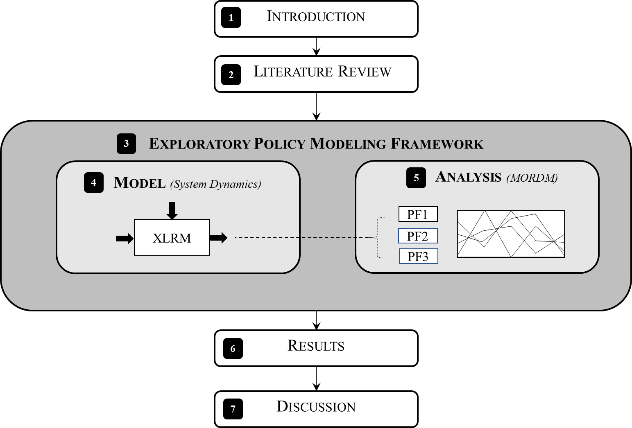

Figure : Research Methodology.

The research methodology contributes the following three deliverables:

1. **Framework**. The research gap emphasized the need for multi-disease modelling to support policymaking. In Chapter 4, a general analytic framework outlines exploratory modelling principles in a manner that can be used for public health topics. On its own, this framework is widely applicable to other research applications beyond the case study adopted in this thesis.
2. **Model**. Chapter 5 presents the proof-of-concept multi-disease model for evaluating various public health intervention strategies. This chapter seeks to understand how the transmission of multiple infectious diseases can be included in a single model in order to compare the performance of different interventions on policy objectives. Conceptually, the system boundary for the model is described using the XLRM framework by Robert J. Lempert et al. (2006), which outlines the key policy levers, uncertainties, objectives and relationships of the system. The model itself is an extension of the Susceptible-Infected-Susceptible structure commonly used in epidemiology. An example case study (interrupting the transmission of gastroenteric disease across Uganda) is used to illustrate how different intervention strategies influence the many objectives of policymakers. Online, secondary sources of data are synthesized into a database of information which is used to formalize the model (key data gaps and uncertainties are noted). The model is constructed using Vensim system dynamics software and validated against available, open source information.
3. **Analysis**. Finally, the results of the multi-disease model are analyzed in Chapter 6 through the use of robust optimization techniques. Specifically, this section uses Many Objective Robust Decision Making (MORDM) with *a posteriori* preference elicitation in order to gain insight concerning the tradeoffs between many objectives. Furthermore, various problem formulations are used to evaluate the impact of multi-actor perspectives on the solutions obtained. All experimentation is performed using the exploratory modeling workbench (<https://github.com/quaquel/EMAworkbench>) by J. H. Kwakkel (2017). The workbench is an open source Python library which facilitates the generation of computational experiments and model analysis.

This methodology can be applied by researchers to other deeply uncertain public health issues. Note that the chosen approach for exploratory modelling (multi-disease model with system dynamics) and analysis (MORDM) are interchangeable with other methods (for instance, agent-based modelling and many-objective robust optimization), since the theories laid out in the analytic framework are method-agnostic. Importantly, the specific modelling and analysis methods should always be tailored to the particular policy problem under study. The following section provides justification for the particular exploratory modelling and analysis techniques chosen to study the transmission of gastroenteric pathogens in Uganda.

## Justification of Methods

### Reflection on modelling method chosen

System dynamics and agent-based modelling are two popular modelling approaches that are commonly applied to understand disease transmission. System dynamics approaches are “well-developed in epidemiology,” while agent-based models have “recently gained momentum” (Rahmandad & Sterman, 2008). System dynamics modelling techniques were chosen to create the multi-disease model for several reasons: (1) the multi-disease model is better suited to a broad system boundary; (2) the high level of aggregation is more appropriate for top-down policy support; and (3) the assumptions used in system dynamics are established practice in public health modelling.

##### (1) Broad system boundary required

System dynamics models traditionally adopt a broader system boundary in order to incorporate a wide range of causal factors involved with disease transmission. On the other hand, agent-based modelling provides more granular information on transmission patterns and individual behaviors. However, modelling at the agent level comes at a computational and cognitive cost- requiring additional time and resources to run the model (as well as to understand its outcome). Accordingly, modelers generally resort to limiting the system boundary when using agent-based approaches. Since this thesis seeks to provide policy support using an uncommonly wide system boundary, system dynamics techniques were deemed to be a better fit for making the multi-disease model.

##### (2) High-level policy support

There are already a great number of highly specialized epidemiological models that study the transmission of communicable diseases in great detail – this thesis does not attempt to surpass the precision of such expert-led tools. Rather, this thesis is intended to highlight the viability of mapping epidemiology research in a manner that is relevant for supporting real-world (messy) policymaking. The intent of this model is to provide policy-level support rather than high-precision knowledge of pathogen characteristics or of individual interactions. The use of system dynamics is considered more of a “top-down” approach than other techniques, which is useful in this application since the model is targeted towards the perspective of a policymaker (Ding, Gong, Li, & Wu, 2018).

##### (3) System dynamics is established practice in epidemiology

System dynamics modelling is beneficial for studying feedback loops, time delays, and other nonlinearities. To create the model, the population is divided into a small number of compartments (by age or disease status, for example). Since this type of modelling involves looking at the population from an aggregate perspective of cohorts, individual interactions were not modeled at a discrete or agent-based level. Instead, homogenous mixing and uniform contact rates were assumed in modelling disease spread, which is commonly done in epidemiology (Chowell, Sattenspiel, Bansal, & Viboud, 2016). In short, system dynamics was selected because the structures and assumptions used have long been established practice in the epidemiological and public health domain.

### Reflection on analytical method chosen

There are many different ways to computationally search for promising candidate policies in light of conflicting objectives. This thesis adopts the MORDM method proposed by Kasprzyk et al. (2013), which uses a many-objective evolutionary algorithm (MOEA) to find a set of policies close to the Pareto-optimal front. The notion of **Pareto optimality** means finding a set of multiple best solutions for the problem, where each solution is a compromise between different objectives. A clear estimate of the Pareto front can be highly useful in helping policymakers to select robust plans as well as to learn about the underlying dynamics of the system.

MORDM is intended to be done in collaboration with decision makers, in order to incorporate lessons learned as part of the policy deliberation process (Kasprzyk et al., 2013). Since MORDM does not require assumptions about policymaker preferences before determining the Pareto front, this approach represents *a posteriori* decision support (Kasprzyk et al., 2013). MORDM was selected for this analysis because of this benefit of enabling the decision maker to gain an understanding of a larger set of superior solutions without the premature aggregation of performance measures. Ultimately, it is up to the decision maker to select the final policy once these trade-offs between different options are made clear. Though to the author’s knowledge MORDM has not been used so far to inform public health policymaking, the approach holds great potential for supporting experts in discovering, analyzing, and fine-tuning health development policies.

##### Using Many-Objective Evolutionary Algorithms

MORDM incorporates MOEA in the search phase in order to perform global optimization and discover high-performing policy options (Kasprzyk et al., 2013). Mimicking natural processes of evolution, MOEAs iteratively evaluate possible strategies across the many objectives until the best candidates are found. Using an MOEA is chosen over classical optimization methods for the following reasons:

* Rather than handling a single solution, the population-based approach of MOEAs can be used to find a large number of solutions in a single run.
* MOEAs are ideally suited to working in parallel systems, which can dramatically reduce computational expenses.
* Because the algorithm’s evolutionary processes are separate from the issue it is applied to, MOEAs are easily applied to different problems.

The application of MOEAs to many-objective policy problems is useful for keeping performance measure disaggregated while enabling the evaluation of trade-offs between various alternatives (Kasprzyk et al., 2013). In short, MOEAs provide an efficient way to determine the Pareto front and highlight potentially robust policy options.

##### Choice of NSGA-II

The particular algorithm used during the MOEA search is the **Nondominated Sorting Genetic Algorithm II** **(NSGA-II)**, which was selected because it has the following characteristics:

* NSGA-II uses a fast, non-dominated sorting procedure (Narzisi, Mysore, & Mishra, 2006).
* In many applications, NSGA-II has been found to converge better than alternative algorithms.
* NSGA-II is capable of preserving a good level of diversity, thus avoiding getting stuck in a local minimum.
* The algorithm excels at obtaining a variety of solutions. NSGA-II uses an elitist strategy that allows it to find a better spread in the non-dominated front than other algorithms and get better solutions with less computational complexity.

##### Choice of regret as a robustness metric

To compare the robustness of various policy options, the particular metric selected for this thesis is the **90th percentile minimax regret**. Originally developed by Savage (1951), regret metrics are based on the difference between the performance of the chosen option and the performance of the best possible option under that same scenario (McPhail et al., 2018). As described by Herman, Reed, Zeff, & Characklis (2015), the 90th percentile minimax regret for any given state of the world is determined by subtracting the minimum regret value ( $\min_{s}{F\left(x_{s}\right)}_{i,j }$) from the option chosen in that particular state of the world ( $F{(x)}_{i,j}$). This performance deviation (${ D}_{i,j}$) from the best solution is normalized by dividing by the value of the objective in that state of the world (Herman et al., 2015).

$$D_{i,j}= \frac{\left|F{(x)}_{i,j}-\min_{s}{F\left(x_{s}\right)}_{i,j})\right|}{{F(x)}_{i,j}}$$

Due to the high-stakes consequences of health development, the 90th percentile was chosen because of the assumption that policymakers have a relatively high level of risk aversion and prefer quite conservative solutions. Furthermore, the 90th percentile portrays the tail end of poor performance while reducing distortion from extreme outliers. The use of a relative robustness metric was chosen in order to compare potential policies to one another, rather than to an arbitrarily defined metric. This helps to avoid inserting unnecessary subjectivity into the model, preventing the results from being discarded later based on the choice of criteria.

## Methodology conclusion

##### Academic Contribution

This research delivers a multi-disease model for evaluating the performance of various public health interventions under deep uncertainty, which to the author’s knowledge has not yet been performed. Specifically, the academic value of this thesis is to contribute:

* An **analytical framework** that synthesizes exploratory modelling principles to provide support for public health policymaking. This framework is transferable to other policy problems in the health domain beyond the case study used here, and can incorporate different modelling and exploratory analysis methods.
* A **multi-disease model** that evaluates the performance of various interventions against many objectives. Academically, there is a gap in the consideration of how interventions can work across more than one pathogen and how that knowledge can be leveraged for policy design.
* An application of **exploratory policy modelling and analysis** techniques to a public health problem. To the author’s knowledge, this is the first application of *a posteriori* preferential elicitation methods to either infectious diseases or WASH. By not aggregating many objective preferences upfront*,* this research shows a wider set of potentially optimal strategies and paves the way for greater integration between sectors such as WASH and health.

##### Methodology conclusion

This chapter laid out justification for system dynamics and MORDM when other methods for modelling and analysis could conceivably have been chosen. System dynamics techniques are widely used in epidemiology and were deemed appropriate for the case study. Advanced analytical methods such as MORDM have yet to be applied to exploring public health policy topics; although they hold substantial potential for supporting low-income countries develop their health systems in a robust manner. The academic value of the preceding methodology is that it can be used by other scholars in creating future public health policy support tools.

The next chapter organizes some fundamentals of exploratory policy modelling that are applicable to large-scale public health topics.

# Exploratory Policy Modelling Framework

Public health models have largely followed the high-precision, narrowly-scoped examples common to clinical research. Meanwhile, exploratory policy applications in diverse fields –ranging from economics (Seong et al. 2005) to climate change (Shortridge & Zaitchik, 2018)– have enabled researchers to explore broader and more unpredictable issues raised by policymakers. What opportunities does the field of exploratory policy modeling present for the public health sector? The literature review identified a research gap surrounding the application of exploratory modelling and analysis techniques to addressing public health issues. Therefore, the following chapter addresses Sub-Research Question 2:“**What foundations of exploratory modeling are useful to support public health policymaking under deep uncertainty?**”To answer this question, this chapter organizes basic exploratory modelling principles into five foundations that are useful for supporting public health topics.

## Foundation 1

### Use a systems thinking approach

While the treatment of an infectious disease may lie squarely in the domain of clinical medicine, the transmission of the disease does not. Successful disease intervention requires knowledge of community behaviors, infrastructure, education, the environment, the economy, and other non-medical factors. According to Rietveld et al. (2016), experts frequently attempt to address problems in isolation when in reality the problems are tightly connected. Within public health, this means that programs which focus on improving a single pathway of disease transmission, while neglecting other routes by which the disease can spread, are unlikely to achieve their objectives. As argued by Tayler, Parkinson, & Colin, (2003), it is futile to educate people on the benefits of handwashing after defecating if the people do not have access to a water supply where they can wash their hands.

A systems thinking approach means paying attention to the whole system, especially when it comes to the interdependencies and interactions between its individual parts (Huston & Moriarty, n.d.). For infectious diseases, systems thinking may require the analyst to look outside of their field, beyond purely laboratory- or statistics-based analyses (Xia et al., 2017). While traditional empirical approaches work to isolate cause-effect relationships between individual parameters, systems approaches study the way that a variety of actions impact multiple outcomes over time (Rietveld et al., 2016). A systems approach encourages transdisciplinary thinking for complex problems, making it well-suited for dealing with large-scale public health problems.

Public health issues are more than just the sum of their parts. For instance, the way that an infectious pathogen spreads in humans is not just about the biology of the pathogen. It is also about the behavior of humans – their culture, desire to travel, financial means, education levels, infrastructure, and so forth – that determines transmission patterns. For many diseases of poverty, pathogens are spread through pathways that are complex and interdependent, thus understanding their solutions cannot be done in isolation (Eisenberg, Scott, et al., 2007). As argued by Eisenberg et al (2012), a systems approach is needed in order to quantify robust intervention strategies and provide this information in a manner that supports effective resource allocation in policymaking. When decision support models are narrowly focused on a single issue, they provide an incomplete picture of an interventions benefits for supporting policy decisions.

Systems thinking approaches are essential for using scarce resources effectively. The vast majority of epidemiological models are tailored toward finding an optimal strategy for a single disease under narrowly-defined conditions. In reality, however, many groups of infectious pathogens share the same prevention, control or treatment strategies. Given this overlap, it is important that decision support models provide policymakers with a more holistic picture of what an intervention can or cannot accomplish by looking at a wider set of potentially affected diseases.

## Foundation 2

### Consider various stakeholder perspectives

Different parties to the decision may have vastly diverging perspectives of the same problem, especially where the issue is contentious. This is the case when the health problem is so socio-politically controversial to the point that different stakeholders do not even agree on basic facts about the system. A researcher’s best-guess model may immediately be dismissed by political constituents with different perspectives on the issue. To build a predictive model, stakeholders with different perspectives of the problem would first need to come to consensus about parameter values. The modeler can easily spend just as much time trying to get stakeholders to agree on model parametrization as on building the model itself.

A stakeholder’s perspective of the problem will unavoidably change the way in which model solutions are presented. For instance, at which level of granularity should the problem be specified – national, district, or community-level? And should the presented solution set be those policies that are optimal for tomorrow, or for ten years from now? Even if computational algorithms can be used to find a Pareto set of robust policy options that perform well across the many criteria, the results attained will be governed by the initial problem formulation. While all stakeholders may want to use the available budget in order to ensure that the least number of people are affected by devastating infectious diseases, there are still a number of ways that that general goal could be operationalized depending on one’s view of the issue.

The variety of perspectives involved in any health-related development project means that there is more than one way to frame the problem at hand. In such cases, the aim of the analysis must take into account ways that the *perspective* of other actors influence the system (Enserink et al., 2010). Therefore, there is a need to consider alternative **problem formulations** on the ability of a certain policy to meet the objectives. There has been more attention paid in many-objective decision analytic literature towards the significance of the problem framing step in modelling. However, much of this literature focuses on the need to build consensus between stakeholders during an initial problem structuring phase. In contested, deeply uncertain systems this may not a trivial exercise. Rather than spending a great deal of time on upfront consensus-building, an alternative strategy is to test policy performance against multiple different formulations of the same problem. Instead of arguing over which modelling perspective is the “correct” one, decision makers can switch to looking for strategies that do well no matter which version of the model is used (Bankes et al., 2013). In short, a public health modeler should not assume that there is only one way to frame the “optimal solution,” nor that consensus can always be reasonably achieved between many actors.

## Foundation 3

### Aim to learn and explore, rather than predict

For many complex public health problems, creating a predictive model is not feasible. This is the case when information surrounding the transmission of a certain disease is unknown or incomplete. For instance, it would be impossible to create a perfectly predictive model for an outbreak of an emerging disease when researchers have very little information. Exploratory modelling, however, could be used to test different values of parameters prior to having all of the data. Not only does this allow policymakers to start to gain some insight into the problem, but can also help researchers identify which parameters about the disease actually matter most for the decision maker’s objectives, therefore setting a priority on data collection.

Exploratory policy modelling present substantial possibilities for learning about the potential impacts of public health investments prior to committing precious resources. Such techniques provide opportunities for supporting low-income countries make evidence-based investments that improve their population’s well-being. Unlike traditional predictive models, exploratory models can be used even in cases of data gaps and uncertainties. Existing data can be synthesized into an exploratory model, pointing out the most important features that decision makers should be aware of. This is important for policymakers working on large-scale public health issues, who will never have complete information.

Traditional methods of disease modelling wait until enough scientific consensus has been reached on parameters about the disease (usually through extensive randomized control trials) before models can be developed and “solved.” However, the alarming extents of infectious diseases in low-income countries means that it is not constructive to wait until “enough” data has been collected before modelling, especially because decision makers will have to make choices concerning these diseases whether the data is present or not. Furthermore, since these diseases of poverty have been well-studied for decades, it is questionable to assume that more information about the problem would result in better decision-making.

To date, the bulk of research into infectious disease has been performed from a “risk factor” or clinical standpoint, which is crucial for understanding pathogen characteristics but is not immediately translatable for practitioners working on real-world decisions. In cases where the optimal strategy is extremely sensitive to assumptions, traditional decision support systems may be unsuccessful. However, models can also be used to reveal the extent of that uncertainty to policymakers, enabling them to act accordingly given a clear understanding of the current, imperfect evidence (Knight et al., 2016). Models allow users to gain a general understanding of the realm of possible outcomes from their policy ideas. In order for models to support real-world public health problems, uncertainty and sensitivity analysis must be a central component of the process.

## Foundation 4

### Move beyond optimization

It is unlikely that any complex public health policy problem would have a single, undisputed “best” solution. Just like in other policy domains, public health decisions are characterized by uncertainty, multiple stakeholders, and conflicting values. This makes it difficult to use a quantitative model for achieving a single, uncontested answer. Thus, modelers should be careful in how they use terms like “optimality” or “solve”, since policy problems are more value-laden than purely mathematical ones.

Recently, there has been a shift towards applying “robustness” instead of “optimality” metrics to policy analysis problems. A growing body of research highlights the importance of ensuring that a policy option is not only potentially high-performing, but also relatively insensitive to various uncertainties or problem perspectives (J. Kwakkel & Haasnoot, 2018).

Furthermore, it is desirable to have policies that are not only “optimal” but also *adaptable.* Adaptive policies allow a decision maker to make a time-urgent decision while also preserving needed flexibility to ensure that the policy survives in the long run (Walker, Marchau, & Kwakkel, 2013). Rather than giving the decision maker a single (static) solution, exploratory modelling can help identify ways of modifying policies to protect against potentially catastrophic situations. By searching for conditions that make the policies under consideration fail, the policies can be modified and iteratively improved (Bankes et al., 2013).

## Foundation 5

### The goal is to support good decision-making

A final foundation of exploratory public health policy modeling is to remember that the goal is to help make good decisions. To accomplish this, it may be enough for policymakers to see how the relative performance of different available options compare to each other. Modelers are challenged to start from a policy-level perspective (e.g. infrastructure projects, education promotion, financial investment) and then to quantify how policies map to disease reduction. From this top-down perspective, perfect data is not necessarily a prerequisite to drawing useful conclusions in the same way that it is for building a predictive scientific model. Here, pathogen modelling is flipped from being driven by the characteristics of the pathogens to the characteristics of the control strategies. Rather than asking, *“what is the best way to defeat this particular disease?”* the question becomes, *“given the resources available, which strategy is most likely to improve public welfare?”*

In order to support a good intervention decision, groups of pathogens should be organized by *control strategy* rather than by *clinical or biological feature***.** Most often, groups of infectious diseases are categorized according to their clinical presentation or biological classification (e.g. “respiratory infections”, “bacterial infections”). What is clinically relevant for a single individual does not necessarily provide the best population-level perspective. Also, the objectives of policymakers are typically not pathogen-specific, unless there is a high-profile outbreak of a serious epidemic.

To support actual policy choices, it is necessary for researchers to bear in mind the finite resources available in the real world. This does not necessarily mean to always look for the “cheapest” solution, but to search for creative ways to combine programs for the maximum benefit of the population. To achieve efficient public health resource prioritization, holistic solutions that work against multiple health threats, rather than perfectly for a single threat, may be a better option. Overall, the goal of modelling in deeply uncertain problems is to support decision-making.

## Framework presentation

Public health policy concerns are broader than clinical medicine. Future disease models used to support policymaking should consider research advancements made in exploratory policy modelling in order to ensure that the solutions presented are aligned with the needs and perspectives of decision makers. This section organized some basic foundations for supporting robust public health policies through quantitative modelling (Figure 7).

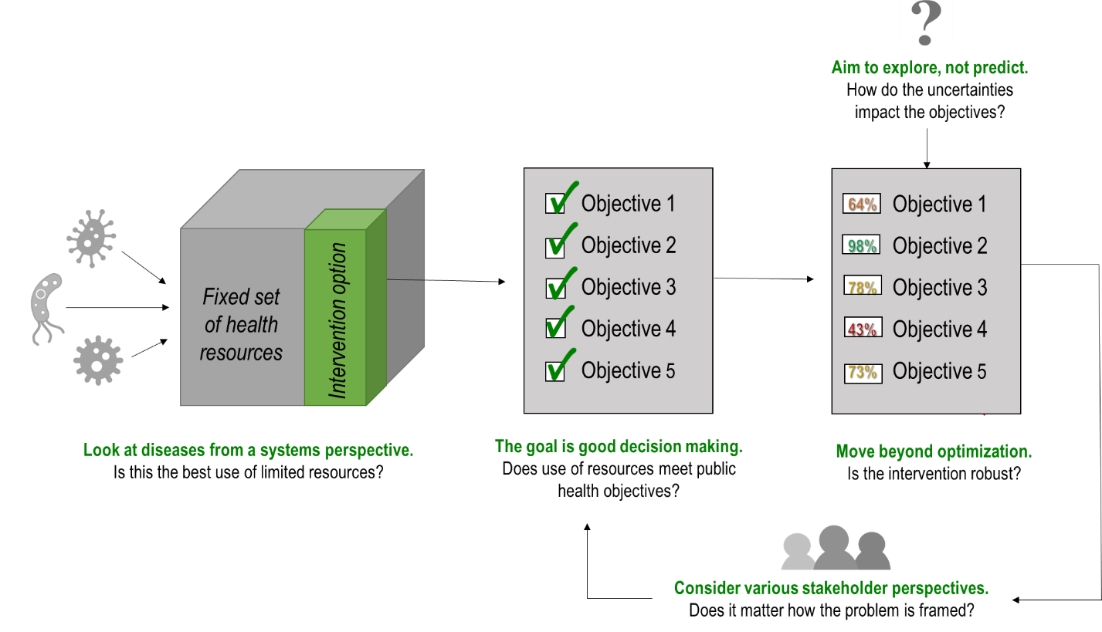

Figure : Foundations of Exploratory Public Health Policy Modeling.

As depicted in Figure 7, public health policymakers have a large number of different illnesses to combat using a finite set of resources. By putting a particular intervention option within its broader health context, a modeler can more effectively support policymakers in comparing different intervention options against many objectives. Exploratory analysis takes this a step further, by seeing if different assumptions of the uncertain values changes the ability of the policy to meet the objectives. Finally, contested problems should consider adopting multiple problem formulations in order to understand if this changes model results.

Practically, public health policymakers have a limited set of resources to work with. Models can support them in making decisions about how to use those resources most effectively. Disease models that group pathogens by similar means of control, rather than by biological characteristics, may improve the salience of different public health policies for non-infectious disease experts. Models aimed to support real-world decision-making should avoid presenting outcomes as certainties when large assumptions are required. Instead, exploratory techniques may be used to help policymakers understand the existence and implications of different uncertainties. Furthermore, policies should be designed to ensure that the objectives are not met only for a single scenario or problem definition, but under a wide range of possibilities.

This section outlined foundations of exploratory modeling useful for supporting deeply uncertain public health policy issues. In the following chapters, the foundations laid out in this exploratory public health policy framework are applied to a real-world case study.

# Multi-Disease Model Presentation

This section presents the conceptualization, formalization, verification and validation of a model that tests different public health interventions against multiple diseases circulating in a population. By putting interventions in the context of a larger number of diseases, decision makers may gain a richer picture of how various interventions affect population health. In this way, decision makers can be supported in choosing interventions with greater impact given limited resources.

The goal of this chapter is to develop a model that can be used to test the performance of different policies against many objectives. This chapter addresses Sub-Research Question 3:“**How can the transmission of multiple infectious diseases be included in a single model in order to compare the performance of different interventions on policy objectives?**”

In the next section, a specific case study will be outlined in order to give context to the remainder of the model development phase. Subsequently, the model is conceptualized by specifying the key objectives, uncertainties, levers, and relationships related to the case study system. Section 5.3 describes the data availability and limitations concerning the case study. The most important sub-models and features are presented in Section 5.4, followed by a discussion on verification and validation in Section 5.5. Finally, demonstrations of the model are provided in Section 5.6 through the use of illustrative pre-specified policy options.

## Case Study Introduction

Uganda is a low-income country that has struggled for decades against widespread prevalence of many infectious diseases. The most recent population census noted that approximately 25% of children reported having an episode of diarrhea within the two weeks preceding the survey, indicating that many infectious pathogens are endemic throughout the country. The number of Ugandans with access to sanitation infrastructure “remains abysmally low,” as only 14% of households have access to improved sanitation (World Bank Group, 2016). Hirai et al. (2016), note that the majority of children do not have a location to wash their hands and 41% of children live in households where water collection time is greater than 30 minutes, which are both significant risk factors for disease.

The Government of Uganda has an array of national and international plans to reduce conditions of poverty and improve public health. However, Uganda’s own National Health Policy notes that health research has been held back because of “a lack of policy framework and an uncoordinated priority setting of the research agenda” (Ministry of Health, 2010).

According to the Ugandan Ministry of Health, diseases related to hygiene and sanitation currently contribute over 70% of the overall disease burden (Ministry of Health, 2010). The majority of these diseases of poverty are easily preventable with basic improvements in living standards. Despite the efforts of international development organizations, however, a reduction in diarrheal disease and other infections has failed to materialize. The multi-pathogen source of diarrhea makes intervention attempts complicated (especially in resource-poor settings, when the particular causal agent is usually unverifiable) (Hirai et al., 2016; Muli, 2018). Recurring episodes of diarrhea have detrimental long-term effects on a child’s physical and mental development (Loevinsohn et al., 2015). Because of the numerous pathogens which result in diarrheal disease in children, reduction in the overall incidence of diarrhea may require a more holistic approach than is currently applied (Wilson-Jones, Gautam, & Smith, 2018).

##### A Note on Terminology

In this thesis, the term “gastroenteric disease” is used, for lack of a better classification, to refer to the pathogens included in this model. **Gastroenteric disease** refers to any illness that is caused by intestinal infection (PATH, 2017). Gastroenteric disease groups together multiple infectious pathogens that are spread through inadequate water, sanitation and hygiene conditions and negatively impact the gastrointestinal system. There is a large number of microorganisms that can cause disease in the body’s intestines, including bacteria, viruses, protozoa and parasites. Diarrheal illnessis one type of gastroenteric disease, which can be caused by pathogens such as: rotavirus, *Shigella*, or *E. coli,* among others (PATH, 2017). Non-diarrheal gastroenteric diseases – including soil-transmitted helminths, polio, and typhoid – are often spread in the same way and therefore share many of the same intervention strategies as diarrheal diseases (PATH, 2017). Intestinal infections usually cause diarrhea or dysentery (mucus/bloody stool) but may also present with nausea, vomiting, and abdominal pain. So symptoms of “gastroenteric disease” may include diarrhea, other non-diarrheal effects to the intestinal system, or (in the case of helminths) be largely asymptomatic.

The four gastroenteric pathogens instantiated in this model are summarized below in Table 1. Readers who are unfamiliar with gastroenteric diseases may want to refer to the 1-page summaries of each pathogen provided in Appendix A.

Table : Overview of Gastroenteric Pathogens Considered

|  |  |  |
| --- | --- | --- |
| **Pathogen** | **Type** | **Explanation** |
| **Rotavirus** | Virus | Virtually all children in the world will contract rotavirus by the time they are two years old. Rotavirus is highly contagious, often passed on from person-person or object-person with a contaminated surface. The virus is also highly resilient in the environment (able to survive for months on an inanimate object). |
| ***Ascaris lumbricoides*** | Helminth | This parasitic worm (or “helminth”) is a non-diarrheal gastroenteric pathogen spread by unsanitary conditions. Ingestion via drinking water is possible but considered a lesser transmission pathway; soiled hands and food is thought to play a bigger role. Over 1.2 billion people around the world currently carry this parasitic worm. In Uganda, prevalence is highest in southwestern districts, where prevalence is typically over 80% (Adriko et al., 2018). |
| ***Cryptosporidium*** | Protozoa | In low-income countries, current estimates are that around 45% of children experience cryptosporidiosis before they are two years old (Mor & Tzipori, 2008). Studies have shown that a single episode of cryptosporidiosis in infancy can lead to stunting, even if the infection is asymptomatic (Squire & Ryan, 2017). This protozoan may account for almost 20% of diarrheal episodes in children in developing countries, and up to 9% of diarrheal episodes in developed nations (Mor & Tzipori, 2008). |
| **Enterotoxigenic *Escherichia coli (E. coli),* or ETEC** | Bacteria | ETEC is the leading bacterial cause of diarrhea in children and adults in lower-income countries. In adults the cases are so severe as to be mistaken for cholera (Gupta et al., 2008). This is also true for the elderly, who may require hospitalization since they generally present with more severe dehydration than children (Qadri, Svennerholm, Faruque, & Sack, 2005). ETEC infection can be prevented by safe food and drinking water, as well as washing hands with soap frequently. |

There is increasing recognition of the enormous impact that gastroenteric illnesses have on the poorest and most vulnerable communities (Arndt & Walson, 2018). There are a range of policy options available for reducing spread of infectious gastroenteric pathogens in the environment, such as: increasing drinking water quality or quantity, improving sanitation conditions, education about handwashing, vaccination, mass drug administration, and beyond. Even though these interventions are well-studied, technologically simple, and cost-effective to implement, low-income areas continue to be devastated by the effects of gastroenteric diseases (Kolaczinski, 2006).

## Model Conceptualization

In this section, a conceptualization of a model to test different strategies for reducing the spread of gastroenteric diseases in Uganda is presented. The multi-disease model is outlined using the XLRM Framework by Lempert et al. (2006) which organizes the model’s main objectives, levers, uncertainties and relationships (Table 2). Identifying these four components is a central activity of model conceptualization, since it clarifies what will and will not be looked at in the model. In the following sub-sections, each of these components is outlined in more detail.

Table : Summary of XLRM Framework

|  |  |
| --- | --- |
| **Levers (L):** | Levers refer to the policy options that the decision makers have control over or an ability to influence. Policymakers may increase or decrease the values of these levers to try and achieve their objectives. |
| **Uncertainties (X):** | The exogenous factors that are beyond the control of decision makers but still influence the system. Like the weather and the stock market, the values of these uncertainties cannot be perfectly predicted in advance. Ideally, the chosen policy would be relatively insensitive to shifts in these uncertainties. |
| **Outcomes (M):** | Outcomes refer to the performance metrics of interest to the decision maker. |
| **Relationships (R):** | Relationships are the internal connections between parameters that determine how combinations of levers and uncertainties translate to different performance outcomes. |

### Policy Levers

Policy levers represent the factors that decision makers may potentially change in an attempt to influence their objectives, which are listed in Table 3. These levers were chosen to represent common strategies used in development programs to improve public health in low-income countries. Each of these levers is in some capacity effective against the pathogens under study. The model is intended for understanding which levers – or combination of levers – is most promising to achieve the many objectives of policymakers.

Table : Description of Policy Levers

|  |  |  |
| --- | --- | --- |
| **Policy Levers** | | **Explanation** |
| L1 | **Construct new community groundwater wells** | Dig new boreholes. Ideally, a single shared well can produce enough water to serve the drinking water needs of a small community, though well quality varies dramatically with local geology. Potential benefits of installing new wells: less time spent walking to collect water; less contamination than relying on surface water; more water to practice hygienic behaviors. |
| L2 | **Maintain existing wells** | Repair existing wells. Broken pumps and handles are frequently cited problems in low-income countries. |
| L3 | **Construct latrines** | Build new Ventilated Improved Pit (VIP) latrines to contain feces. Note that the effectiveness of this policy lever depends on people actually using the latrines constructed, since they may prefer to defecate openly. Without regular maintenance and cleaning, latrines may fall to disrepair after a few years as is commonly reported in reviews of development programs. |
| L4 | **Maintain existing latrines** | Clean and maintain existing wells. This lever also includes the cost of manual pit emptying, since VIPs become full after a few years. |
| L5 | **Distribute chlorine tablets to households** | Provide Household Water Treatment (HWT) by distributing chlorine pills. Chlorine tablets are relatively cheap and can be easily added to a bucket of water to inactivate a variety of fecal-oral pathogens. Note that the impact of this policy lever depends on the household’s decision to consistently and correctly use the chlorine pills, which is listed as a deep uncertainty. |
| L4 | **Build handwashing stations** | Construct handwashing stations where people can wash hands with soap and water after defecating and before food preparation. |
| L7 | **Run a vaccination program** | Increase the budget to subsidize and/or promote vaccination. Note that this policy lever is effective only for pathogens which have a vaccine available (e.g. Rotavirus). The ability to inoculate all infants also depends on the strength of the medical supply chain, which must be capable of ensuring that sufficient stocks of vaccines are available in medical centers. |
| L8 | **Increase use of oral rehydration treatment (ORT)** | Increase the budget to subsidize and/or promote the availability of Oral Rehydration Therapy (ORT) in medical centers. ORT is used to rehydrate people suffering from acute or chronic diarrhea. |
| L9 | **Mass Drug Administration (MDA) campaign** | Each year, provide a single dose of albendazole to beneficiaries. Albendazole is a safe, effective, and highly affordable drug that is capable of completely clearing *Ascaris lumbricoides* infection within about 24 hours. However, the drug wears off in less than a year so it must be repeatedly administered. |

### Outcomes

The objectives of policymakers are numerous and may even be conflicting. This makes finding ideal solutions difficult, since not all objectives can reasonably be achieved. In this thesis, the fundamental goal of health policymakers (to improve population welfare) is separated into the following five broad objectives (Figure 8).

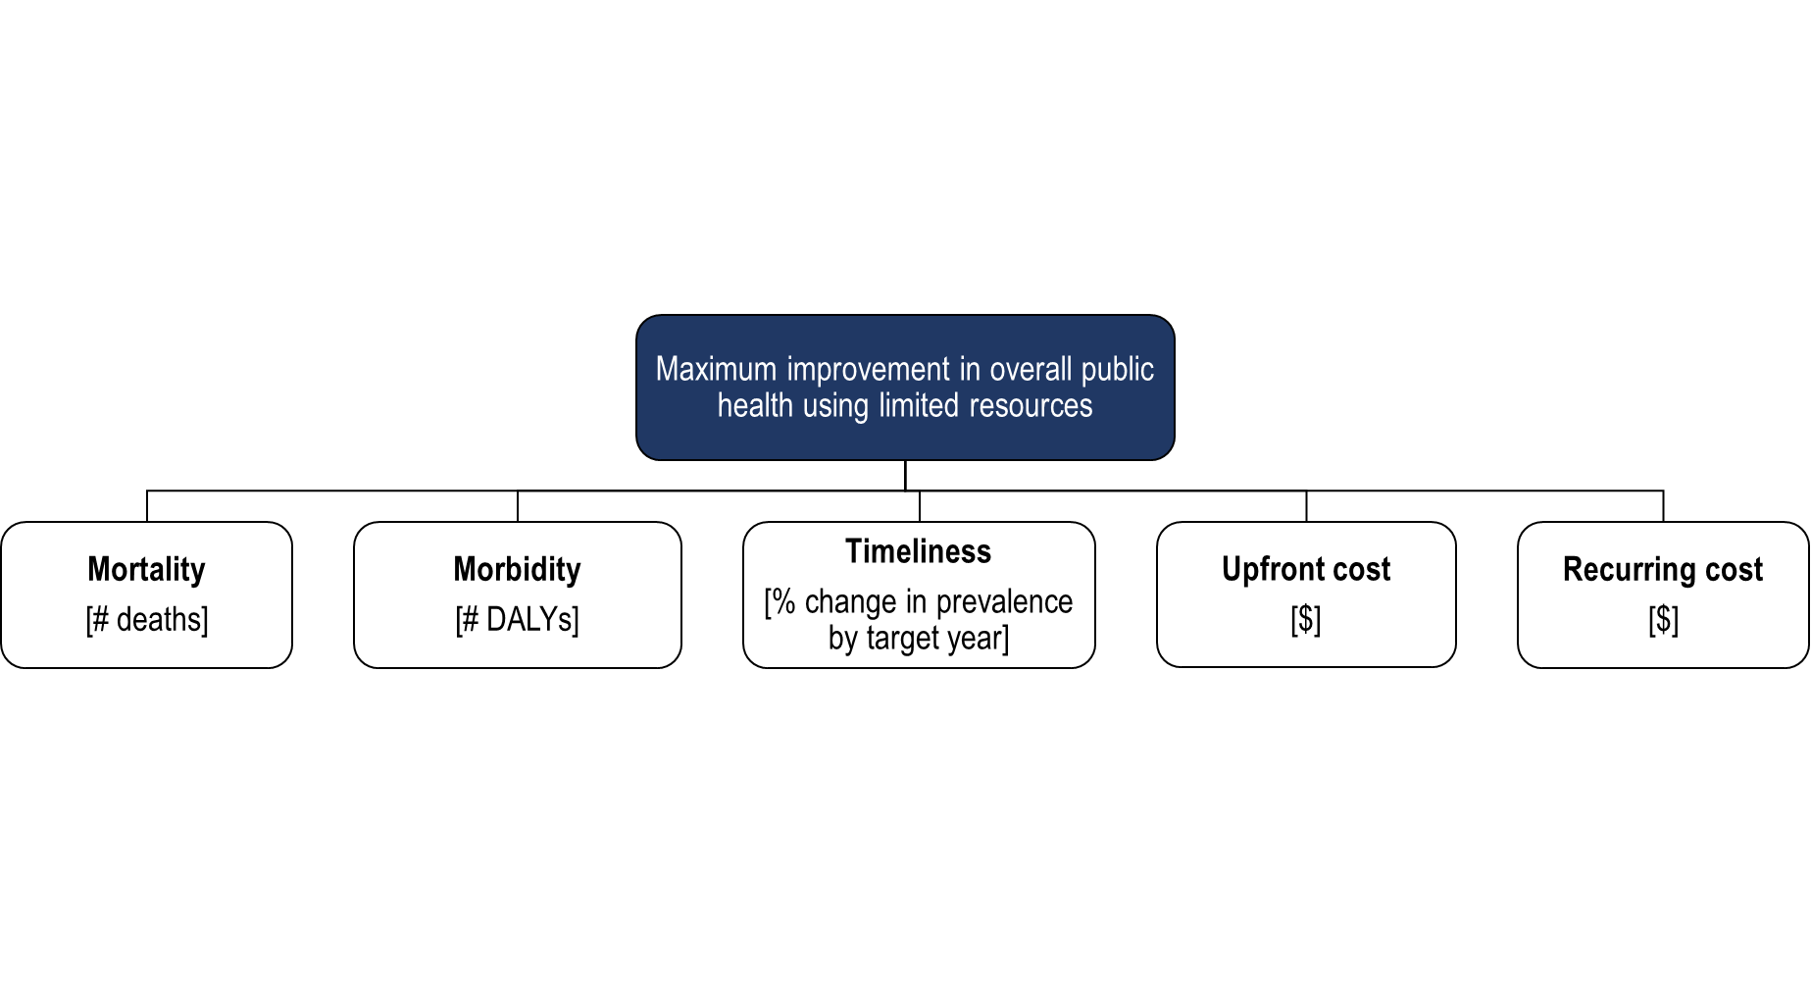

Figure : Many objectives of public health policymakers.

While this is still a relatively high level of aggregation it should be sufficient for illustrating the complexity surrounding many-objective tradeoffs. Right away, we can tell that there will likely be tradeoffs between number of lives saved and expenditure, for example. Precisely how much these tradeoffs impact performance, however, is less obvious before seeing the results of the analysis.

##### Multiple problem formulations

Different implementations of the problem formulation will provide different results, no matter how sophisticated the modelling technique. To counterbalance this effect, multiple problem formulations are incorporated in this thesis. Each are common perspectives and entirely valid ways of formulating the problem, and may not be mutually exclusive. The exercise of comparing them is not to find out what is the “right way” to view the issue, but to understand if different ways of formulating the problem influence the optimal solution set. The four interpretations of the objectives specified are summarized in Table 4 below.

Table 4: Description of Objectives (M) using four different problem formulations

|  |  |  |  |  |
| --- | --- | --- | --- | --- |
|  | PF1: Minimum rotavirus burden in Children <5 (medium term) | PF2: Minimum ascariasis in Youth  (short-medium term) | PF3: Minimum burden, all gastroenteric diseases (immediate) | PF3: Minimum burden, all gastroenteric diseases (long term) |
| **Mortality**  [# deaths] | Minimum Child mortality due to rotavirus | Minimum Youth mortality due to *A. lumbricoides* | Minimum Total Lives Lost | Minimum Total Lives Lost |
| **Morbidity** [DALYs] | Minimum Child morbidity due to rotavirus | Minimum Youth morbidity due to *A. lumbricoides* | Minimum disability burden | Minimum disability burden |
| **Timeliness**  [%] | Percent reduction in Child prevalence in **10 years** | Percent reduction Youth prevalence in **5 years** | Percent reduction of total number infected in <**1 year** | Percent reduction of total number infected in **20 years** |
| **CapEx** [$] | Minimum upfront expenditure | Minimum upfront expenditure | Minimum upfront expenditure | Minimum upfront expenditure |
| **OpExt** [$] | Minimum recurring expenditure | Minimum recurring expenditure | Minimum recurring expenditure | Minimum recurring expenditure |

All four problem formulations are different implementations of the same set of objectives (lowest mortality, morbidity, etc.). **Problem Formulation 1 (PF1)** is a single-disease problem formulation which is solely focused on minimizing the negative impact of rotavirus (which primarily impacts children under age five). **Problem Formulation 2 (PF2)** is a single-disease formulation that looks only as the burden of *ascariasis lumbricoides* in youth. Comparing these two problem formulations is interesting because the two pathogens are devastating in separate ways. While rotavirus is a high-mortality disease (rarely causing long-lasting morbidity), *A. lumbricoides* leads to extensive physical and cognitive impairments (such as stunting and reduced educational performance), while rarely ever causing death.

Next, it is interesting to compare the single-disease formulations (PF1 and PF2) with formulations that attempt to find solutions that work across all four gastroenteric pathogens. The idea is to see if the “optimal” solutions proposed to policymakers are indeed different when focused on more than one disease at a time.

The third **Problem Formulation (PF3)** provides a multi-disease perspective concentrated on the short term. Under PF3, the goal is to find solutions that minimize overall deaths and disabilities for all four gastroenteric pathogens within one year. This perspective may be common for health care practitioners; humanitarian aid workers; and investors concerned with seeing immediate impact of their interventions. Finally, the fourth **Problem Formulation (PF4)** seeks to minimize overall deaths and disabilities for the entire population between now and 2040. Thus, PF4 is the broadest and most long-term interpretation of the stated objectives. Such a perspective might be expected from national planning agencies; proponents of the SDGs; financers concerned with the longevity of their investments; or those with strong utilitarian opinions.

Each of these formulations are entirely valid and important ways of looking for a solution to the same issues, and ideally there would exist a Pareto optimal solution set that works across all perspectives. The reader should note that there is not a single “right” way to interpret these objectives. By analyzing the same model through the lens of various worldviews, the aim is to understand how similar or different the results are. This is useful for understanding to what extent the candidate solutions are sensitive to different worldviews or assumptions about the problem.

### Uncertainties

The extent to which each policy lever can fulfill its goals is dependent upon exogenous uncertainties. The presence of so many uncertainties means that it is desirable to find policy options that are robust (i.e. insensitive to) the wide range of different possible individual behaviors. By analyzing policy outcomes under a wide range of plausible values for these unknowns, decision makers can be better informed to how these uncertainties affect the performance of their policy ideas. Table 5 lists the key uncertainties to be explored:

Table : Description of Exogenous Uncertainties (X)

|  |  |  |  |
| --- | --- | --- | --- |
| **Exogenous Factor** | | **Explanation** | **Range** |
| X1 | **Fraction of people who actually use community latrine** | In order for a latrine improvement program to perform successfully, the beneficiaries must consistently use the new latrines. If beneficiaries feel unsafe, uncomfortable, or stigmatized for using a community latrine, they may prefer open defecation to the improved sanitation. | 10 – 100 |
| X2 | **Cost of well repair** | A life cycle cost of water supply by IRC estimated that cost of maintenance for each well in Uganda is between 6618272 (worst case) and 2438981 (ideal) shillings, or roughly 1800-660 USD. | 660 – 1800 |
| X3 | **Fraction of households that actually use chlorine tablets** | In order for Household Water Treatment (HWT) methods to be successful, chlorine tablets must be consistently and correctly added to all collected water prior to ingestion. For example, this involves ensuring that turbid water it filtered first, that the right dose is added, and that the tablets are given sufficient activation time. There is anecdotal evidence suggesting that people do not use the tablets when they dislike the taste of chlorine. | 10 -100 |
| X4 | **Intensity of hygiene education campaign** | This factor encompasses the extent to which hygiene messaging “sticks with” the population subjected to the hygiene campaign. In other words, it is the fraction of households that are reached by the program and decide to change their behavior because of it. Note that a more “intense” hygiene campaign is likely more expensive for policymakers to implement. | 10 -100 |
| X5 | **Reliability of vaccine supply** | Due to supply chain failures, medical centers may not have enough vaccines for patients that want them. Even for drugs that have been a part of the standard vaccination package in Uganda for many years, supply chain irregularity has been a barrier to delivering full coverage. | 10 - 100 |
| X6 | **Fraction of people seeking ORT** | Even if all medical centers are equipped with sufficient stocks of oral rehydration solution, healthcare workers will only be able to administer the ORT to as many patients seek treatment. Patients may seek treatment with non-traditional healers or not be able to walk a long distance to a healthcare center, for instance. | 10 - 100 |
| X7 | **Percent willing to accept MDA** | This represents the fraction of people who are willing to accept albendazole. Even though this has been scientifically verified as a highly safe and efficacious drug, some beneficiaries may not trust or want it. | 10 – 100 |

The reader will note that with the exception of the *cost of well repair* factor, all the other exogenous factors relate to uncertainty surrounding individual behavior. While policymakers can increase investments towards infrastructure or medical programs, they have little control over whether community members actually accept and use these services. For instance, the intended beneficiaries may: not trust the vaccine offered; not know about the correct treatment for diarrhea; or prefer open defecation over using a latrine. Additionally, it is possible that beneficiaries may know about the importance of good hygiene and water treatment but not may always follow best practices.

### Relationships

While improved WASH conditions and medical treatment availability are intrinsically desirable, each of these policy levers has different relationships with the particular pathogens included in the model. Figure 9 depicts the relative effectiveness of each lever on reducing the prevalence of disease.

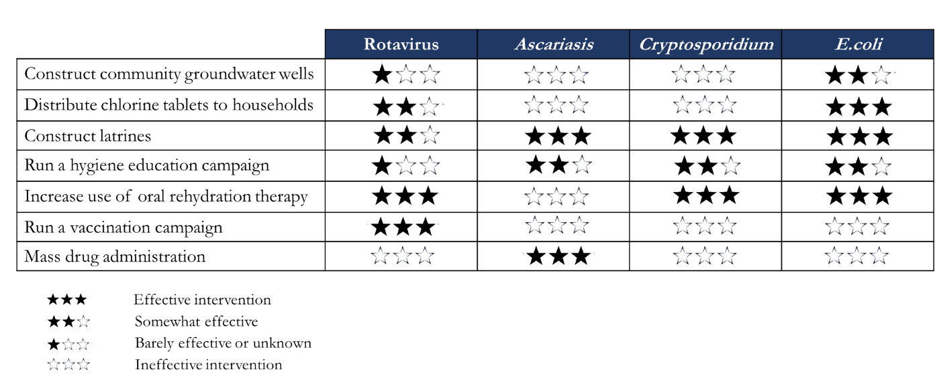

Figure : Overview of Conceptual Relationships.

For instance, constructing community groundwater wells is only slightly effective against rotavirus and *E. coli*, and is not at all effective for ascariasis and cryptosporidiosis.

Note that this scorecard is only intended to give the unfamiliar reader a relative understanding of the relationships between interventions included. The actual effectiveness depends on many factors (included in the model) which will be discussed in the next section. More detailed information on these relationships is included in Appendix A.

### Summary of Conceptualization

The system diagram structures the key levers, uncertainties, objectives and relationships of the multi-disease model into a conceptual system diagram (Figure 10).

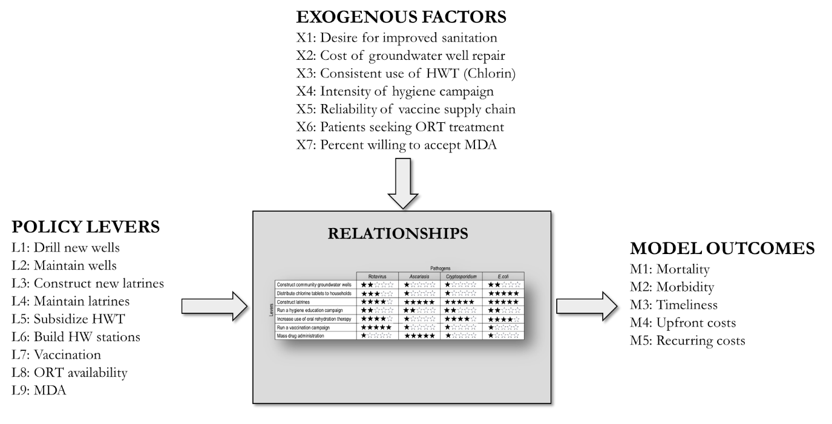

Figure : System Diagram.

The next section provides a brief discussion about data availability for the relationships described. While the ability of these interventions to reduce the diseases mentioned here are widely agreed upon, the quantification of these relationships is deeply uncertain.

## Data Gathering

The data used to parameterize the model were obtained from online, open-source databases. The data regarding disease prevalence in Uganda is secondary information gathered from online, open source databases and documents, which were originally collected by government agencies or non-governmental organizations. Similarly, information surrounding the transmission of pathogens of interest was gathered by reading relevant literature from online medical journals (e.g. PubMed). This information was synthesized into a single database for purposes of this model application (a link to the database is provided in Appendix B). This section describes data availability and limitations for purposed of model formalization.

### Data gaps

##### Data gap: disease prevalence

Unfortunately, no census-type database of disease rates exists in order to verify the accuracy of transmission patterns. While it is widely understood that the diseases included in this model are endemic throughout Uganda, availability on infectious disease in developing countries is scarce (particularly down to the pathogen-level). Therefore, even when there is information about the prevalence of diarrhea in an area, it is rare to have that information supplemented with the causal agent of the diarrhea (be it Rotavirus, *E. coli*, *cryptosporidium*, or something else). From a clinical treatment standpoint, the causal agent generally does not matter because any severe diarrhea should be given oral rehydration treatment in order to reduce the likelihood of dehydration, malnutrition, and other complications. From a prevention standpoint, however, it is crucial to have an idea of the prevalence of causal agents since this (as shown in the model) has implications for policy intervention.

##### Data gap: WASH interventions

Despite improved water and sanitation being one of the earliest methods used by humans to improve public health, the topic of WASH intervention effectiveness is deeply under-researched. While studies have validated the causal chain for WASH interventions, disease reduction is not regularly evaluated in literature (Yates, Vujcic, Joseph, Gallandat, & Lantagne, 2018). In particular, there has been little research to quantify how much a particular intervention may reduce the prevalence of a certain disease. One of the reasons for this lack of quantification is because it is extremely challenging to randomize individuals or to performed blinded studies in WASH evaluations (Fischer Walker & Walker, 2014). The WASH sector lacks a gold standard study to determine the effectiveness of an intervention, and many studies are observational designs that do not control well for confounding factors (Fischer Walker & Walker, 2014). Basic, “foundational research” is urgently needed as to the impact and the cost-effectiveness of commonly used WASH interventions (Yates et al., 2018). A systematic review by Mills & Cumming (2016) found insufficient amount and quality of evidence regarding the effects of WASH interventions on health. In short, more data collection and rigorous academic evidence is urgently needed concerning the WASH-health sector nexus.

##### Data gap: Sanitation and Hygiene

Within the WASH sector – which is already under-researched – there is a need to pay greater attention to the effectiveness of hygiene and sanitation. A meta-analysis by Mills & Cumming (2016) found that there was “better and more quantitative evidence” about the health impacts for water quality interventions (like household-based treatment) than for hygiene and sanitation interventions. Sanitation and hygiene programs are more often assessed with “low quality or qualitative studies” (Mills & Cumming, 2016). This trend of greater and higher quality research for water quality services than for sanitation and hygiene is supported elsewhere in literature (Freeman et al., 2017; Krause, 2010; Yates et al., 2018). Aspects of hygiene campaign effectiveness at reducing diarrhea may be especially understudied, with a greater proportion of low-quality evaluations.

##### Data gap: Cost-effectiveness of interventions

Data regarding complete cost-benefit analyses of WASH interventions are not available (Duflo, Greenstone, Guiteras, & Clasen, 2015). A systematic review by Yates et al. (2018) found that despite financial considerations being one of the most commonly stated objectives of WASH programs, few studies have analyzed the cost-effectiveness of interventions. Loevinsohn et al. (2015) argued that even though the health benefits of WASH interventions are likely enormous, most studies of their effectiveness do not systematically evaluate their additional, non-health benefits that are likely also substantial. These other benefits may include reductions in the incidence of other morbidities such as stunting, decreases in time spent collecting water, and the amenity value of private toilets (Duflo et al., 2015). For this study, cost information from a meta-analysis by (McGinnis et al., 2017) was used to parameterize the model (Table 6).

Table 6: Description of WASH cost estimates used in model parameterization

|  |  |  |  |
| --- | --- | --- | --- |
|  | **Cost/unit per year** | **Cost/person per year** | **Description** |
| Latrine program (Upfront cost) | $272 | $15.69-17.89 | Cost per person for installing a VIP in household (approximately $272 to install a household pit latrine) |
| Latrine program (Recurring cost) | - | $2.01 | Cost of cleaning supplies (bleach, brooms, bucket, hand brush), regular maintenance, and manual pit emptying with a bucket |
| Hygiene  (Upfront cost) | $57.00 | $0.36 | Cost of installing a $57 station shared between 155 people |
| Hygiene  (Recurring cost) | - | $3.15 | Cost of soap, hygiene education programs, and staff for capacity building |
| HWT  (Recurring cost) | - | $3.09 | Cost of providing annual tablets, plus yearly "O&M" (cleaning of storage vessels) |
| GW Supply (Upfront cost) | $7,960 | $18 | Cost of borehole fitted with hand pump (approximately $8000 installation) shared between 300 people |
| GW Supply  (Recurring cost) | - | $9.23 | Cost of borehole, hand pump, and water source maintenance |

* Cost data were extrapolated from the meta-analysis by (McGinnis et al., 2017).

## Model Formalization

The model is created using the System Dynamics software known as Vensim ® DSS 7.3.5. The model is instantiated from starting year 1990 until year 2040, with policy experiments beginning in year 2020. Data generated for the period 1990 to 2019 is used for historical calibration of the model results. Experiment results for the years 2020 to 2040 are analyzed further in Chapter 6: Many Objective Exploration.

### Sub-models and assumptions

To organize the modelling process the formal model was built through a series of connected sub-models, which influence one another in various ways. The following section details the important sub-models contained in the final model.

#### Open Defecation Sub-Model

The fraction of feces contained safely depends both on fraction of the population with access to adequate sanitation and the fraction of people who regularly use sanitation facilities. While policymakers may be able to affect the number of people with access to sanitation by subsidizing or building more latrines, they are unable to control the behavior or individuals to actually use provided latrines. Thus, this exogenous uncertainty is marked in orange and its influence will be tested in the exploratory section.

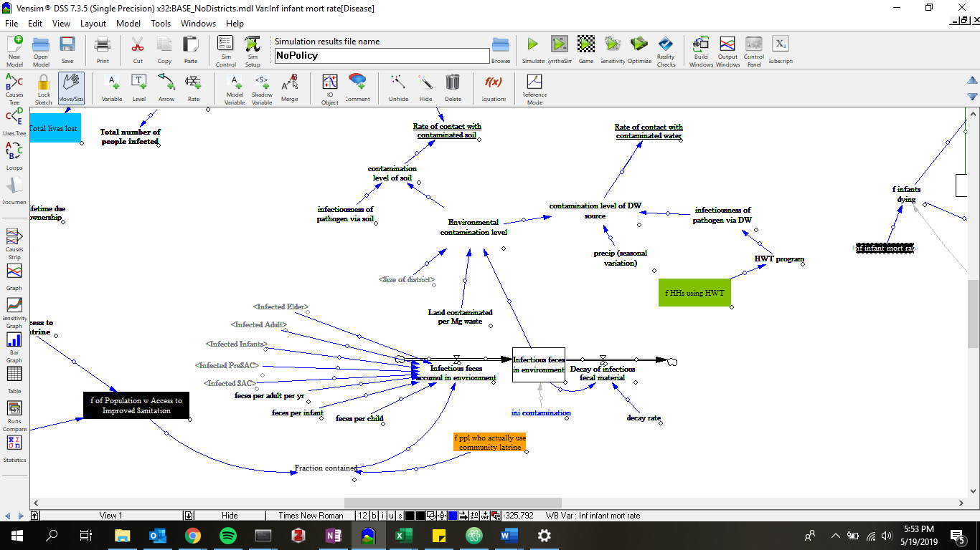

Figure : Open Defecation Sub-Model.

The orange box denotes an exogenous uncertainty. Green boxes denote policy levers.

#### Cohort Sub-Model

The aging chain depicted in Figure 11 divides the population into five cohorts: Infants (<1 years old), Pre-School Aged Children (PreSAC; 1-5 years old), School Aged Children (SAC; 6-17 years old), Adults (18-49 years old), and Elderly (+50 years old). Furthermore, each cohort is separated into “Susceptible” and “Infected” cohorts, which vary depending on the Rates of Transmission and the Rates of Recovery for a particular pathogen.

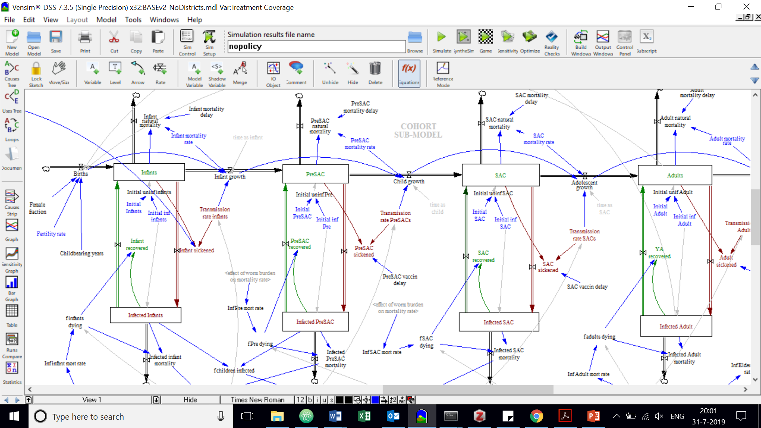

Figure : Aging Chain

This aging chain divides the population into five cohorts: Infant, Pre-School Aged Children (Pre-SAC), School Aged Children (SAC), Adults, and Elderly. Note: only 3 cohorts depicted for clarity.

The Cohort Sub-Model is central to the model structure, as it details the demographics of Uganda. At present, Uganda has approximately 38 million people. This number is projected to rise to at least 80 million by 2040 as Uganda has the third the highest birth rate in the world (UNPF, 2017).

#### Sanitation Sub-Model

In order to prevent infectious feces from contaminating soil and drinking water reservoirs, one strategy is to increase access to adequate sanitation. Thus, a potential policy lever (marked in green) is *Number of new latrines to build.* By entering a value here, the user is able to test how an increase in *Number of Acceptable Latrines* (and by extension, *fraction of population with access to improved sanitation*) ultimately impacts the environmental contamination level. However, while building latrines is necessary to increase sanitation access, it is also important to mention the key role that the rate of maintenance plays on *Average latrine lifetime*. While most sanitation projects are intended to last ten years or more, in reality many latrines break down or fill up in just a few years. Information from literature indicate that a typical Ventilated Improved Pit latrine in Uganda may be expected to last only a few years unless maintenance practices are scaled up above what is currently seen (Chunga, Ensink, Jenkins, & Brown, 2016). Therefore, a latrine construction program may need to be supplemented with a latrine maintenance program, which is included as a separate lever.

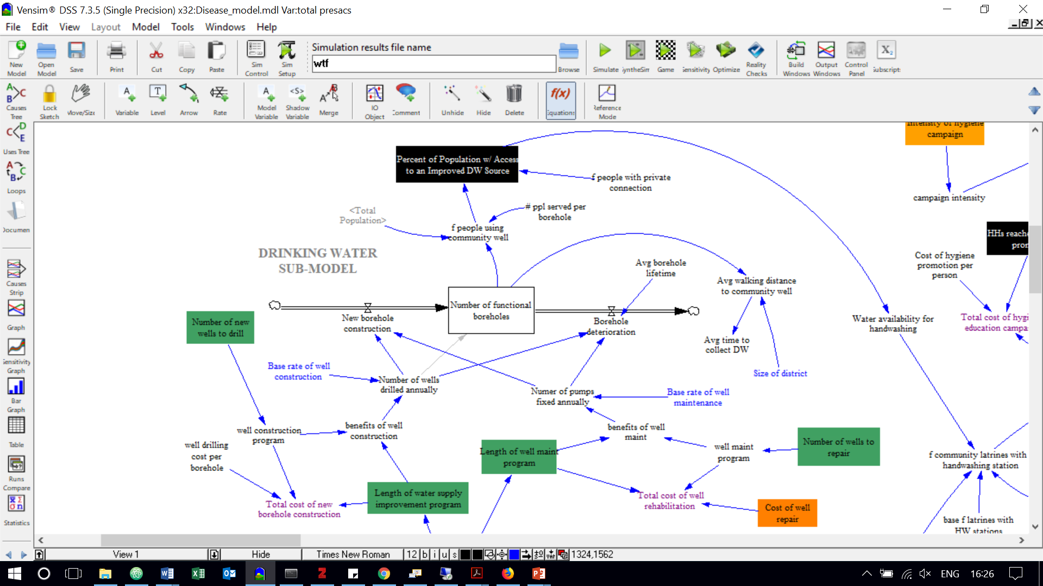

Figure : Sanitation Sub-Model.

#### Drinking Water Supply Sub-Model

The structure of the drinking water supply sub-model is closely related to the sanitation sub-model. Once again, the user can adjust the number of wells to be installed (the policy lever *Number of new wells to drill* is indicated in green) and these wells break down or dry up at the end of their lifetime. Literature suggests that the average borehole in Sub-Saharan Africa can be designed for a period of about 10 years, which is what is used in the model. This “decay rate” of drinking water wells however can be slowed by increasing the amount of maintenance provided (i.e. *Number of pumps fixed annually*). Just like with the sanitation sub-model, increasing the frequency of maintenance not only moves wells from being “deteriorated” to “new” (i.e. in the case of a broken-down pump that is repaired back to its original state), but also decreases the rate at which wells move from “new” to “deteriorated” (since it is assumed that better care would increase the *Average borehole lifetime*). It is up to the user to choose how many wells to build and/or maintain, as well as for how many years to sustain each program. The *cost of well repair* is marked as an exogenous uncertainty, since such repairs are highly variable and well-specific.

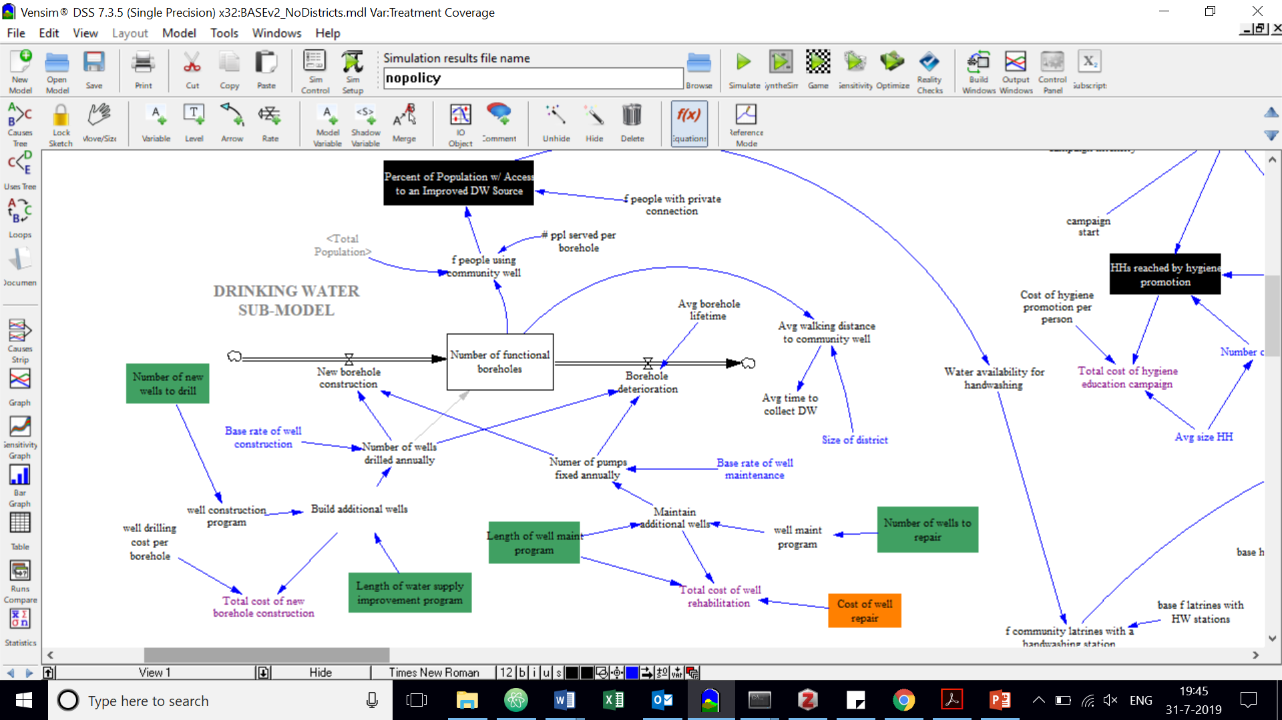

Figure : Drinking Water Sub-Model.

#### Hygiene Sub-Model

While clinicians and public health experts are well aware of the significance of handwashing with soap and water at stopping disease transmission, the effectiveness of sustaining behavior change through a public education campaign is highly uncertain. Compared to the construction of water wells and latrines, hygiene promotion is a much more imprecise tactic and has consequently been less studied than its WASH counterparts. Yet improved hygienic practices is potentially a very powerful and cost-effective option because it could (in theory) interrupt the transmission of a large number of gastroenteric pathogens. In reality, it is unclear how the knowledge that one *should* wash their hands translates to *actual* handwashing rates. For example, a study by Freeman et al. (2014) found that only about 1 in 5 people around the world wash their hands with soap after defecating.

The most basic component of a hygiene education campaign would be to motivate the population to wash their hands with soap and water after defecation and before eating. Additionally, effective hygiene campaigns may promote the need to wash food before consuming it; to clean the containers used to fetch and store water; to use household chlorination treatments; and the importance of not defecating openly. Giving people the knowledge and motivation to protect themselves is potentially a far-reaching intervention; however, many questions remain unanswered. How intensely do people need to be exposed to hygiene education in order for their behavior to change? How long does it take for people to ignore what they learned (“*memory loss*”) and revert back to old ways? How do factors like soap price affect behavior? The answers to these questions remain uncertain.

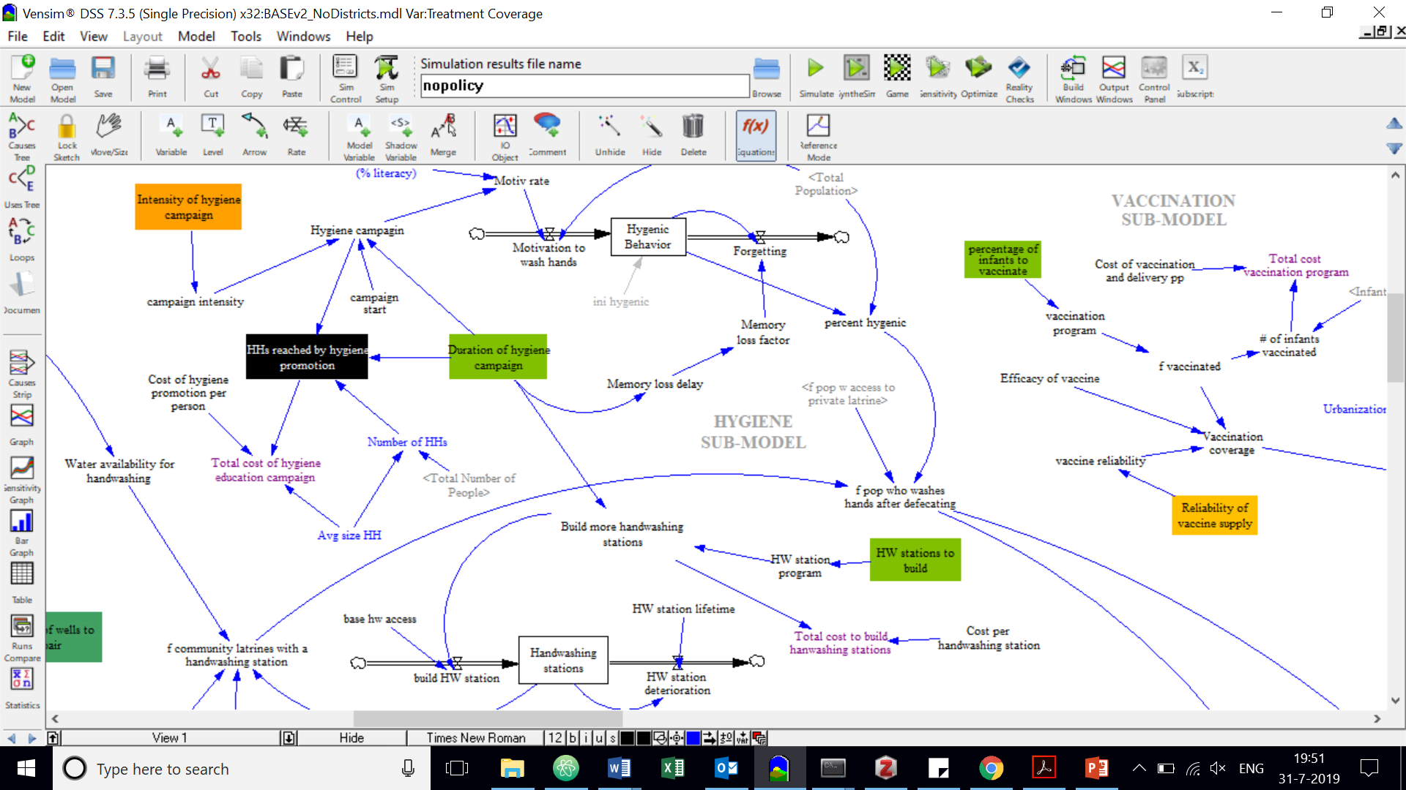

Figure : Hygiene Sub-Model.

#### Vaccination Sub-Model

Inoculating children is a potentially powerful strategy at reducing infectious disease transmission. Of the four pathogens included in this case study, only a vaccine against rotavirus exists. Recently, the Government of Uganda announced its decision to include rotavirus vaccination in its standard immunization package (Ministry of Health, 2018). This is an important step to stopping preventable child mortality, though it should be noted that several factors will significantly impact the performance of the vaccination campaign:

1. **Reliability of supply**. For the vaccine to be administered to all infants, an effective logistics system (i.e. cold chain capacity) is a necessary prerequisite. As it is, estimates suggest that about 50% of Ugandan children are fully immunized with the vaccines that have long been included in Uganda’s standard package (Bbaale, 2013). Thus, we might expect to see roughly the same rate of coverage once the rotavirus vaccine campaign is fully in place.
2. **Indefinite coverage.** It cannot be certain that the Ugandan government will be able to freely provide this vaccination forever, even with the financial assistance of international donors and pharmaceutical companies. The program will always be in danger of those external agencies ceasing their support. This recently happened when the pharmaceutical giant Merck & Co. Inc. suddenly announced that it would no longer send rotavirus vaccines to West Africa (Doucleff, 2018). Merck failed to meet is commitment of donating rotavirus vaccines to four countries in 2018 and 2019; and has deciding that it will completely stop delivering to West Africa in 2020 (Doucleff, 2018). Thus, the sustainability of the rotavirus vaccine campaign in Uganda may always be at the mercy of external agencies.
3. **Efficiency gap.** In developed nations, rotavirus vaccination demonstrates high effectiveness, capable of decreasing the number of severe rotavirus infections by more than 90% (Tissera et al., 2016). However, the effectiveness in endemic countries is much lower. The same vaccines have been shown to reduce severe rotavirus episodes by only about 30–60% in endemic countries (Tissera et al., 2016). Thus, even if the Ugandan government does manage to inoculate the entire population, due to this efficiency gap a substantial portion of the population will remain unprotected against rotavirus.

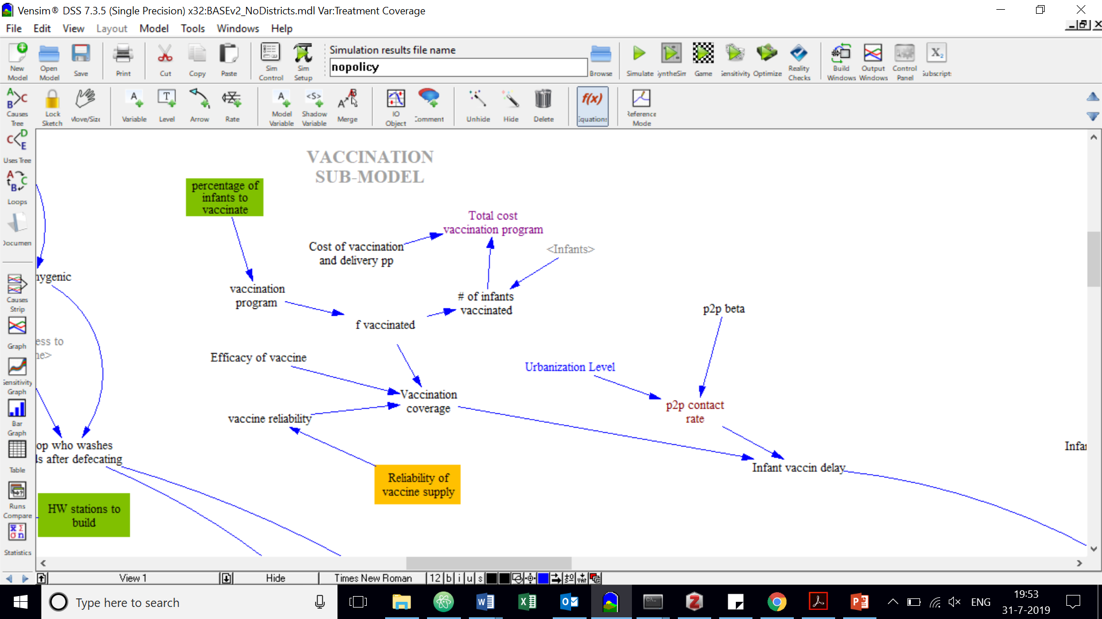

Figure : Vaccination Sub-Model.

#### MDA Sub-Model

Mass Drug Administration involves providing a single dose of the drug albendazole to a wide segment of the population. This is the control strategy recommended by the World Health Organization (WHO) against *Ascaris lumbricoides*. The WHO states that deworming should occur annually where helminth prevalence in the community is over 20%, and twice a year when the prevalence is above 50%.

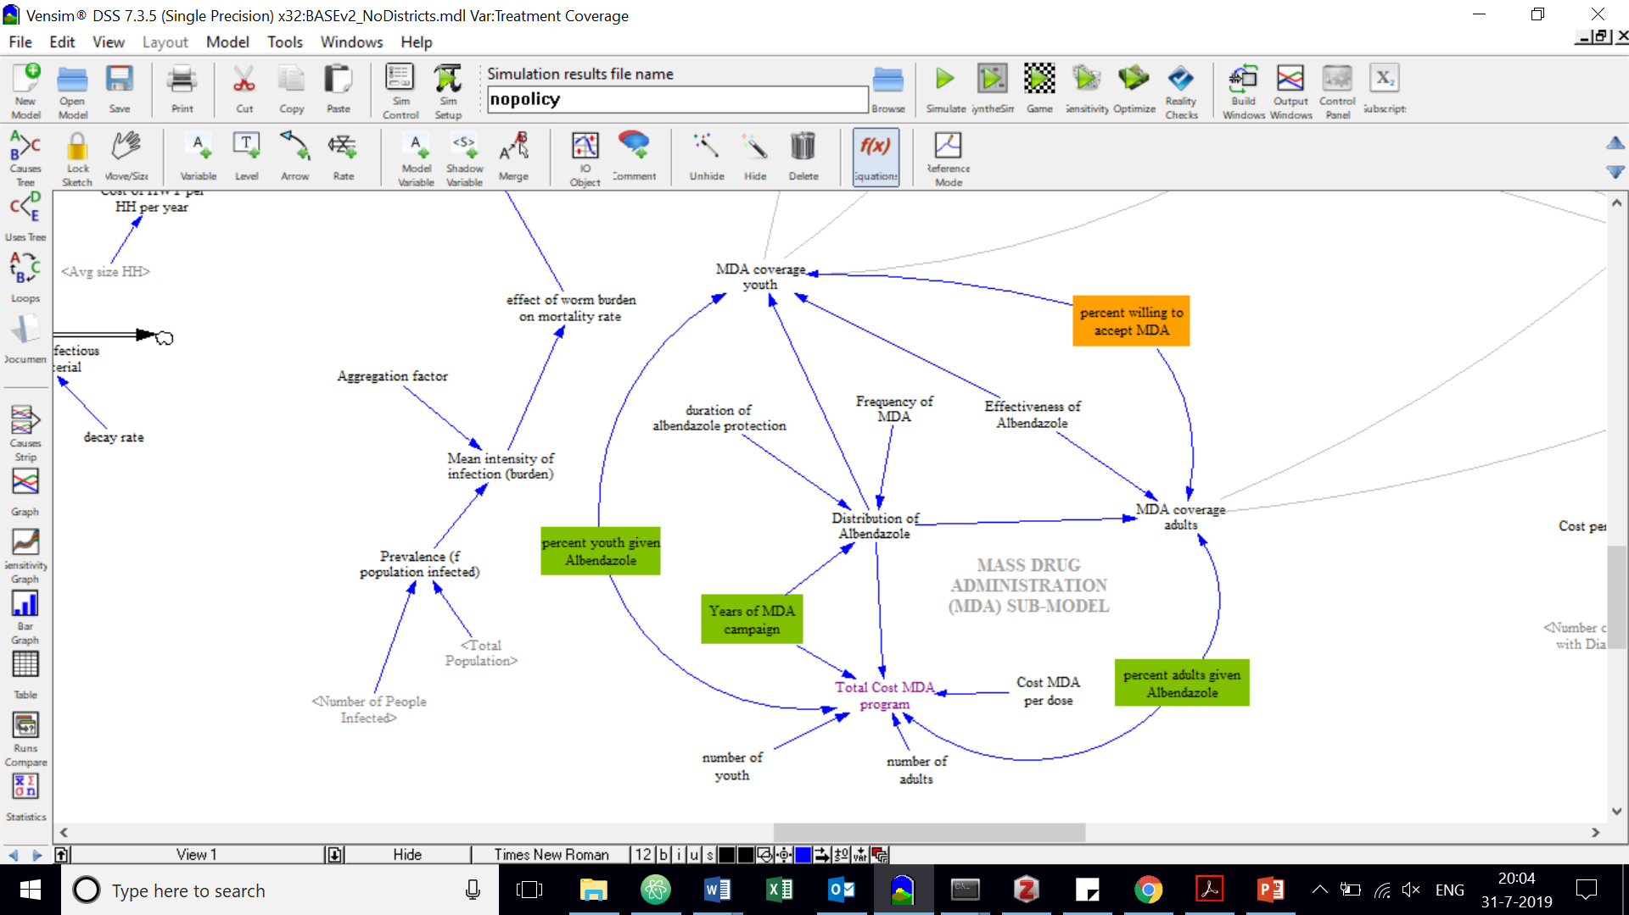

Figure : MDA Sub-Model.

#### Treatment (ORT) Sub-Model

Oral Rehydration Therapy (ORT) is a the primary method to treat diarrhea, which works by providing fluids and electrolytes to patients suffering from dehydration and nutrient loss. A 2012 study found that nearly one-third of medical centers in Uganda had no stock of ORT available, despite the widespread problem of severe diarrhea and ORT being the recommended treatment method (Löfgren, Tao, Larsson, Kyakulaga, & Forsberg, 2012). In the model, the effectiveness of this policy option depends on the number of patients who seek ORT in medical centers. There are many anecdotes in literature of patients insisting on getting antibiotics, which is typically an ineffective course but is perceived by patients to be “stronger.” ORT can significantly reduce the mortality rate of people dying from diarrheal dehydration, but it does not prevent people from acquiring (or re-acquiring) infections. Rehydration therapy is not effective against non-diarrheal gastroenteritis (i.e. *Ascaris lumbricoides* infection).

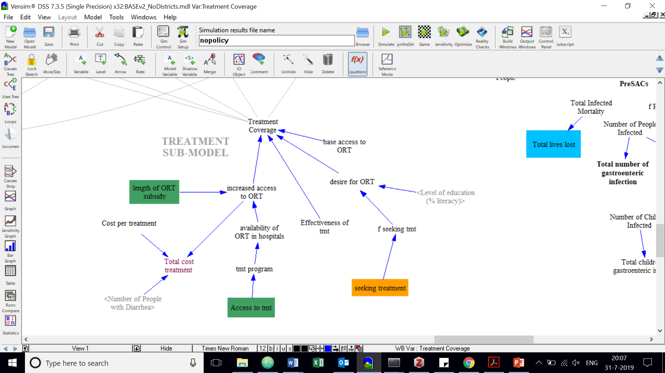

Figure : ORT Treatment Sub-Model.

## Verification and validation

##### Validation

The model starts at year 1990 and projects to 2040; thus, data generated for the years 1990 to 2019 are used to calibrate the model. Historical information from the past 30 years is used to validate the generated results. The model reads initial values from year 1990 from an Excel spreadsheet, which were obtained from literature and online databases (data sources provided at the link in Appendix B). Data about each cohort were extrapolated from the 1991 and 2014 censuses administered by the Uganda Bureau of Statistics (Information from <http://data.un.org>). For example:

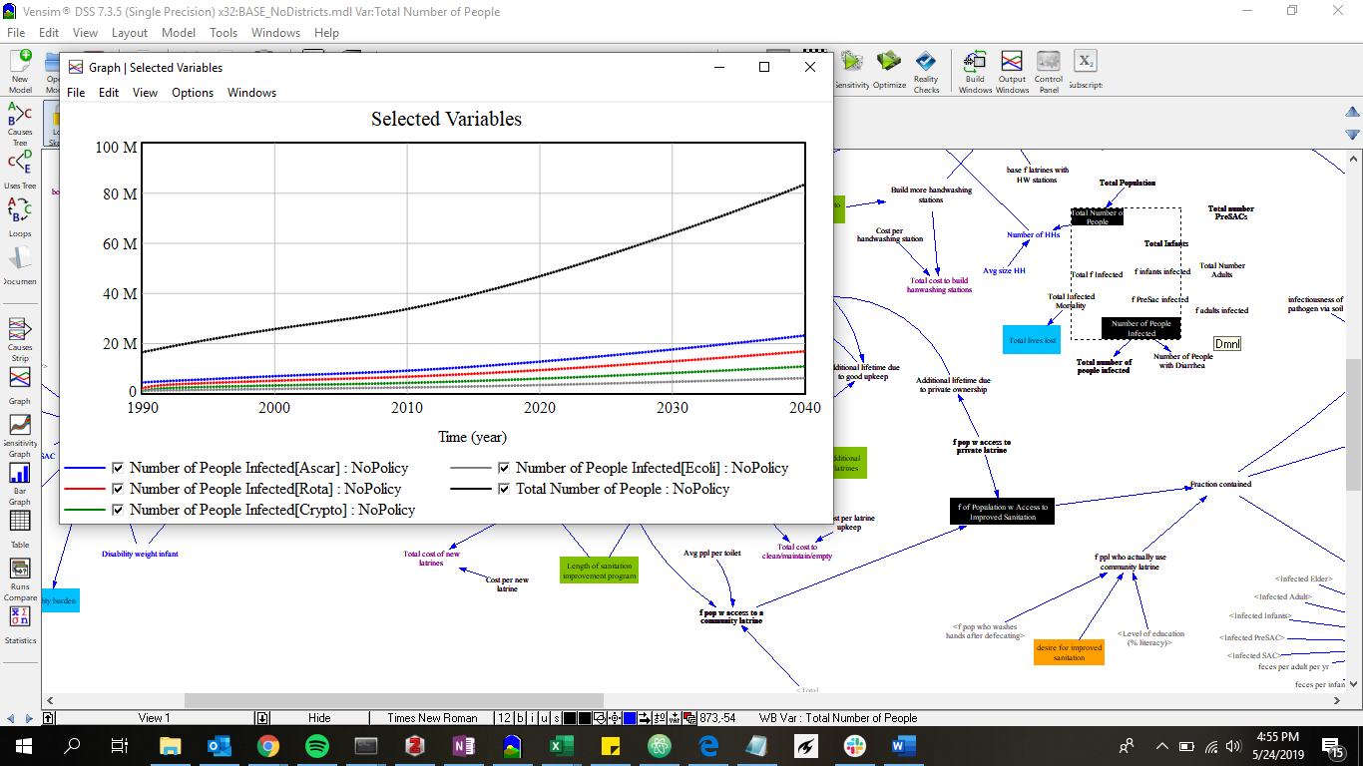

Figure : Infected versus total population.

Ugandans infected with rotavirus, *A. lumbricoides, Cryptosporidium*, and enterotoxigenic *E. coli.* Vensim output showing Uganda total population versus prevalence of four pathogens included in the model. Population projections were compared to UBOS census data.

Unfortunately, no census-type database of disease rates exists in order to verify the accuracy of transmission patterns. Because there are no comprehensive surveys of disease prevalence per pathogen, some relationships had to be extrapolated from approximations found in literature. For instance, where data on estimates of diarrhea prevalence were published, it was assumed that 40% of diarrhea cases were due to rotavirus, 11% to *cryptosporidium*, and 7% to *E. coli*.. These estimates were achieved by taking the total number of diarrheal cases reported and multiplying by the attributable fraction of the particular pathogen, as determined from literature. Because water, sanitation, hygiene, and vaccination conditions have not changed drastically in recent decades, the trends are assumed to remain steady since 1990. However, the reader is cautioned that the prevalence of diseases varies greatly between age cohorts and districts (for more detail on prevalence estimates, see Appendix A). The model can be easily updated should more accurate data become available, but for purposes of this illustration these rough estimations are considered a sufficient starting point.

##### Verification

Verification refers to checking that the conceptual model was translated correctly into the model code. For this thesis, model verification primarily consisted of running parameters at extreme values and then checking the result. Additionally, two versions of the model were created – one for the national-level (which is used in this thesis) and another for district-level analysis. The combined output from 112 districts in the district-level model were checked against the national-level output.

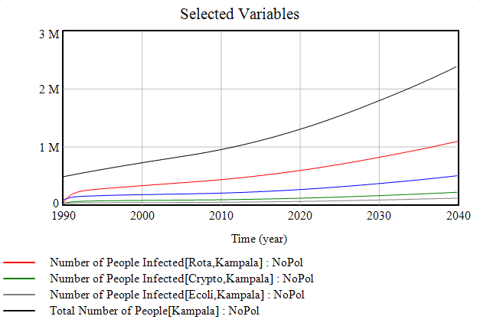

Figure : District-level functionality (Kampala shown).

The model can also be used to analyze at the district-level, as well as the national level. This feature is useful for finer-gained evaluation as well as for model verification.

## Model Results

In this section, a few example policies are created to highlight the usability of the model and display some sample output. These examples provide context for readers who do not have background in infectious disease or WASH and give a visual overview of how a multi-disease model may be used for intervention planning.

#### Example Policy 1: Increase (ground) WATER supply

In Example 1, the model user chooses to focus on increasing the fraction of the population that has access to an improved drinking water source. The user can enter how many new groundwater wells they would like to construct each year and specify over how many years this should be done. They can also optionally specify the number of community wells for which they would like to provide maintenance services. The model includes approximations for the cost of drilling and maintaining a well, so that the user can also get a quick estimate of the cost of their policy idea over time.

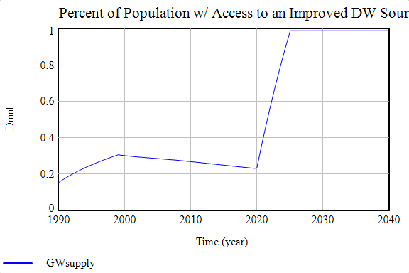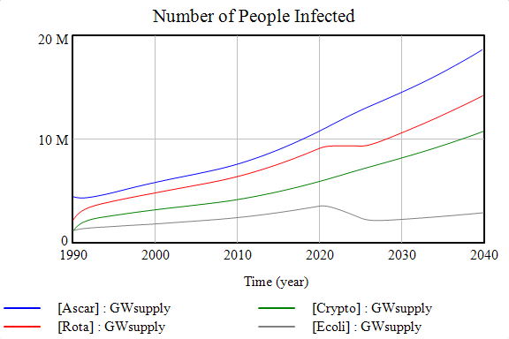

Figure : Pre-Specified Policy 1 – Groundwater Supply.

Figure (A) increasing access until 100% population is within walking distance of community well (N.B. assume wells are created instantaneously). Figure (B) corresponding alleviation in health burden.

In this example, new wells are constructed starting in 2020 until 100% of the population has access to a community groundwater well within walking distance. In Figure 21(B) the corresponding anticipated public health benefits can be seen, as after 2020 there is a dip in prevalence for both rotavirus (red line) and *E. coli* (grey line). The reduction is attributed to an increase in hygienic behavior because households have a greater supply of water, and also to the assumption that people will ingest less from (more pathogenic) surface water sources. Because ascariasis and cryptosporidiosis are infrequently transmitted through the consumption of drinking water (and both are hardy enough to survive for long periods of time in groundwater sources), increasing the supply alone is assumed to have a negligible impact on transmission trends for these two pathogens.

#### Example Policy 2: Vaccination Campaign

In Example 2, the model user chooses to implement a vaccination program. The goal of this campaign is to inoculate 100% infants, and the user adjusts the policy lever accordingly. However, the vaccine is only about 30-60% effective in rotavirus-endemic countries, thus it is expected that at least ~40% of infants will not be protected, even if they are vaccinated (Tissera et al., 2016). Furthermore, we know that from other vaccines included in Uganda’s standard package that there are often disruptions in supply, which are difficult to anticipate but nevertheless have a great deal of impact over policy performance. In the model, the value of the parameter *reliability of vaccine supply* is set at 75%, but this baselines assumption will be relaxed later on in Chapter 6 when different values of uncertainties like this one are explored.

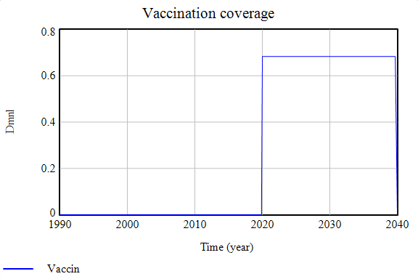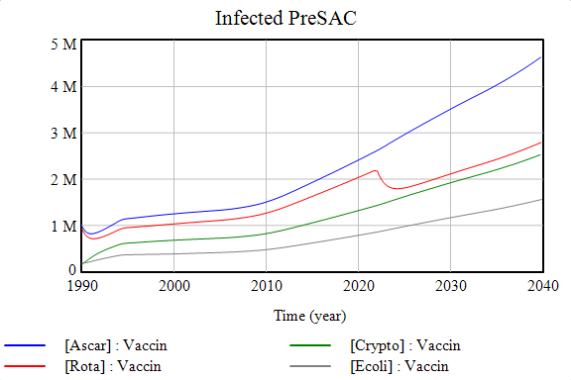

Figure : Pre-Specified Policy 2 – Vaccination.

Figure (A) vaccinate all infants beginning in 2020 (assumes that infants targeted are vaccinated immediately). Figure (B) PreSAC prevalence of rotavirus shown, with a 2-year delay from the start of the 2020 vaccine campaign start (to account for time for vaccinated infants to become PreSACs).

The vaccination campaign is only effective for rotavirus (no vaccine exists for the other three pathogens) thus, a decrease in prevalence is only observed in the rotavirus (red line). A delay is built into the model which takes aging into effect; such that we will not observe a reduction in adult incidents of rotavirus for instance until about 20 years after the start of the vaccination campaign.

#### Example Policy 3: Increase availability of ORT in medical centers

The main course of treatment for severe diarrhea is Oral Rehydration Therapy (ORT) which is a simple solution of sugars and electrolytes designed to protect a patient from becoming extremely dehydrated. In Example 3, the policy lever *access to treatment* is increased to 100% at year 2020. This translates to virtually all medical centers having sufficient stock of oral rehydration solution on hand, which they can give to patients who need it. As described in Section 5.2, the effectiveness of this policy lever depends on the exogenous uncertainty *people seeking treatment*, since medical centers can only administer as much ORT to as many patients as arrive at their facilities.

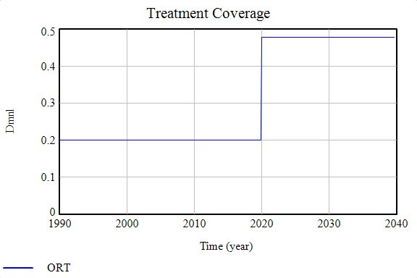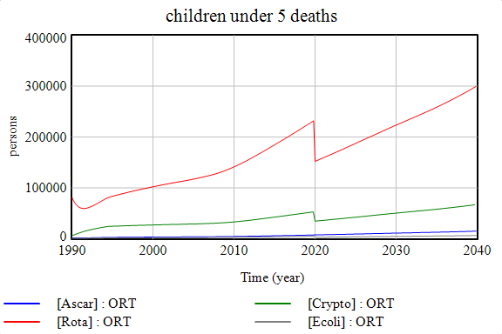

Figure : Pre-Specified Policy 3 – Oral Rehydration Therapy (ORT).

Figure (A) increasing access to ORT in medical centers at year 2020, up from approximately 20% (current treatment rate). Figure (B) corresponding alleviation in child mortality rate (assumed instantaneous for illustration).

Increased availability of ORT will be particularly beneficial to children, who are most susceptible of dying from the severe dehydration that ORT alleviates. Thus, one can see in Figure 23(B) a decline in mortality rate for Infants and PreSACs against severe diarrhea once the availability of treatment is increased. Note that because ascariasis is a non-diarrheal gastroenteric disease, ORT is not an effective treatment strategy for this pathogen. A final note is that while oral rehydration therapy is an effective strategy to reduce diarrhea-related morality in the infected, especially in children, it does not prevent infection nor confer any lasting protection. Once treated, patients return to the “Susceptible” faction and can immediately re-acquire the pathogen. Thus, the infection may be just as prevalent in the population as without treatment and morbidity levels remain high.

#### Example Policy 4: Increase access to improved sanitation

In Example Policy 4, the user focuses on the construction and maintenance of latrines. Enough new latrines are built so as to give 100% of the population access to improved sanitation.

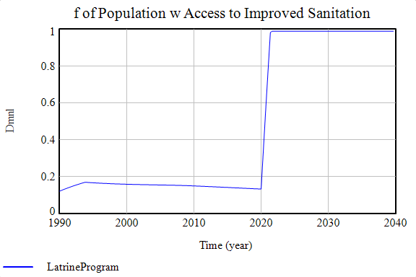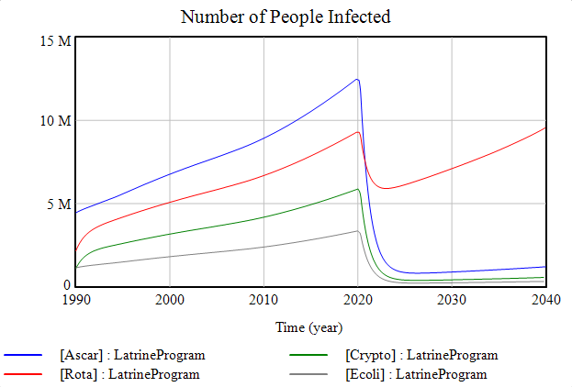

Figure : Pre-Specified Policy 4 – Latrine Program.

Figure (A) increasing access until 100% households have access to a latrine (assume latrines are created instantaneously). Figure (B) corresponding alleviation in health burden.

As can be seen from Figure 24(B), the latrine improvement policy corresponds to a substantial reduction in the number of people infected across all diseases. For *A. lumbricoides, cryptosporidium,* and *E. coli*, the transmission is virtually eliminated since all feces are contained, preventing the pathogens from spreading in the environment to a new host. Rotavirus is substantially reduced but not eliminated, since a clean environment alone is not enough to prevent transmission between young children.

#### Example Policy 5: MDA

In Example Policy 5, the user decides to combat the widespread prevalence of *Ascaris lumbricoides*. In endemic nations like Uganda, individuals are exposed to infection from birth and are repeatedly at risk of re-infection due to inadequate WASH conditions and constant exposure to parasite eggs in the environment. Though the parasite is rarely fatal, it is disturbing to realize that the national prevalence of the worm is generally above 60%, while in the southwestern provinces it is at least 80% (Adriko et al., 2018).

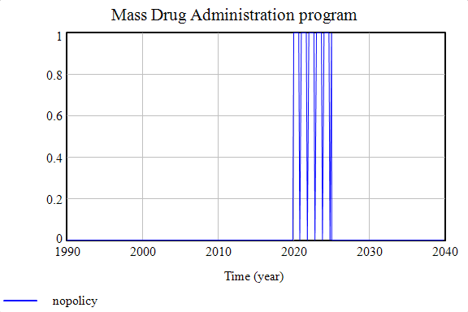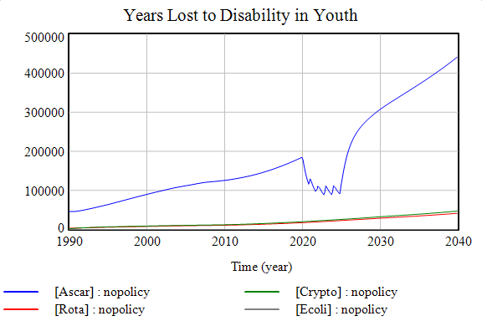

Figure : Pre-Specified Policy 5 – Mass Drug Administration (MDA).

Figure (A) providing MDA to 100% of population annually for five years. Figure (B) corresponding alleviation in health burden.

It is important to note that the benefits of MDA last a little less than one year, as can be seen from the “bounce back” in Figure 25(B). Thus, the campaign must occur annually until the parasite is completely eliminated from the population in order for the benefits to be sustained.

## Model Development Conclusion

This chapter addressed the question: “**How can the transmission of multiple infectious diseases be included in a single model in order to compare the performance of different interventions on policy objectives?**” System dynamics techniques were used to create the multi-disease model, which enabled the elements from a variety of disciplines to be considered. With the help of this model, the user can compare how the performance of different interventions map to their policy objectives.

Not all relevant features could be simulated given limited time and data. For instance, seasonality was not incorporated though research suggests that weather variability is important for the transmission of *E. coli,* *Cryptosporidium*, and perhaps rotavirus (see more details in Appendix A).

Readers should be aware that model results are only appropriate at the level of aggregation for which they were created. For example, a user may examine the model and determine that a national policy of increased ORT subsidization is not an effective use of donor funding. However, that does *not* mean that ORT is useless for an individual or community. Again, model results must be used at the level of aggregation for which they were designed and extrapolating findings beyond that level requires further research.

A major limitation of the study is that it was not done in interaction with stakeholders. Emerging research on modelling for decision support suggests that interactive approaches may be particularly effective at not only informing decision makers, but also in getting valuable feedback for model design. Finally, incorporating features from existing epidemiological models could greatly increase the credibility of projected results.

The example policies described in this section illustrate the diversity in possible interventions, as well as some of the main strengths and weaknesses of each strategy. How well do these interventions perform against the many objectives specified by policymakers? Additional trends will be explored more in the next chapter – Many Objective Experimentation.

# Many-Objective Experimentation

The relationship between policy levers and performance outcomes depends on many uncertain factors beyond of the control of the policymaker. Traditionally, this uncertainty is accounted for by using an expected value from on an established probability distribution. However, this is difficult in situations of deep uncertainty, when stakeholders do not agree on the likelihood or impact of a particular uncertainty on the system. An alternative is to test policy performance against a wide range of values for these unknown parameters, thus stakeholders do not need to agree on the probabilities of these parameters upfront. That is one of the major advantages of the Many-Objective Decision Making (MORDM) approach used in the following chapter.

The goal of this chapter is to find a set of Pareto optimal strategies that are robust against the various uncertainties and to understand tradeoffs between objectives. As shown in Figure 26, experimentation using MORDM contains four main steps: (1) formulating the problem statement in a way that the objectives can be evaluated quantitatively according to the needs of the decision maker; (2) generating a Pareto approximate set of initially promising strategies; (3) stress-testing the promising set of strategies by exploring their performance under a wide range of plausible futures; and (4) adjusting the most robust candidate strategies to guard against any vulnerabilities identified in scenario discovery.

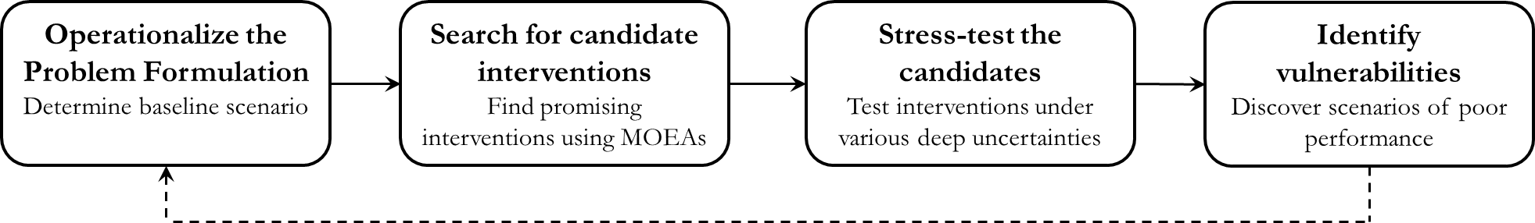

Figure : Outline of Many-Objective Robust Decision-making (MORDM).

Optionally, the last step can be fed back into the beginning to incorporate decision-maker feedback and lessons learned. Though an interactive approach with stakeholder consultation was beyond the scope of the current thesis, it is hoped that the following chapter provides a clear example for applying MORDM experimentation to future public health and development problems.

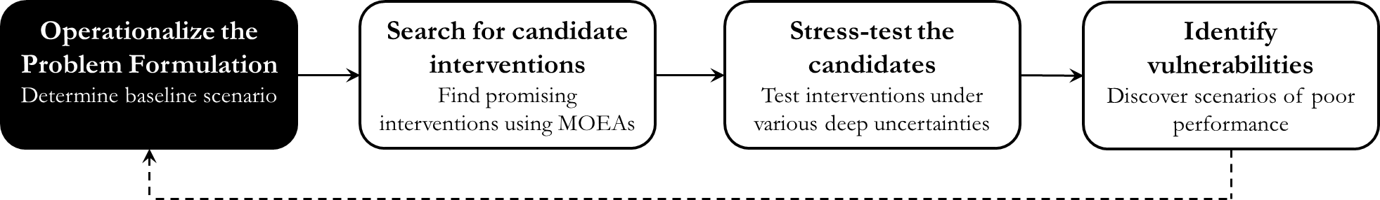

## Operationalize the Problem Formulations

Not everyone will agree on the best way to define large-scale objectives like “minimum mortality” and “lowest cost.” In the model development chapter (Section 5.2), four different ways of looking at the same set of objectives were described, which are reiterated here:

**Table 4**: Description of Objectives (M) under four different problem formulations

|  |  |  |  |  |
| --- | --- | --- | --- | --- |
|  | PF1: Minimum rotavirus burden in Children <5  (medium term) | PF2: Minimum ascariasis in Youth  (short-medium term) | PF3: Minimum burden, all gastroenteric diseases (immediate) | PF3: Minimum burden, all gastroenteric diseases (long term) |
| **Mortality**  [# deaths] | Minimum Child mortality due to rotavirus | Minimum Youth mortality due to *A. lumbricoides* | Minimum Total Lives Lost | Minimum Total Lives Lost |
| **Morbidity** [DALYs] | Minimum Child morbidity due to rotavirus | Minimum Youth morbidity due to *A. lumbricoides* | Minimum disability burden | Minimum disability burden |
| **Timeliness**  [%] | Percent reduction in Child prevalence in **10 years** | Percent reduction Youth prevalence in **5 years** | Percent reduction of total number infected in <**1 year** | Percent reduction of total number infected in **20 years** |
| **CapEx** [$] | Minimum upfront expenditure | Minimum upfront expenditure | Minimum upfront expenditure | Minimum upfront expenditure |
| **OpExt** [$] | Minimum recurring expenditure | Minimum recurring expenditure | Minimum recurring expenditure | Minimum recurring expenditure |

It is unlikely that all of these objectives can be met at once, so the decision maker will have to face some difficult compromises. This section addresses Sub-Research Question 4: “**What does using different problem formulations reveal about the tradeoffs between many objectives?**”First, an overview of how each of the problem formulations is operationalized in python is described. Then, a description of the reference scenario used to test the initial policy sets is provided. Finally, a set of eight pre-specified policy options is tested against each of the four formulations, in order to gain an understanding of how policy performance changes based on the perspective used to calculate it.

### Programming implementation

The objectives outlined in Table 4 are described in here in such a way that they can be calculated and compared. Under these formulations, it is desirable to minimize all objectives.

|  |  |
| --- | --- |
| **M1** | **Mortality [# deaths]:**  Total number of lives lost on average over the target period. The target period begins in 2020 and ends at the target end date (e.g. 2040 for a 20-year perspective). For single-disease problem formulations, only mortality rates due to the pathogen of interest are considered (i.e. Rotavirus for PF1 and *Ascaris lumbricoides* for PF2). For the multi-disease formulations of PF3 and PF4, mortalities caused by all four gastroenteric pathogens are considered. |
| **M2** | **Morbidity [# DALYs]:**  Similar to the mortality calculation, the average Disability Adjusted Life Years (DALYs) over the target period is determined, using both single and multi-disease perspectives. The DALY calculation involved multiplying the number of years spent living disabled by a disability weight. |
| **M3** | **Timeliness [% change in prevalence over the time period]:**  The notion of “timeliness” is an attempt to explicitly capture the temporal aspect of a decision maker’s preference. This objective is operationalized as the difference between the percent of the population infected over the time period. This net change is calculated by subtracting the fraction of people infected at the end year from the fraction of people infected in 2020. Ideally, this number is close to negative 1, indicating a large decrease in the fraction of people infected. If no action is taken, it is possible that the fraction of people infected could actually increase, which would result in an outcome closer to positive 1. |
| **M4** | **Upfront Cost [$]:**  The amount of money required to initiate the policy lever, generally for hardware costs like construction of groundwater wells and latrines. This is determined by getting the maximum value of capital expenditure over the time period of interest. |
| **M5** | **Recurring Cost [$]:**  The recurring cost is the amount of money required to sustain the program annually and also includes software costs like education and maintenance. |

The goal of implementing different formulations is not to decide which perspective of the problem is superior; rather, it is to acknowledge that different perspectives are possible and to see what effect this ultimately has on the recommended solution sets. In an ideal case, the model would uncover solutions that are effective under all problem formulations.

To test the way that problem formulations impact objective tradeoffs, various pre-specified policy options are tested against the same **reference scenario**. This reference scenario represents our initial best-guess values of the uncertainties (Table 7).

Table : Uncertainty values used to create the Reference Scenario

|  |  |  |  |
| --- | --- | --- | --- |
| **Uncertainties** | **Minimum** | **Maximum** | **Reference** |
| Reliability of the vaccine supply (%) | 10 | 100 | **75** |
| Number of people seeking ORT (%) | 10 | 100 | **75** |
| Intensity of the hygiene promotion campaign (%) | 10 | 100 | **75** |
| Desire for improved sanitation (%) | 10 | 100 | **75** |
| Households consistently using water treatment (%) | 10 | 100 | **75** |
| Percent willing to accept MDA (%) | 10 | 100 | **75** |
| Cost of well repair (USD) | 660 | 1800 | **1700** |

For the first six uncertainties, parameter values close to 100% indicate the best-case possible future states of the world, in which everyone: practices ideal hygienic behavior, correctly and consistently uses chlorine, seeks treatment when needed, accepts MDA when offered, wants to use latrines and where enough vaccines are always available. Accordingly, uncertainty values near 0% indicate extreme worst-case scenarios for the decision maker (where none of the beneficiaries cooperate with the policy). The seventh uncertain parameter, *cost of well repair,* ranges between the maximum and minimum expenditure per well as found in literature. The initial value of all uncertainties were set at 75% of their maximum value (for all problem formulations) in order to create the same reference scenario, representing an optimistic yet cautious view of how the uncertainties may turn out.

### Results of different problem implementations

In order to visualize the differences between problem formulations a series of parallel coordinate plots are generated. Each colored line represents a possible policy option, with lines closest to the bottom of the y-axis being performing more favorably in terms of the decision maker’s objectives.

#### Pre-specified policy performance under PF 1

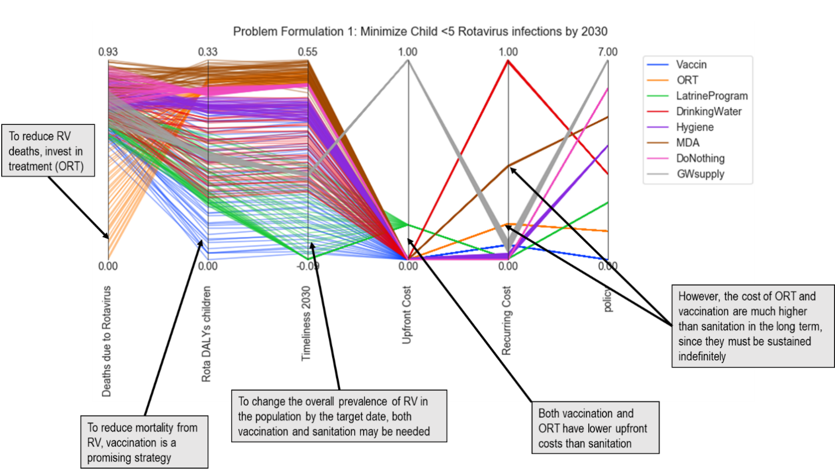

Figure : Objective tradeoffs for pre-specified policies using PF1.

(Above) How eight different policies perform using a model that is focused on minimizing the burden of rotavirus in children within ten years. (Below) feature scores highlighting the most sensitive policy levers.

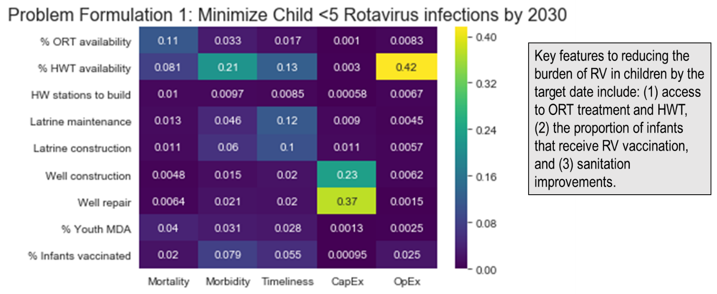

#### Pre-specified policy performance under PF 2

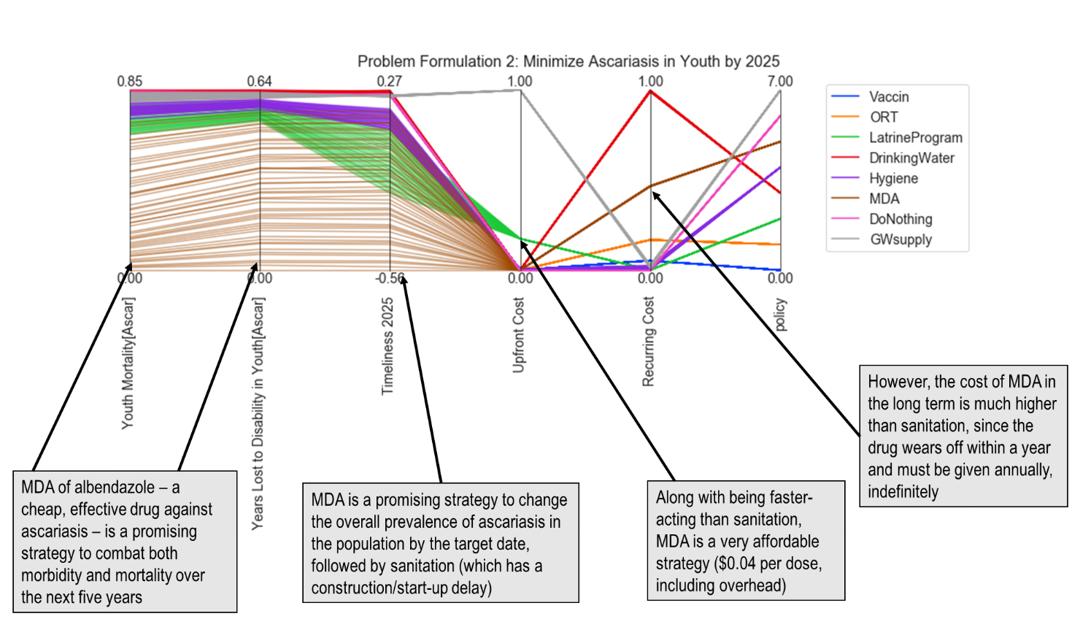

Figure : Objective tradeoffs for pre-specified policies using PF2.

(Above) How eight different policies perform using a model that is focused on minimizing the burden of *Ascaris lumbricoides* in youth within five years. (Below) feature scores highlighting key policy levers.

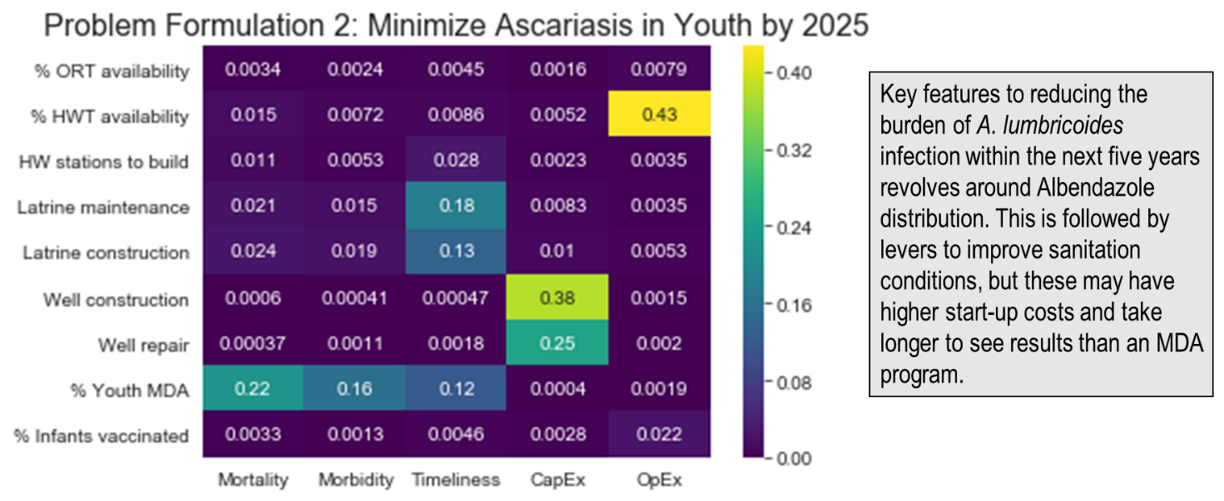

##### Problem Formulation 1 (Rotavirus in Children)

Problem Formulation 1 and 2 are single-disease perspectives of rotavirus and ascariasis. Under the rotavirus-focused perspective (PF1), policies that increase vaccination and ORT rates appear to be attractive options (Figure 27). Treating drinking water with chlorine is also a relatively favorable strategy, although potentially costly over time. The feature scores for this problem formulation affirms that these are potentially sensitive levers for intervention to influence the objectives

##### Problem Formulation 2 (Ascariasis in Youth)

Using an ascariasis-focused view of the health objectives (PF2), Mass Drug Administration is clearly a promising strategy for reducing mortality, morbidity, and overall prevalence of this parasitic worm within a few years. In the short term, this is a highly cost-effective strategy but may be much more expensive than other alternatives in the long run (Figure 28). The policies focused on Drinking Water and Groundwater Supply appear to be the least promising strategies for meeting the objectives, since their lines are all located near the top of the figure.

##### Problem Formulation 3 (“save children, now”)

By comparing a multi-disease formulation to the single-disease ones, we can see that some of the same themes emerge. For instance, under Problem Formulation 3 the use of ORT is attractive for reducing mortality rates at a low upfront cost (Figure 29). Once again, the downside of this strategy is that does not work to reduce the overall prevalence or morbidity levels – only fatalities. The aim of PF3 is to reduce the burden of disease from all four gastroenteric pathogens immediately (i.e. within one year), so fast-acting policies are preferred here. Because MDA and drinking water treatment are also relatively quick options, some combination of these levers may be the desired strategy.

##### Problem Formulation 4 (“help everyone, long-term”)

Problem Formulation 4 adopts a long-term, population-wide outlook of the stated objectives by seeking to minimize the overall impact of gastroenteric illness by the year 2040. Under this perspective, the Latrine Program appears to be a cost-effective and sustainable strategy against all four pathogens (Figure 30). According to PF4, rotavirus vaccination is likely to be a costly, yet not highly effective policy. This can be seen by looking at the *Timeliness* objective which has a high positive value, indicating that overall percentage of people infected will likely increase rather than decrease.

##### Multi-Disease Problem Formulations

A major difference in PF3 is that focusing on drinking water is much more effective at reducing the *Timeliness* metric than it is using PF4. This is likely to the difference in time horizons between the two formulations. Water treatment with chlorine is quick and easy to deliver to households, requiring virtually no start-up time. Thus, the water treatment option appears much more favorable for decision makers who seek a quick turnaround (PF3), rather than long-term change (PF4). Similarly, while Latrine improvement is still a favorable policy option in PF3, it is not quite as attractive as it was under PF4. This is also likely due to the difference in time horizons, since the time to build new sanitation infrastructure means that much of the full benefits are not realized within just a few months or years.

#### Pre-specified policy performance under PF 3

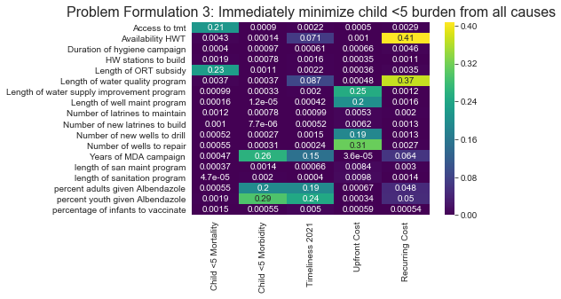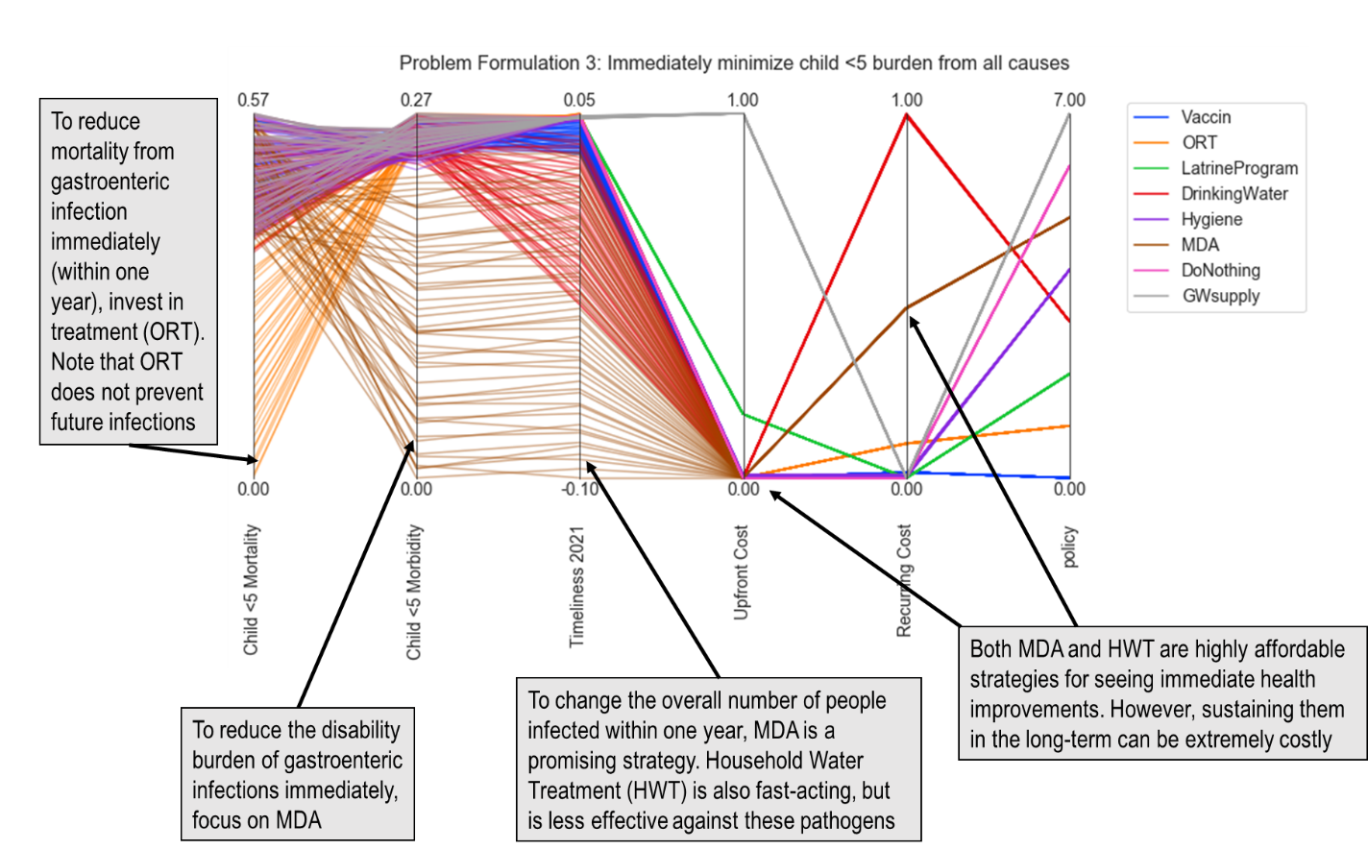

To see immediate improvements in health objectives, strategies should focus on increasing treatment with ORT and providing MDA to at-risk cohorts.

Figure : Objective tradeoffs for pre-specified policies using PF3.

(Above) How eight different policies perform using a model that is focused on alleviating child suffering within one year. (Below) feature scores highlighting the most sensitive policy levers.

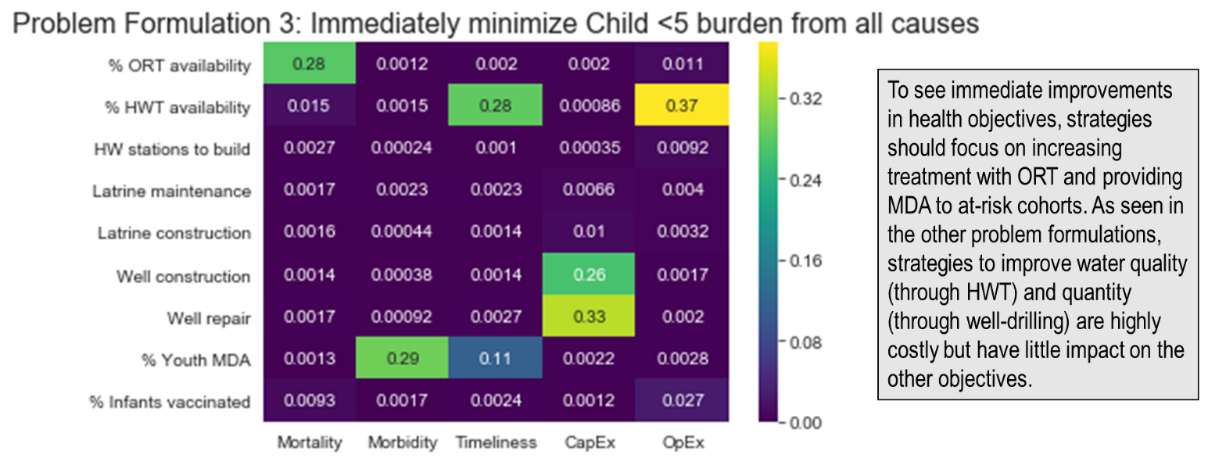

#### Pre-specified policy performance under PF 4

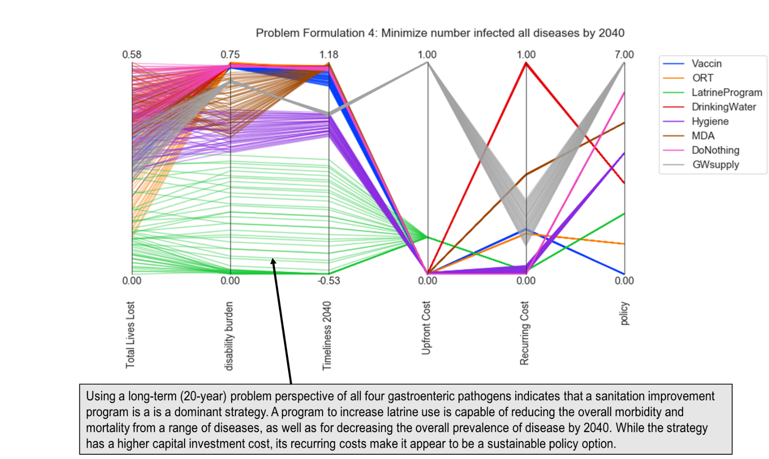

Figure : Objective tradeoffs for pre-specified policies using PF4.

(Above) How eight different policies perform using a model with a long term, multi-disease perspective. (Below) feature scores highlighting the most sensitive policy levers.

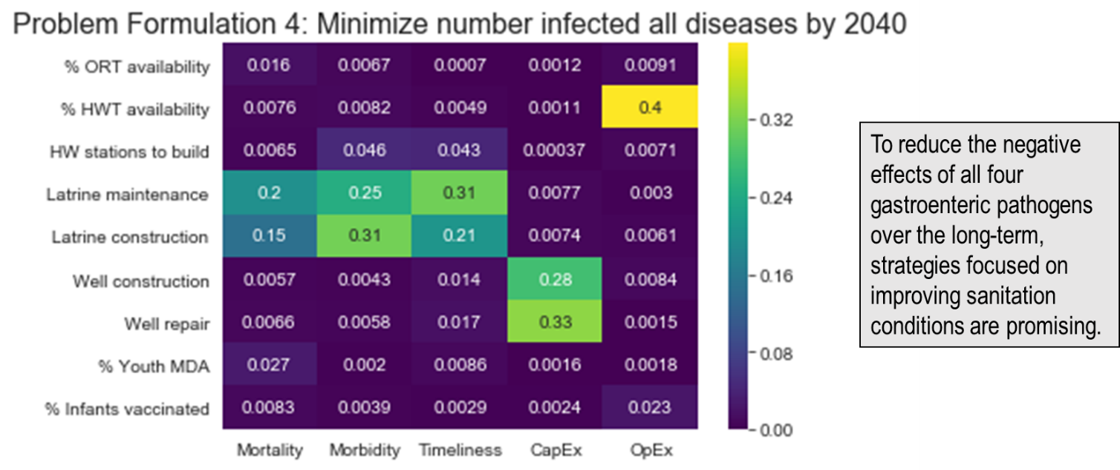

##### Tradeoff Conclusion

When public health policy problems are characterized by conflicting objectives, the potential solutions are judged in terms of the way they compromise between those goals. This section addressed Sub-Research Question 4:“**What does using different problem formulations reveal about the tradeoffs between many objectives?**” By using a set of pre-specified policy options to illustrate their tradeoffs, the influence of different formulations of the same objectives was visible. They impact how the objectives are perceived, operationalized, and ultimately calculated in determining the final solution sets.

Studying multiple problem formulations is not intended to impart greater cognitive burden on stakeholders, but to gain insight by comparing and contrasting different views of the same issue. Interestingly, the preceding examples showed that no matter which formulation was adopted, policies focusing solely on improving groundwater supply were dominated by alternative strategies. This is interesting because constructing new groundwater wells is one of the most common strategies used in development projects. Had we included an *E. coli*-only problem formulation, the groundwater supply levers likely would have appeared more favorable since such sources are generally more protected from bacterial contamination than surface waters. However, a broad perspective indicated that this appears to be an ineffective strategy when all four pathogens are considered.

Using pre-specified policies, the changes in policy performance from one formulation to the next could clearly be seen. Where rotavirus in children was deemed to be the main concern (PF1), the “optimal” solution sets focused on rotavirus vaccination and treatment. When the main concern was perceived to be ascariasis in youth, MDA strategies that targeted ascariasis appeared favorable. Though such conclusions may seem trivial or not in need of computational analysis, what they imply is that the upfront perception of the problem has *already biased the results*. In other words, the question posed by the policymaker (e.g. “what is the best way to stop rotavirus in children?”) perhaps has had a greater impact on the solutions generated than the entire process of modeling and analysis itself.

In the next section, more information on the combinations of policy levers impact these tradeoffs will be provided. This thesis has emphasized that there is no “right” way to formulate these public health concerns, but policymakers and health modelers must be aware of the crucial role that problem framing has on the tradeoffs generated. If indeed policymakers only have a single public health concern, then optimizing solutions for that one particular problem is an appropriate course of action. However, if policymakers have a large number of problems they are dealing with, then models which present narrowly defined solutions do policymakers a disservice by hiding the broader context.

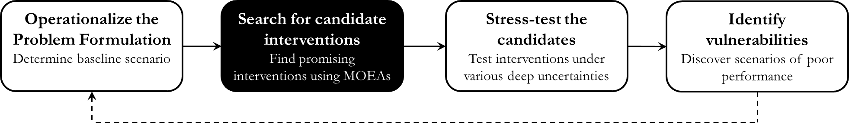

## Search for candidate interventions

In the previous section, a set of pre-specified policies were used (e.g. “Vaccination”, “ORT”, “Drinking Water”) to understand the impact of different problem formulations. These policies were determined subjectively, from the mind of the modeler. In the following sections, pre-specified policies are no longer used. Instead, policies are generated with the assistance of a many-objective evolutionary algorithm (MOEA) known as NSGA-II to search for potentially high-performing combinations of policy levers. Rather than only studying pre-specified policy options, the directed search phase of MORDM aims to find promising new combinations of policy levers that perhaps would not have been thought of without computational assistance.

The aim of this section is to use the NSGA-II algorithm to approximate the Pareto front for each problem formulation. The operators used in evolutionary algorithms are used to help find solutions close to the Pareto front, though due to the stochasticity in the algorithm this is not guaranteed. It is expected that if bad individuals are created, they will be eliminated by the selection operator and good individuals will be emphasized (Deb, 2001). In order to ensure high-quality results, the experiments should be parameterized carefully.

##### Design of Experiments

Under each of the four problem formulations, the NSGA-II algorithm is run for 15,000 function evaluations. Epsilon parameters used in the search are indicated in Table 8, which were chosen by experimenting with different combinations of values. Both epsilon progress and hypervolume metrics were used to asses convergence (see Appendix C for additional information on experimental design). In order to reduce the effects of random number generation, algorithm runs were tested multiple times with different random seeds (Appendix C).

Producing an estimate of the Pareto front with this design took approximately 4 to 5 hours per problem formulation. The experiments were run using a google cloud virtual machine instance with 8 CPUs and 30 GB RAM.

Table : Parameters and corresponding results from MOEA search

|  |  |  |  |  |  |
| --- | --- | --- | --- | --- | --- |
| **Search parameters** | | | **Search results** | | |
| Directed search nfes | 15,000 |  |  | PF1 | 1,055 solutions found |
| ε-value (Mortality) | 5 |  |  | PF2 | 717 solutions found |
| ε-value (Morbidity) | 5 |  |  | PF3 | 975 solutions found |
| ε-value (Timeliness) | 0.001 |  |  | PF4 | 1,026 solutions found |
| ε-value (CapEx) | 1,000,000 |  |  |  |  |
| ε-value (OpEx) | 1,000,000 |  |  |  |  |

The result of the directed search using NSGA-II was a set of potentially promising policy candidates for each problem formulation (Table 8). For brevity, the remainder of this section will focus on displaying and discussing results from PF1 and PF4 (the search results from the other problem formulations can be viewed in Appendix C.4.). This is done for clarity and conciseness, and to emphasize the key differences between a single- and multi-disease perspective. As in the previous section, parallel coordinate plots are used to visualize the tradeoffs in the objective space (here the lever space is also included). Each policy found in the directed search is shown as a grey line, so we can look for trends in how these lines cluster (Section 6.3 will discuss individual policy recommendations).

### Promising policy options to combat Rotavirus

From Figure 31, it is apparent that candidate strategies for reducing the burden of rotavirus tend towards policies that emphasize latrine maintenance, handwashing stations, vaccination, and ORT availability. Drilling and maintaining groundwater wells; increasing HWT availability; and increasing MDA coverage all appeared unfavorable for meeting the specified objectives.

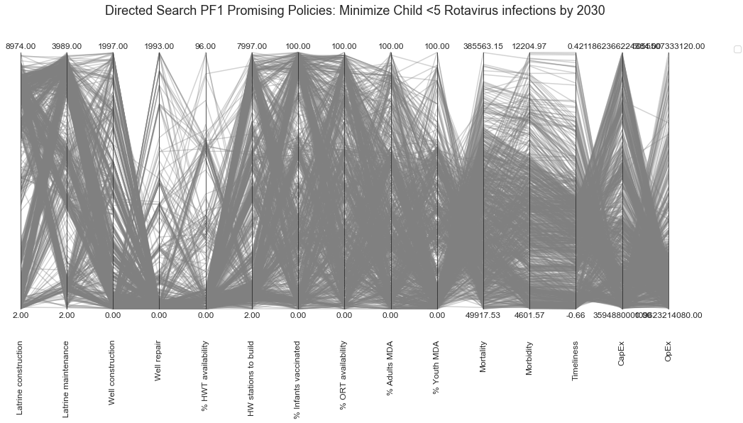

Figure : Results of directed search under PF1 (rotavirus in children).

The use of NSGA-II resulted in the identification of 1,055 policies, which tended to emphasize latrine maintenance, handwashing stations, vaccination, and ORT availability, over other levers.

The spread of the *Timeliness* objective is insightful because it reveals that while there are some policies able to decrease the overall prevalence of rotavirus in children by 66%, there are other policies that will see the prevalence in children actually rise by 2030, up to 29% more infections than today. Furthermore, though such combinations of policy levers appear to perform well against rotavirus, the objective space shows that there are tradeoffs especially in terms of cost. The variety of crossing lines over the *CapEx* and *OpEx* objectives make this apparent.

### Promising policy options from a multi-disease perspective

Using a multi-disease perspective of the objectives, the promising results found by NSGA-II have some differences than the rotavirus-focused view (Figure 32).

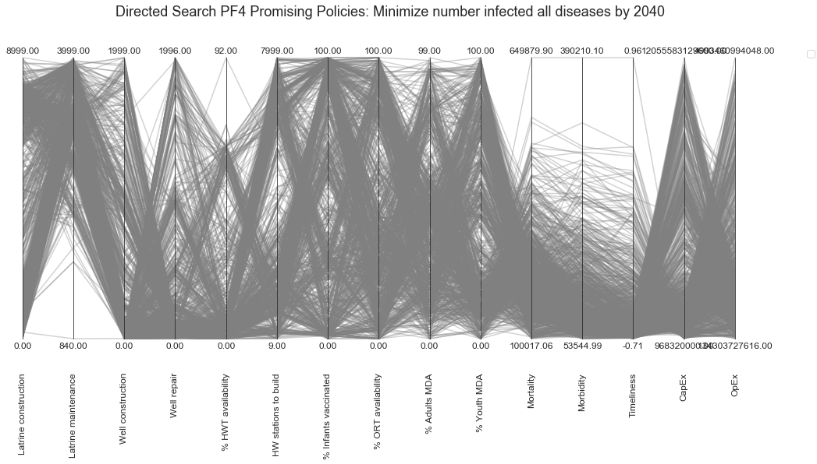

Figure : Results of directed search under PF4 (multi-disease)

Studying this set of promising policy options found by the MOEA search reveals that under PF4 it is desirable to construct new latrines, and extremely desirable to maintain as many as possible. Rotavirus vaccination, handwashing stations, oral rehydration therapy, and mass drug administration are all recommended, but in different combinations (as indicated by the crossing lines over the lever space). Furthermore, it is unlikely that all of these levers can reasonably be implemented while keeping costs low, so in the next section the levers are refined and explored to produce more meaningful policy recommendations based off this initial search.

##### Search conclusion

Due to time and computational limitations, the directed search could not be run for more function evaluations. For future models intended for actual decision support however, it is recommended that the algorithm runs be extended to assure convergence and that a more thorough seed analysis is performed on each problem formulation.

In this search step, NSGA-II was used to find sets of policies that perform well against the reference scenario. In the remaining sections, these solution sets will be further refined through processes of stress-testing and vulnerability analysis to identify which of these candidate policies are most robust to different future scenarios.

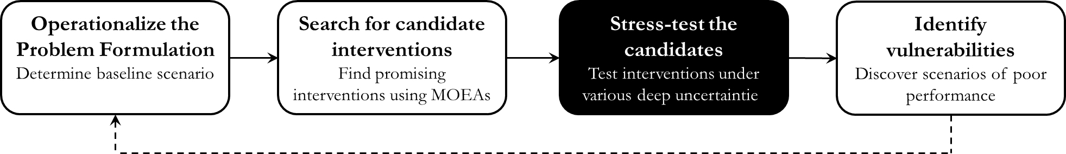

## Stress-test candidate interventions

In the previous step, computational algorithms were used to find a Pareto approximate set of solutions under the reference scenario. In this step, this set of promising interventions is evaluated over a large number of alternative future states of the world, which are captured by an “uncertainty ensemble.”The purpose of this stress-testing is to see how the initially promising interventions behave in circumstances beyond just the reference scenario, by relaxing the initial assumption of the uncertain parameters. The outcome of this step is a Pareto-approximate set of intervention strategies.

##### Generate uncertainty ensemble

The first step to stress-testing across many different future states of the world is to generate an uncertainty ensemble. Each ensemble is a set of vectors containing values for the uncertain parameters. As shown below, the multi-disease model has seven key uncertainties, which may vary between the maximum and minimum values indicated.

|  |  |
| --- | --- |
| **Description of the uncertainty space** | |
| Reliability of the vaccine supply (%) | [10 – 100] |
| Number of people seeking ORT (%) | [10 – 100] |
| Intensity of the hygiene promotion campaign (%) | [10 – 100] |
| Desire for improved sanitation (%) | [10 – 100] |
| Households consistently using water treatment (%) | [10 – 100] |
| Percent willing to accept MDA (%) | [10 – 100] |
| Cost of well repair (USD) | [660 – 1800] |

Latin Hypercube sampling (LHS) is used to create a 300-point uncertainty ensemble containing values over the range of these seven uncertain input parameters. The motivation for using Latin Hypercube as opposed to random sampling to explore a multidimensional space is to make the most of the exploration of the space for a given number of points (Saltelli & Annoni, 2010). Running this ensemble against the promising policy results allows the implications of a wide range of combinations of these uncertain values to be explored. It is useful to create this scenario ensemble upfront, so that each problem formulation can be tested against the same set of uncertainty combinations.

Once the ensemble of 300 scenarios is generated, the promising candidates from step 2 are subjected to experimentation in order to see which ones are still high-performing. The interventions that still perform well against a wide range of plausible future states of the world are called “robust.” The robustness of each candidate strategy is calculated based on its performance against an outcome indicator (a robustness metric), which in this case is the 90th percentile minimax regret. As noted in the Methodology chapter, this regret metric essentially focuses on the worst-case scenarios (minus the extreme outliers). Accordingly, this metric can provide suggestions tailored to scenarios that are very different than ones that policymakers would have come up with if they looked only at ones they thought were more likely.

Initially, directed search using MOEAs resulted in Pareto approximate sets containing a large number of solutions for each problem formulation. These large solution sets were narrowed by selecting the subset with the lowest quartile results under the *Mortality* objective. Each set of promising candidate strategies from the resulting database was subjected to experimentation against the 300-point uncertainty ensemble, producing a set of approximately 100,000 experiments per formulation. This experimental design took approximately 5 hours of CPU time per problem formulation. 90th percentile minimax regret calculations were performed as described in the Methodology chapter on the resulting database.

On the following page, the results of the regret computations are shown for all four problem formulations. By comparing the four images to one another, it is apparent that policy recommendations change between perspectives. In the sub-sections that follow, more detail on the results behind each problem formulation is provided.

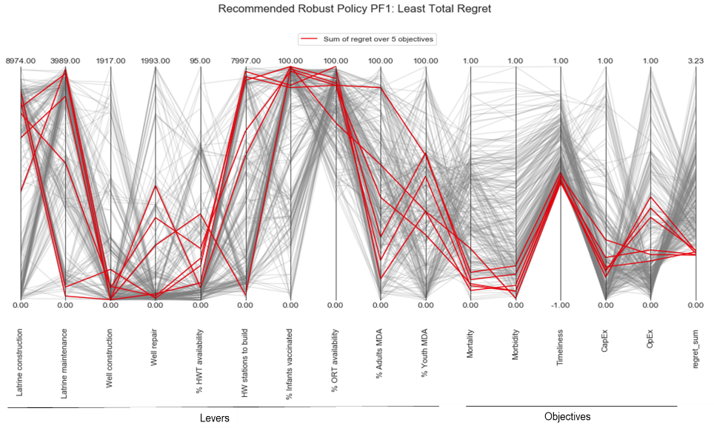 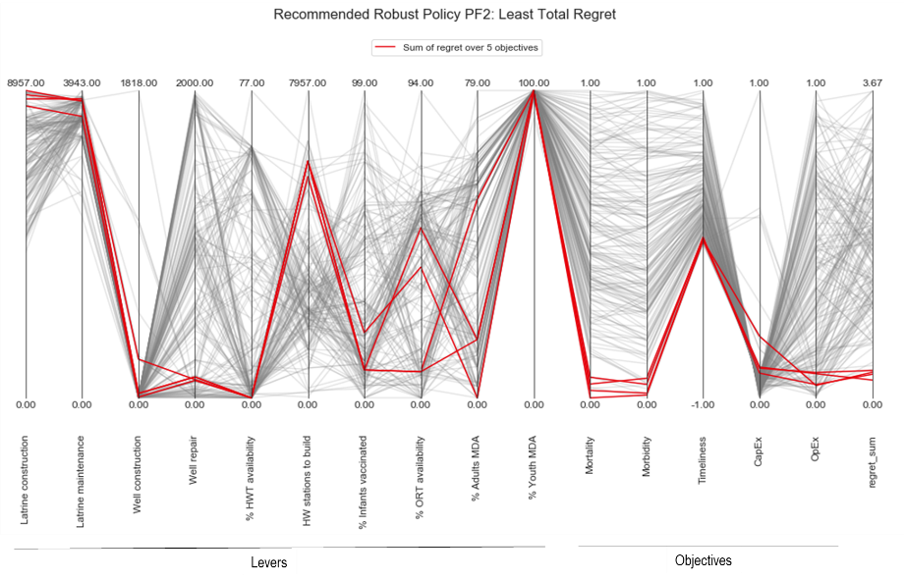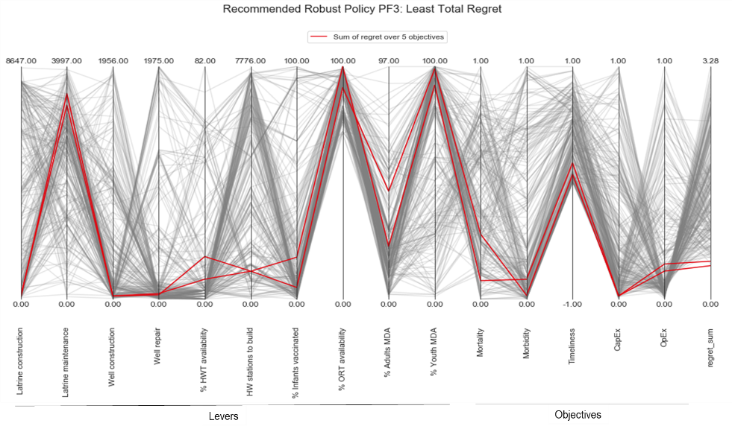 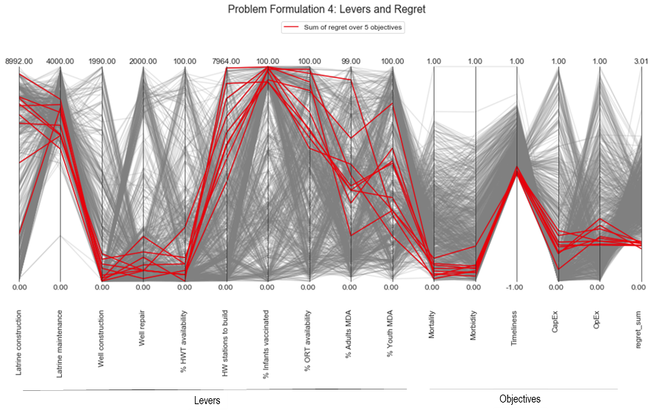

Figure : Policy recommendations under each problem formulation

By observing the trajectory of the red lines, it is clear that the least regret policy option changes based on the problem formulation. The red lines indicate the policy options where the sum of the regret is smallest. In the following sub-sections, more detail on these results per problem formulation is provided.

### Robust candidates under Problem Formulation 1

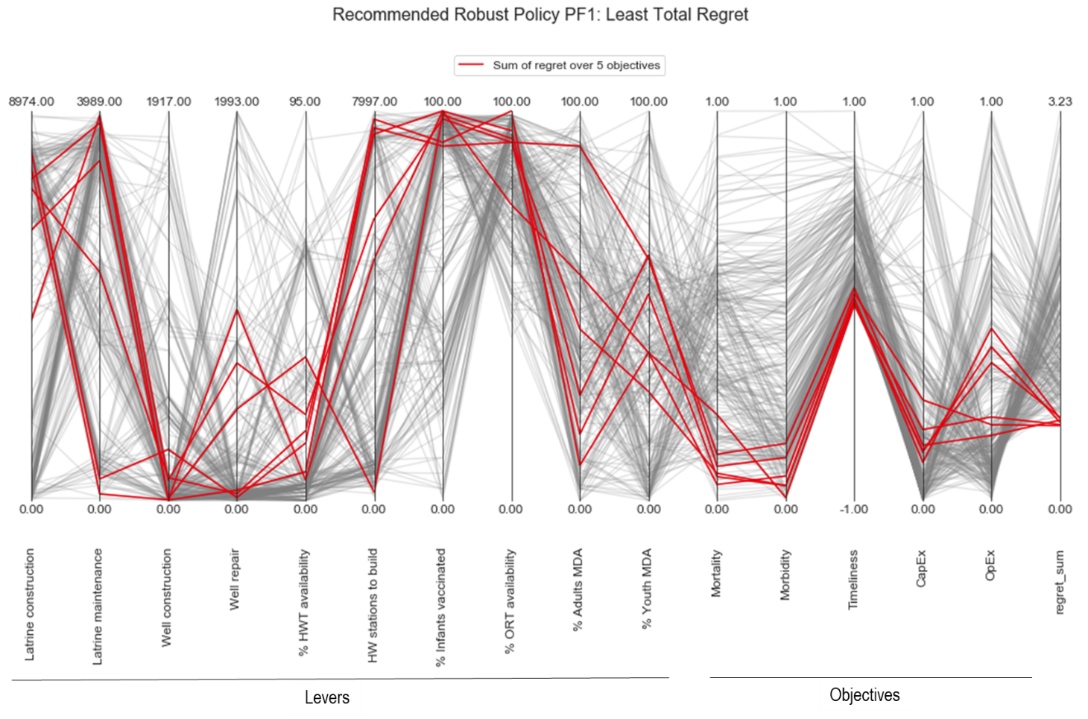

Figure : Robust policies under PF1.

Red lines indicate the cluster of policy options where the sum of the regret from all five objectives is the lowest.

By studying Figure 34, it is apparent that the lowest-regret options under PF1 tend to cluster around latrine improvement, handwashing stations, vaccination, and ORT availability. The policy with the least overall regret under Problem Formulation 1 has the following combination of levers:

|  |  |
| --- | --- |
| Number of new latrines to build | 8070 |
| Number of latrines to maintain | 221 |
| Number of new wells to drill | 251 |
| Number of wells to repair | 15 |
| % HWT availability | 14 |
| Handwashing stations to build | 7832 |
| % Infants vaccinated | 92 |
| % ORT availability | 100 |
| % Adults given MDA | 9 |
| % Youth given MDA | 38 |

### Robust candidates under Problem Formulation 2

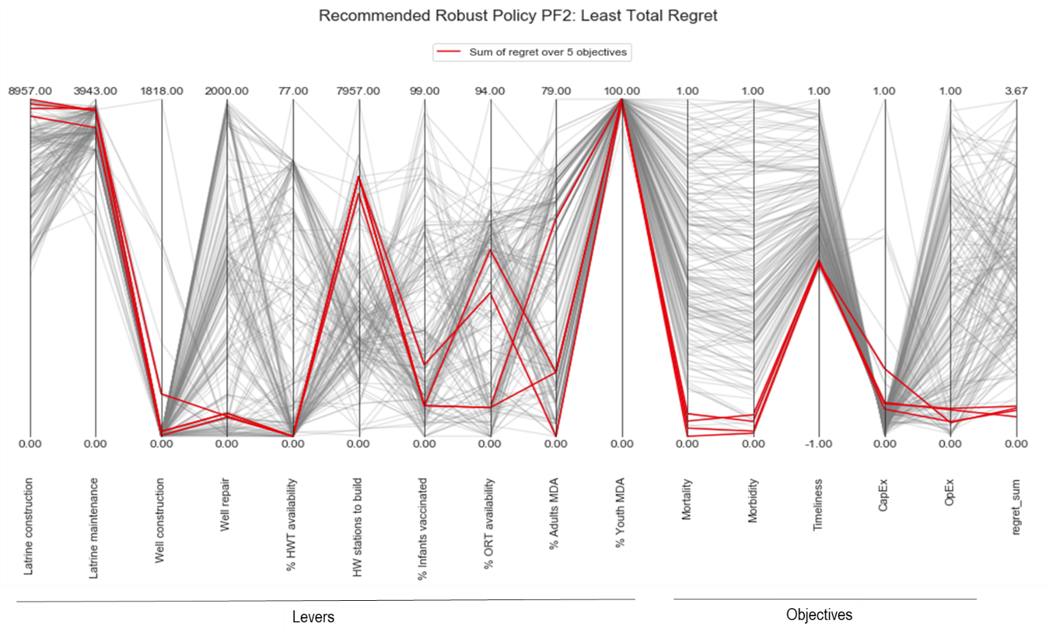

Figure : Robust policies under PF2

Red lines indicate the cluster of policy options where the sum of the regret from all five objectives is the lowest.

Similar to the first problem formulation, the least total regret option under PF2 suggest that latrine-building and maintenance is favorable (Figure 35). Unlike PF1 however, vaccination and ORT is not advised. Instead, MDA to combat ascariasis (especially in youth) is recommended. Thus, the policy with the least overall regret under the ascariasis-focused problem perspective contains the following combination of levers:

|  |  |
| --- | --- |
| Number of new latrines to build | 8510 |
| Number of latrines to maintain | 3611 |
| Number of new wells to drill | 5 |
| Number of wells to repair | 113 |
| % HWT availability | 0 |
| Handwashing stations to build | 5731 |
| % Infants vaccinated | 9 |
| % ORT availability | 8 |
| % Adults given MDA | 51 |
| % Youth given MDA | 100 |

##### Single-disease problem formulation results

Using two separate problem formulations resulted in two distinct policy recommendations. While both show latrine and hygiene improvements to be beneficial, the rotavirus-only formulation distinctly advises ORT and vaccination while the ascariasis formulation distinctly recommends 100% MDA in youth. The MDA strategy would not work against rotavirus, and the vaccination strategy would perform poorly against ascariasis. In essence, two separate problem formulations resulted in the proposal of two distinct policies.

### Robust candidates under Problem Formulation 3

Problem formulation 3 could be nicknamed the “save children, now” option for its emphasis on immediate improvements in any of the gastroenteric conditions affecting children. Figure 36 shows that the robust policy recommendations here are different than the previous single-disease formulations:

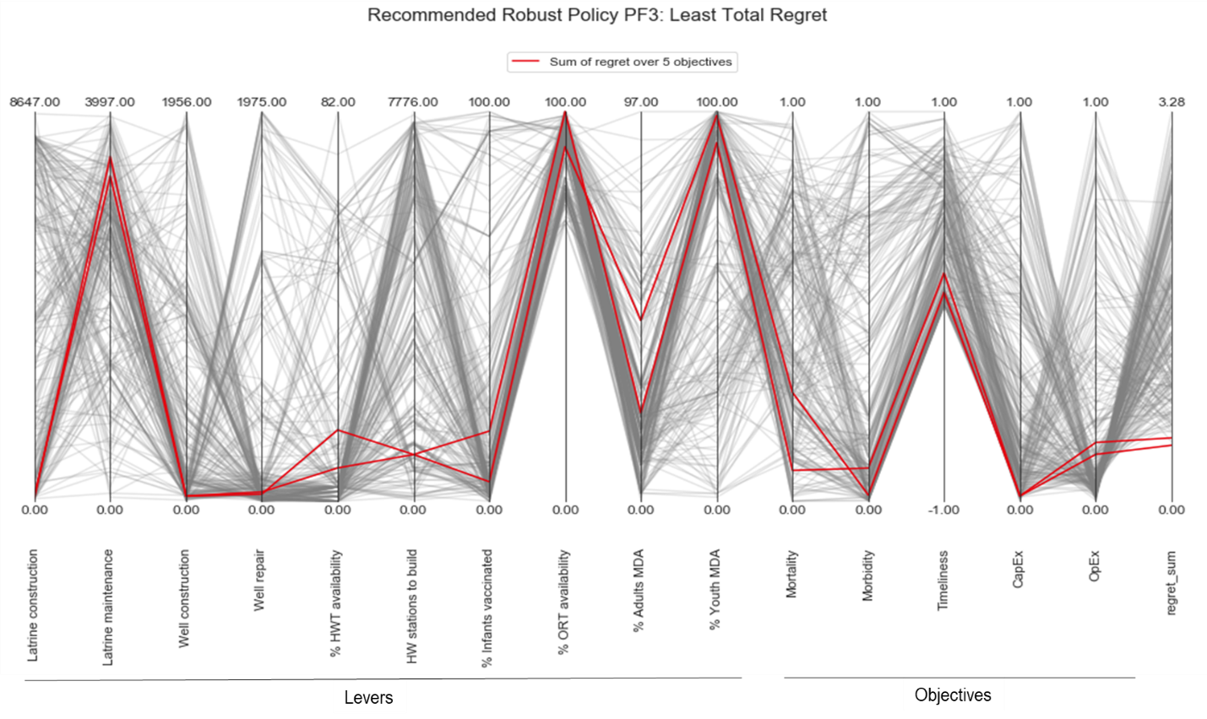

Figure : Robust policies under PF3

Red lines indicate the cluster of policy options where the sum of the regret from all five objectives is the lowest.

As anticipated, the short-term problem formulation of PF3 emphasizes the fastest-acting policy levers (ORT and MDA). Sanitation is not as highly favored due to the amount of time it takes to build new infrastructure. This problem perspective results in a policy that is a combination of the most immediately impactful levers from both PF1 and PF2. The advantage of this policy perspective is that it provides a solution that does not ignore either rotavirus or ascariasis, but considers all four pathogens to finding a low mortality and morbidity solution. One could easily envision a program where vaccines and MDA are distributed simultaneously in order to see an immediate improvement in health benefits.

|  |  |
| --- | --- |
| Number of new latrines to build | 73 |
| Number of latrines to maintain | 3537 |
| Number of new wells to drill | 27 |
| Number of wells to repair | 47 |
| % HWT availability | 7 |
| Handwashing stations to build | 931 |
| % Infants vaccinated | 18 |
| % ORT availability | 100 |
| % Adults given MDA | 22 |
| % Youth given MDA | 92 |

By putting this proposed policy into the model, the results over time can be seen (Figure 37):

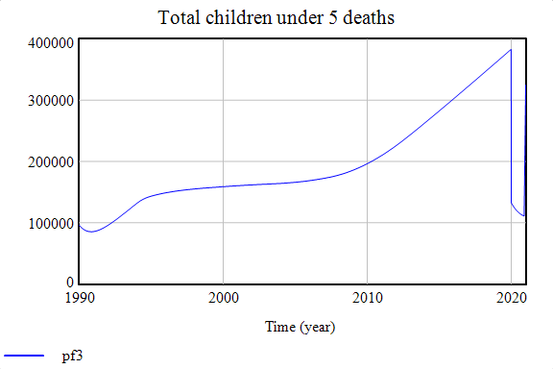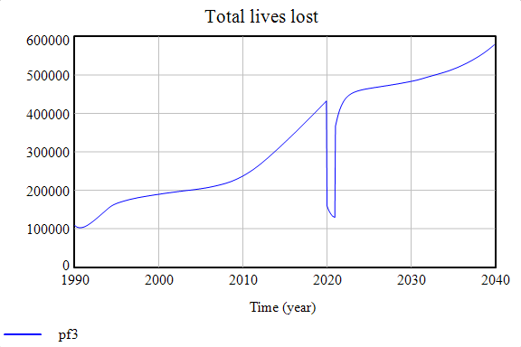

Figure : Results of PF3 policy option over time.

Figure (A) effect of recommended policy on children using 2021 timeline. Figure (B) the same policy shown for the entire population using a 2040 timeline.

Looking at Figure 37(A), it is clear that the recommended policy is highly effective for PF3. As ORT and MDA programs are expanded to cover 100% of children within one year, the mortality in children sharply drops off before 2021. However, by evaluating this problem using a long-term problem formulation (PF4), it becomes apparent that this massive effort must be sustained annually for the results to be permanent as seen in Figure 37(B).

### Robust candidates under Problem Formulation 4

The final problem formulation considers strategies for combatting all four diseases over the long term.

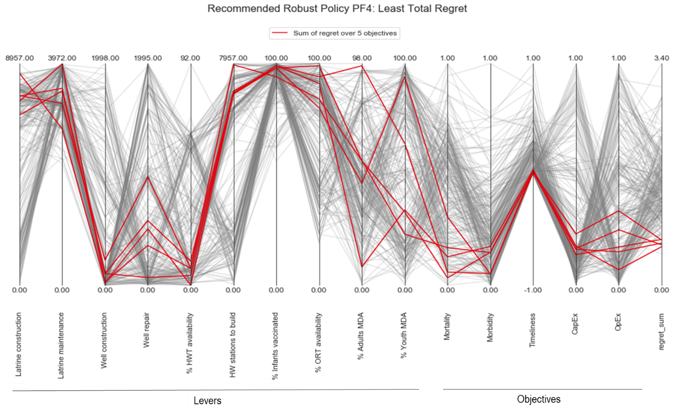

Figure : Robust policies under PF4

Red lines indicate the cluster of policy options where the sum of the regret from all five objectives is the lowest.

Under this multi-disease perspective, Problem Formulation 4 recommends: sanitation, hygiene, vaccination, and ORT (Figure 38). MDA is favorable but to a far lesser extent than in the Ascaris-only formulation (PF2) or in the immediate (PF3) perspective.

|  |  |
| --- | --- |
| Number of new latrines to build | 7643 |
| Number of latrines to maintain | 3528 |
| Number of new wells to drill | 104 |
| Number of wells to repair | 69 |
| % HWT availability | 4 |
| Handwashing stations to build | 6857 |
| % Infants vaccinated | 99 |
| % ORT availability | 91 |
| % Adults given MDA | 8 |
| % Youth given MDA | 34 |

The result of this policy recommendation is a long-term decrease in the total number of gastroenteric infections (Figure 39)

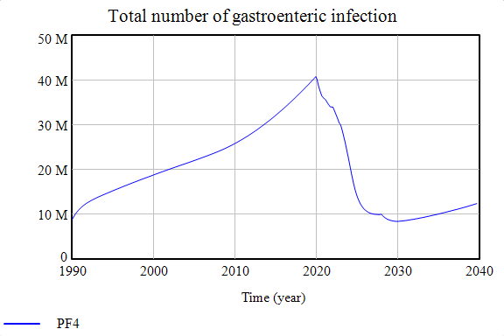

Figure : Impact of PF4 recommendation on total gastroenteric infections

Figure 39 highlights the impact of the recommended policy using the multi-disease formulation, which is a significant decrease in the overall number of gastroenteric infections in Uganda. Because it includes ORT, it performs well at reducing mortality levels from rotavirus, *cryptosporidium*, and *E. coli*. And since it includes sanitation and hygiene infrastructure improvements, the overall morbidity and prevalence of all four diseases is reduced. These features are highlighted in the final policy re-evaluation, where this policy is tested under the other problem perspectives.

### Re-evaluation: Policy recommendation

How does the multi-disease PF4 policy recommendation perform under the other (short term/single-disease) perspectives? Here, the recommended policy is re-evaluated under the other formulations.

#### Re-evaluate PF4 recommendation under PF1

The result of putting PF4 robust policy into PF1 formulation is shown in Figure 40. Because this recommended package includes both sanitation and vaccination, the policy performs well against rotavirus in children over the long term.

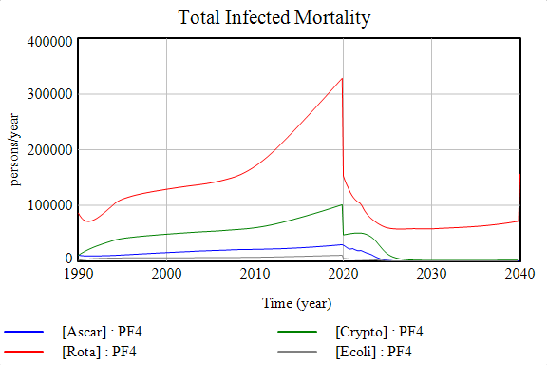

Figure : Recommended policy against rotavirus in children

#### Re-evaluate PF4 recommendation under PF2

Figure 41 highlights the policy performance of the PF4 recommendation under the ascariasis-focused problem perspective. The package includes moderate measures of MDA, which helps to quickly initiate the decrease in Youth DALYs. With the improvements in sanitation infrastructure and maintenance, these benefits are sustained over the long term.

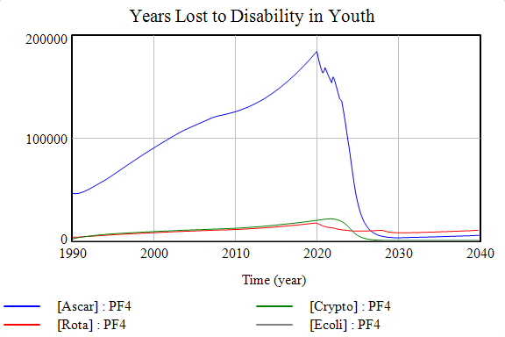

Figure : Recommended policy against ascariasis in youth

#### Re-evaluate PF4 recommendation under PF3

Finally, Figure 42 shows the performance of PF4’s multi-disease recommendation for the short term. Because the package includes ORT measures, the policy performance of the PF4 recommendation under the ascariasis-focused problem perspective. The package includes fast-acting ORT measures to bring down the number of child deaths quickly. Due to the improvements in sanitation infrastructure, these benefits are sustained over time.

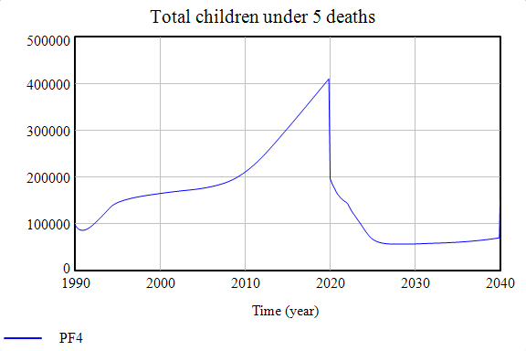

Figure : Recommended policy for children in the immediate term

##### Stress Testing Conclusion

In this section, the non-dominated sets of promising policy options from the directed search were subjected to computational exploration by systematically varying the uncertain parameters. By testing the policy options against a wider range of uncertainties (beyond the initially-specified reference scenario), the performance of policies under a much broader uncertainty ensemble is provided. Specifically, the performance of candidate strategies was re-evaluated under a computationally generated 300-point uncertainty ensemble, leading to sets of strategies that are not only approximately “optimal” but also robust against many different plausible futures. The benefit of this process is that it can help decision makers realize which strategies are most sensitive to deviations from the reference scenario.

The robustness of re-evaluated policy options was calculated using a 90th percentile minimax regret formula. The use of this regret metric is appropriate because there is little to no probabilistic information about the uncertain parameters and it is assumed that public health policymakers have a relatively high level of risk aversion due to the high-stakes nature of the problem. Defining robustness from a regret perspective is useful for comparing alternative strategies to one another while maintaining transparency. It is especially appropriate for health development policymakers, who may want to know which policy option they will likely regret least in a few years if they invest in it now.

Future replications of these experiments should seek to evaluate policy performance against a larger uncertainty ensemble to increase the robustness of the findings. Additionally, the full version of the multi-disease model contains 18 policy levers, though this thesis has only included ten of them in order to maintain clarity in the discussions and visualizations. It would be insightful to analyze these additional levers to gain a more nuanced perception of the differences in solution sets between problem formulations. Furthermore, the experiments could be run at the district level and compared to the national perspectives used here. This is a potentially interesting research extension to see how the identification of “optimal” solution sets is different for local-level policymakers. Also, it would be easier to get more accurate local data sets (especially for well-studied districts like Kampala).

The stress-testing and regret calculations of this section resulted in a set of robust policy options for each problem perspective. Using parallel coordinate plots, regret tradeoffs for each problem formulation could be considered. This was narrowed down to a single policy recommendation by re-evaluating the strategy proposed by the long term, multi-disease perspective under the other problem formulations. In an actual policy setting, the choice of final policy should be done with close involvement of the decision makers (perhaps iteratively, requiring more analysis). In the next and final step of MORDM, these set of robust candidate strategies are subjected to scenario discovery to identify remaining vulnerabilities.

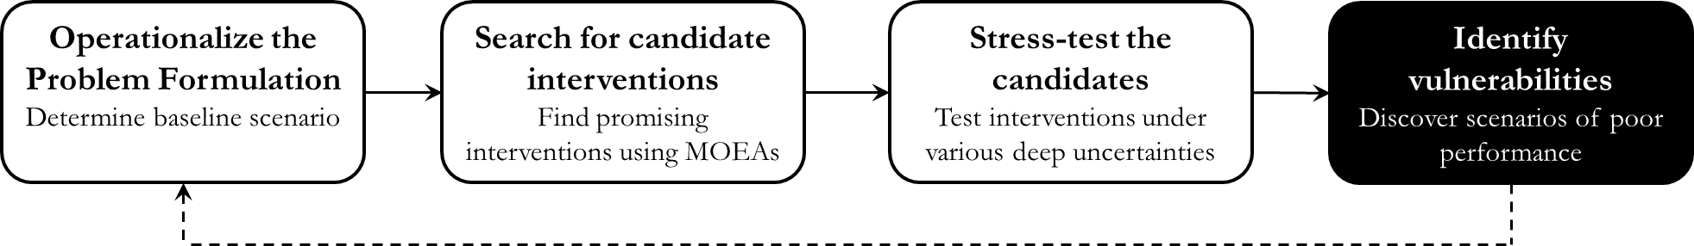

## Identify vulnerabilities

The previous step focused on identifying a robust set of candidate strategies, which perform well against a variety of plausible future states of the world. Now, we might address Sub-Research Question 5: **“Under what plausible future states of the world are the robust policy options vulnerable?”**These important scenarios (which can be difficult to arrive at without computational assistance) are determined through the process of scenario discovery. As described in the Methodology section, a statistical bump-hunting algorithm known as PRIM is used to identify regions of the large, multi-dimensional uncertainty space where the robust policies are vulnerable to failure. Here, the definition of policy **vulnerability** is adapted from (Herman et al., 2015) to mean the ranges of deeply uncertain parameters observed to cause policy performance to degrade below a set threshold.

### Describing poor performance

How badly does a policy have to perform before it is declared to be a total failure? For many public health problems, it is difficult to quantify a number that demarcates between “failure” and “not failure.” However, having a performance threshold is useful for scenario discovery when looking for conditions that cause strategies to perform badly. Some policy issues may have a natural boundary or well-characterized stakeholder preferences that make setting this threshold obvious; while other issues may be less well-defined as to what performance value qualifies as a failure (Bryant & Lempert, 2010). Public health issues like the current case study are generally of the kind without a clear-cut threshold (since some stakeholders might say that it is unacceptable to have even one life lost).

Since this case study does not come with an obvious threshold, policy failures are defined to be situations where the objective surpasses the 90th percentile of the objective score. Because it is desirable to minimize all of the objectives, the 90th percentile contains the 10% worst-case outcomes. Each policy from the robust set of solutions is either assigned a value of 1 if it exceeds this threshold or else is assigned a zero. PRIM aims to maximize both coverage (the fraction of total failure scenarios that lie within the box) and density (the fraction of scenarios within the box that are failures). The result is a series of “boxes” that represent regions of the uncertainty space where otherwise robust policies are vulnerable to poor performance. Once these vulnerabilities have been identified, policymakers can begin to consider ways of mitigating them.

### Problem Formulation 1 Vulnerabilities

Naturally, the first kind of scenarios a public health policymaker might be interested in are ones where there are a high number of fatalities, even though a supposedly robust policy was put in place. For the rotavirus-only perspective, this means looking for combinations of uncertainties where the number of children dying from rotavirus remains high. Applying PRIM to the Mortality objective, these scenarios are identified in Figure 43.

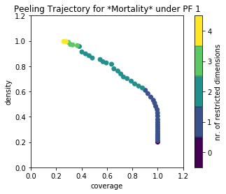 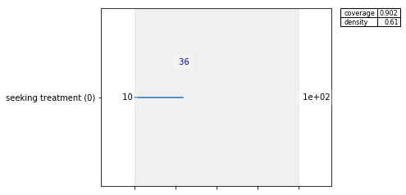

Figure : Rotavirus in children – High mortality scenarios

Coverage: 0.42; density: 0.84; mass: 0.05.

The robust policy options recommended under problem formulation 1 may be vulnerable to failure if the *fraction of people seeking ORT treatment* in medical centers drops below 36%. This makes sense, as medical experts can only use ORT to restore infected children if those children are brought in for treatment.

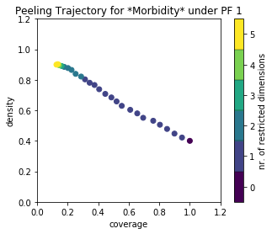 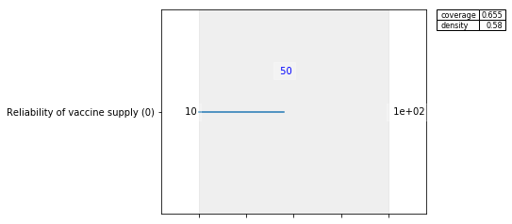

Figure : Rotavirus in children – High morbidity scenarios

Coverage: 0.41; density: 0.70, mass: 0.05.

In addition to high-mortality scenarios, policymakers may also be concerned with combinations of uncertainties that cause their policy to fail to prevent large numbers of disabilities. According to PRIM, problem formulation 1 may fail to meet its *Morbidity* objective when the *reliability of vaccine supply* drops below 50%. In other words, if vaccines are unreliable about half of the time that they are needed, the robust policies identified are unlikely to prevent high levels of rotavirus morbidity in children. This is concerning because literature estimates suggest that this this is close to the supply reliabilty of other vaccines in Uganda (Malande et al., 2019).

### Problem Formulation 2 Vulnerabilities

As indicated in the previous sections, results under the ascariasis-focused formulation recommend policies that provide high levels of MDA (especially in youth). Vulnerabilities to robust policies under PF2 are shown in Figure 45:

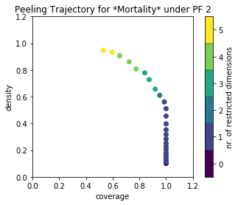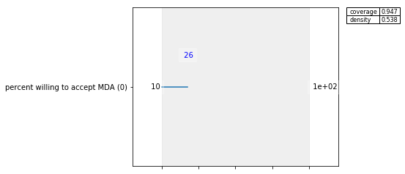

Figure : Ascariasis in youth – High Mortality (and Morbidity) scenarios

Coverage: 0.51; density: 0.97, mass: 0.05.

The results of PRIM indicate that the outcomes for both *Mortality* and *Morbidity* are both vulnerable in scenarios where the *percent of people willing to accept MDA* drops below about 26%. In other words, the government could subsidize and implement a large MDA campaign, but if Ugandans are unwilling to take the doses provided (e.g. because they do not trust it), then the program will fail to improve public health.

### Multi-Disease formulation vulnerabilities

Recall that the solutions proposed under the third problem formulation were a combination of the fastest-acting solutions from PF1 and PF2. Therefore, PF3 shares many of the same vulnerabilities. PF3 is unlikely to meet its *Mortality* objective when the *fraction of people seeking ORT treatment* drops below about 28%. Similarly, PF3 is unlikely to meet its *Morbidity* objective when the *percent of people willing to accept MDA* drops below about 46%.

Applying PRIM to problem formulation 4 revealed no boxes which met the specified thresholds. By lowering the coverage threshold vulnerabilities could be found, which nearly always included combinations of multiple uncertainties. As opposed to previous problem formulations, which appeared rather sensitive to deviations in individual uncertainties, PF4 may potentially be less reliant on any single uncertainty. This potentially highlights the robustness of the PF4 solution set for using a unique combination of levers to meet the objectives under many scenarios.

##### Scenario discovery conclusion

This section addressed Sub-Research Question 5: “**Under what plausible future states of the world are the robust policy options vulnerable?**”This step used scenario discovery to find important combinations of uncertainties that decision makers should be aware of for policy design.

From this, we can conclude that the deeply uncertain variables that matter most for *Mortality* outcomes are instances where beneficiaries do not desire potentially life-saving interventions. Under PF1 and PF3, this translated to scenarios where beneficiaries did not seek ORT treatment in hospitals. Under PF2, both *Mortality* and *Morbidity* objectives were vulnerable where a large proportion of beneficiaries reject the MDA program. Thus, policymakers should consider running promotional campaigns for new policies to ensure that beneficiaries are aware of the program benefits. If the population does not value the new services provided, then the promising candidate interventions may nonetheless fail to perform well.

Ultimately, scenario discovery is a useful tool for learning and for improving the performance of the robust candidate strategies. Note that future extensions of this research could explore the sensitivity of the results obtained to this threshold or use alternative thresholds. In the next chapter, the implications of the findings are discussed.

# Discussion

When it comes to diseases of poverty, interventions are frequently designed in silos. Medical experts emphasize the need for increased vaccination and treatment. Water resource engineers focus on expanding coverage to those without services. And those working to combat neglected tropical diseases (like *Ascaris lumbricoides*)advocate the benefits and affordability of mass drug administration. While policymakers rely on these experts to understand how best to deliver each of these services, it remains the responsibility of policymakers to decide which strategies will be prioritized when not all of them can be financed. A multi-disease model can be a useful tool for supporting policymakers in understanding how various strategies fit together in the wider public health context. Indeed, when the interventions under consideration may potentially affect more than one public health problem, policymakers can only gain an accurate representation of the costs and benefits of such strategies through a multi-disease evaluation.

At a high level, the theory behind this multi-disease model has implications for the formation of international health development strategies. Section 7.1 discusses how the approach to use multi-disease modeling and *a posteriori* analysis can benefit international health development programming. From an academic perspective, the domain of exploratory public health policy modelling suggests a relatively overlooked frontier. Section 7.2 discusses the justification for further exploratory analysis research in public health and a key barrier to wider adoption. Operationally, the results have implications for those who work in health and development within Uganda. Section 7.3 compares the research findings with current strategies being used in Uganda and summarizes key policy recommendations. In Section 7.4 the research questions are briefly revisited followed by a reflection on the advantages and limitations of the thesis approach. Finally, a research agenda is laid out based on the theories and findings presented here.

## Implications for public health policy modelling

The results of this thesis highlight three key implications for the public health modelling community. First, the findings provide justification for why exploratory modeling techniques should be more commonly used in public health policy evaluations. Second, the research illustrates the subjectivity surrounding the interpretation of what an “optimal policy” is, so quantitative analyses should not assume that there is a single way to frame the objective space. Finally, a major barrier to wider adoption of multi-disease evaluations rests with the limitations of existing terminology used to discuss the issue. Each of these implications is discussed in the following sub-sections.

### The need for exploratory modelling in public health policy

The extent of many health problems in low-income countries is deeply uncertain because of the lack of resources to adequately monitor them. Some of the neglected tropical diseases (beyond *Ascaris lumbricoides*) are so uncertain that experts do not even know how they are transmitted, despite estimates that they are extremely prevalent and debilitating diseases. Randomized control trials and predictive risk models are an important part of learning about these diseases and their transmission parameters, but they are insufficient on their own to support policymakers in low-income countries make strategic decisions. Furthermore, single-disease optimization models often make deep assumptions in order to provide strong conclusions for a narrow problem definition or system boundary. Epidemiological models are available for a wide array of diseases to provide insight into transmission; however, the vast majority of these models are not equipped to handle situations of deep uncertainty.

For policymakers concerned with making the right choice of public health investment, integrated solutions that work well against multiple health threats, rather than perfectly for a single threat, may be a better option. An advantage of exploratory modelling methods is that they are better suited to handle data gaps and uncertainties. This is critical for decision makers operating in the global south, for whom it can be an agonizing decision to spend precious resources performing extensive monitoring and data collection rather than spending that money to solve the problem itself. For the following reasons covered in this thesis, exploratory modeling presents many opportunities to enrich public health policy support:

* Exploratory modeling techniques can be used to build a **multi-disease model**, which (due to confounding) would be questionable using predictive methods.
* Where information is **deeply uncertain** or there are severe data gaps, traditional methods of quantitative modeling that focus on probability or risk are impracticable.
* Through sensitivity analysis and exploration, researchers can gain a better understanding of which factors are most important to the outcomes. Data collection efforts can focus only on gathering information on the most important factors, rather than trying to collect data on everything. This helps to create a **data-gathering agenda**, thereby reducing costs and increasing the speed at which policy-relevant information is attained.
* Exploratory models are more appropriate for helping decision makers learn about the system and different strategic options, rather than models that use big assumptions to prescribe a single solution.
* Finally, exploratory modeling is useful in policy situations because it is better suited for considering the **perspectives of different stakeholders** to the decision. Because the model does not need to rely on one party’s assumptions or views of the issue, it may be more appropriate to addressing contentious issues.

The exploratory public health policy modeling framework established in this thesis provides foundations that can be applied directly to public health problems.

### Problem formulations are crucial

A second research implication for the public health modeling community is that the problem formulation is an inherently subjective and therefore crucial aspect for the entire analytical endeavor. Exploring the multi-disease model through MORDM showed that different problem formulations critically impacted the way in which key objective tradeoffs were interpreted. The full value of latrine construction and maintenance was only visible in a multi-disease formulation. Where problems were constrained upfront to only look for the best solution against rotavirus for instance, the high upfront cost of sanitation infrastructure made it a less appealing option than treatment and vaccination. In other words, the way a public health policy issue is formulated *already biases the results* that will be obtained.

### Barriers to multi-disease analysis

A final implication of this thesis for the public health policy modelling community is that one of the key barriers to expanding multi-disease evaluations rests with the limitations of current terminology. As described in the literature review, models which currently account for more than one pathogen generally do so by grouping them under a category such as “waterborne disease,” but this somewhat arbitrary grouping presents many conceptual and analytical limitations. This thesis did not resolve this terminology barrier (since a thoughtful, comprehensive classification scheme is an extensive endeavor), but the need for it is remarked upon.

Here, the term “gastroenteric disease” was used to refer to the four pathogens considered because of the lack of a better classification. Importantly however, each pathogen was treated separately within the model evaluation itself and only mentioned under this classification when all four pathogens were being discussed. Though using the term “gastroenteric diseases” does not in any way affect the analysis, having some sort of grouping helps when communicating the results (as opposed to listing “Rotavirus, *Ascaris lumbricoides*, *Cryptosporidium*, and enterotoxigenic *Escherichia coli”* every time). This is especially so when working with policymakers from non-medical backgrounds or when speaking to the wider public, who may be confused by long lists of Latin names. In that regard, it is easy to see why the moniker “waterborne disease” has been so successful – it not only encompasses a large number of pathogens but it quickly and effectively emphasizes a shared aspect among them.

Existing classification systems do not address policy-relevant concerns. For instance, policymakers do not need to consider control strategies against “bacteria” separately from strategies against “protozoa,” when their primary concern is how best to improve population welfare. Nor is the distinction between “water-based” and “water-related” relevant to understanding which intervention strategies are most worthwhile. Even though many infectious diseases of poverty are related to water, the Bradley Classification system is ineffective for supporting policy-relevant decisions. It is strongly recommended that a new classification system is created to improve both the salience and analysis of multi-disease evaluations. Specifically, the new system should classify pathogens by their primary control strategy. This would help policymakers and practitioners choose control strategies that work across a large number of diseases.

Having a classification would not have changed the way the results were calculated or explored; however, it would have: (1) made it easier to communicate them; (2) made it more clear why these pathogens were chosen in the first place; and (3) made looking at the issue from a multi-disease control standpoint more natural. In order for multi-disease evaluations to become more commonplace, relevant terminology that encourages integrated thinking may be even more pressing than the advanced analytical techniques presented here.

## Implications for international health development strategies

### Addressing the SDGs

The result of MORDM to this topic was to highlight potentially large-scale implications that *a priori* elicitation of objectives may have for public health development projects, many of which are driven by the Sustainable Development Goals. Those who are involved in health development projects and closely use the SDGs to guide their programs may be interested in the implications of this research. Indicators used in the SDGs, while absolutely valuable and worthwhile ambitions, may not be suitable for actual public health policy objectives. For this reason, they are referred to as “proxy objectives” in this discussion.

For instance, having a goal of “number of handwashing stations installed per year” or “number of people given MDA” are *proxies*to the actual goal of improving human health. Proxies are useful metrics that help visualize progress over time because they are generally comparatively easy to measure. However, some development programs appear to make proxies their entire stated goal – such as initiatives intent on maximizing the number of groundwater wells installed per year. As seen from the results, problem formulations that confine the solution set upfront (e.g. by only looking at ways to install the most wells) may miss out on potentially better ways for improving overall population welfare.

Proxy indicators should be explicitly called out in all public health evaluations. If a proxy becomes confused with the real public health objective, programs are in danger of performing sub-optimally. For instance, the following two SDG indicators are relevant for the current case study:

* **SDG 3.b.1** “Proportion of the population with access to affordable medicines and vaccines on a sustainable basis.”
* **SDG 6.1.1** “Proportion of population using safely managed drinking water services.”

SDG 3.8 seeks to ensure that all people receive the vaccines they need. While this is a praiseworthy ambition, constraining the model boundary upfront to only include different ways of maximizing vaccination coverage could potentially overlook better solutions. Presumably, the real objective of policymakers is not to give people vaccines for the sake of it but to achieve better public health, which could possibly be accomplished in other ways. If policymakers take indicator 3.b.1 as their primary objective that might lead to a problem formulation similar to the one seen in PF1. Essentially, the goal is to maximize the number of people receiving treatment or being vaccinated, *rather than a goal of minimizing morbidity and mortality*. The results revealed that the upfront formulation of the problem could dramatically bias the “optimal” solution sets presented to policymakers.

Similarly, if policymakers only focus on indicator 6.1.1 of increasing safe drinking water services, they could potentially miss out on superior strategies for improving overall population welfare. Once again, water quality and supply improvements are worthwhile goals in their own right. However, if decision makers are led to assume that by fully achieving indicator 6.1.1 their populations will no longer be burdened by diarrheal disease, that would be hugely misleading. This application of the multi-disease model indicated that neither water supply nor water quality levers were the most effective means of reducing overall morbidity and mortality rates from the diarrheal pathogens included. Using a long-term and holistic policy perspective (PF4), sanitation improvements were shown to be dramatically more effective and affordable at reducing all four pathogens.

Reflecting on these examples leads one to question if proxy indicators such as the SDGs are biasing or limiting the ability of decision makers to identify better solutions for complex development problems.

## Policy recommendations for Uganda

Policymakers and development agencies working in Uganda struggle to combat an overwhelming burden of communicable disease. These infectious pathogens are responsible for over half of all morbidity and mortality in Uganda. Many of the interventions intended to control these diseases are created in designed “silos,” leading to national planning that can appear disjointed or ad hoc. In terms of the four pathogens considered here, Uganda is already party to a number of strategic programs and cooperative agreements which aim to improve the country’s overall public health (Table 10).

Table : Implications of research findings for existing health policies in Uganda

|  |  |  |
| --- | --- | --- |
| **Initiative** | **Strategy** | **Author’s remark** |
| Uganda’s Health Sector Strategic Plan (HSSP) | This high-level government document sets forth the national goal to “reduce morbidity and mortality due to diarrheal diseases.” | As laid out in this thesis, the problem with targeting policies towards “diarrheal diseases” is that diarrhea-causing pathogens do not all have the same control strategy. Policy targeted towards this arbitrary grouping may perform sub-optimally if pathogen-specific nuances are not considered. |
| World Health Organization (WHO) Rotavirus strategy | Under WHO recommendations, rotavirus vaccinations should be a priority in Sub-Saharan Africa where fatalities are high, and “should be part of a comprehensive strategy to control diarrheal diseases.” As of this year, Uganda will now include the rotavirus vaccine in its standard package to all infants. | The WHO notes that vaccines should be part of a “comprehensive strategy,” but how should resources be divided between vaccinations versus other methods? |
| Uganda  strategy for helminth control | Uganda follows WHO recommendations for helminth control, by seeking to provide periodic deworming through Mass Drug Administration to all at-risk people (PreSACs, SACs, pregnant women). | The results of the model (under PF2) indicate that increasing MDA is an effective way to reduce the helminth *A. lumbricoides*. However, it is not cost-effective in the long term, nor does it work against the other gastroenteric pathogens. A long-term focus on increasing sanitation is an alternative that would work against helminths as well as the other pathogens in the multi-disease model. |
| Government of Uganda (GoU) Water Supply Plan | The GoU vision for 2040 is to increase the availability of safe piped water from 15% to 100% of the population (Government of Uganda, n.d.). There is no equivalent indicator explicitly laid out for sanitation | Increasing piped water supply is a worthwhile goal in its own right. However, if the objective is to improve overall mortality and morbidity, then the lack of sanitation indicator is problematic. |
| National Hand Washing Communication Strategy | A national campaign to promote hand washing with soap. The campaign’s promotional materials highlight the high degree of complexity surrounding the various methods needed to sustain a desired behavior change. | Exploratory modeling could enhance the design and analysis of national handwashing programs. Interactive model-building exercises could be mutually educational for researchers and participating community members. |

The findings from this research have several implications for existing strategies to disease control in Uganda. For example, a strategy to vaccinate all infants in Uganda as theorized here will actually be rolled out across the country in 2020. The scenario discovery results identified that this vaccination policy may be vulnerable to failure in situations where the *supply chain reliability* falls below 50%. To avoid this, it is recommended that the GoU quickly begin to supplement the new vaccination program with efforts to protect against logistics disruptions.

A second example of how this research may provide insight for current policy related to the GoU’s focus on its Water Supply Plan, while having less emphasis on sanitation infrastructure (which is addressed through an assortment of different agencies and plans). The current research indicated that the installation and maintenance of groundwater wells was a dominated solution in every problem formulation. This is interesting because it is one of the main strategies used by development agencies to improve health, yet it is shown to be an ineffective strategy under the multi-disease model. While the provision of more convenient water supply is a worthy goal in its own right, the results suggest that it may not be the most successful strategy for policymakers seeking to reduce morbidity and mortality.

The multi-disease model was applied to a case study in Uganda to illustrate how it could be used for real-world public health policy concerns. In future, this modeling approach could be used to support decisions for Uganda’s next National Development Plan, a policy agenda that is used by the Ministry of Health and other agencies to operationalize program objectives. The goal of the case study application was not to precisely predict the spread of gastroenteric disease in Uganda, but explore the implications of known and unknown information for supporting health-related development projects. The next section will discuss how the analysis of the Ugandan case study contributed to answering the research questions.

## Revisit Research Questions

**Sub-Research Question 1**

How do existing models support policy decisions against multiple public health threats?

With the exception of the Lives Saved Tool from Johns Hopkins, there are few models designed to support policy decisions from a multi-disease standpoint. Research has primarily been conducted to focus on gaining an in-depth understanding of how to effectively combat a single public health problem. The state of research is ripe for wider synthesis – models and frameworks that bring together separate analyses to compare vastly dissimilar strategies to one another and draw higher-level policy conclusions. Multi-disease models pose an opportunity for policymakers with limited resources, especially those from low-income settings, to understand the wider context of a particular intervention.

A second conclusion of Sub-Research Question 1 is that existing quantitative models have traditionally supported policy decisions by working towards a single, optimal solution without considering the different interpretations of what an “optimal” solution is. However, rarely are policy problems so clearly-cut and uncontentious as they are presented in mathematical optimization problems. While it may be much easier for policymakers to be presented with a single “best” solution, doing so requires modelers to make enormous assumptions. Real-world public health policy problems are often characterized by situations of deep uncertainty, and modelers should not use assumptions that hide this ambiguity.

**Sub-Research Question 2**

What foundations of exploratory modeling are useful to support public health policymaking under deep uncertainty?

Sub-Research Question 1 determined that a clear research gap exists surrounding the use of models to help policymakers consider strategic action against multiple diseases. Therefore, Sub-Research Question 2 sought to outline the principles of exploratory modeling that would be useful for supporting policy evaluation across more than one pathogen. The following foundations were deemed particularly relevant:

* A **systems thinking** approach can provide a more holistic and transdisciplinary evaluation of how many different infectious diseases can be controlled.
* Because health policymaking is rarely performed by a single actor, public health policy modelling must incorporate **multi-actor perspectives** and preferences in order to be relevant for real-world application.
* It is more practical for models that address deeply uncertain public health challenges to **aim to** **explore, rather than predict**. This most obvious example of this is when information surrounding the transmission of a certain disease is unknown or incomplete.
* Modelers should **move beyond optimization** metrics by using techniques that do not assume there is a clear-cut decision threshold or only one way to calculate a best solution.

These foundations synthesized existing theories of exploratory modeling into an analytical framework for future public health policy modelling applications.

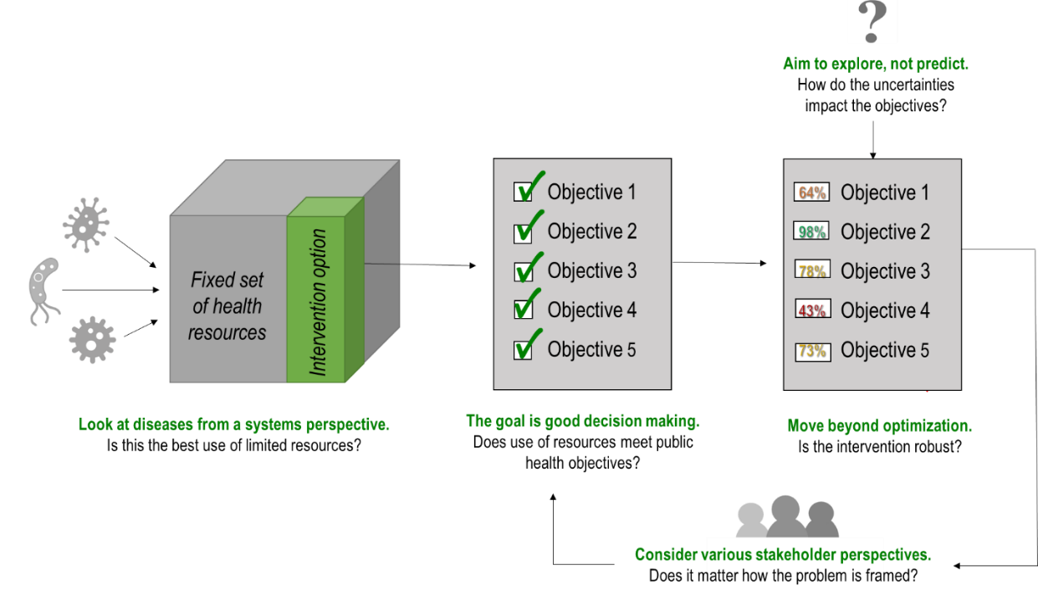

**Sub-Research Question 3**

How can the transmission of multiple infectious diseases be included in a single model in order to compare the performance of different interventions on policy objectives?

Within the multi-disease model, the spread of various pathogens occurs through a limited number of transmission pathways (contaminated drinking water, contaminated hands, and person-to-person contact). Though the pathogens share many characteristics, they are not transmitted to the same extent in all pathways. Therefore, a variety of sub-models are created to model different possible intervention programs, which essentially “cut” different transmission pathways. For some pathogens, cutting one transmission pathway means the virtual elimination of the disease (e.g. improving sanitation until ascariasis is no longer present in the environment). For other pathogens, their ability to survive across multiple transmission pathways means that more than one intervention strategy is likely necessary. This is the case for rotavirus, which could require both sanitation improvement and vaccination to address completely.

With the inclusion of multiple pathogens in a single model, users are able to see how scaling up a particular intervention strategy impacts the overall burden of disease on the population. This is important because many public health policies likely have the same objectives surrounding the increased welfare of the population. By not specifying a policy type upfront (e.g. “increase vaccination coverage”, “increase drinking water access”) the policymaker can be presented with a wider range of potentially effective options instead of biasing their decision problem early on. It is hoped that this instance of a multi-disease model widens the state-of-the-art of disease modeling and encourages more broadly-scoped public health problems in academia.

**Sub-Research Question 4**

What does using different problem formulations reveal about the tradeoffs between many objectives?

The analysis used in this thesis showed that different problem formulations can greatly impact the way in which key objective tradeoffs are interpreted. The use of single-disease problem formulation resulted in policy recommendations that were more limited than the multi-disease formulation of PF4, which was able to evaluate policy ideas against a range of pathogens. Three findings pertaining to the case study are of note:

* In every problem formulation, policies that focused on water supply or water quality were dominated by other policy options.
* The performance of a handwashing promotion program is potentially promising but also highly variable, indicating the large degree of uncertainty surrounding its implementation. More research and experimentation should be conducted to test its viability.
* Because the problem formulation so dramatically influenced the recommendations, policymakers should be aware that their upfront perception or question about the problem (e.g. “what is the best way to stop rotavirus in children?”) may already constrain the solution sets.

**Sub-Research Question 5**

Under what plausible future states of the world are the robust policy options vulnerable?

MORDM was used to determine a set of Pareto-approximate policies, but even the most robust of these options have conditions where they perform poorly. Sub-Research Question 5 was answered by using scenario discovery to identify key vulnerabilities for different intervention strategies. Being aware of these vulnerabilities can aid in policy refinement and may also lead to a description of areas that decision makers should pay attention to during policy deliberation or for future research.

Where policymakers are focused on combatting rotavirus, an extremely unreliable vaccine supply chain may strongly impact the ability to achieve their objectives. To avoid this scenario, policymakers should ensure that the vaccine supply chain receives more consideration and possibly funding. If policymakers still don’t feel comfortable that they can reliably affect this measure, then a strategy that does not rely so heavily on vaccination to meet the objectives could be adopted instead.

Policies that chiefly involve delivering ORT or MDA may be vulnerable in circumstances where beneficiaries do not see the value of participating in the program. Therefore, policymakers might consider adding such an education campaign to any solution adopted in order to avoid the scenario where few of the beneficiaries desire the measures provided.

**Main Research Question**

**How can a multi-disease model be used to support the design of robust, integrated strategies for achieving many public health objectives?**

The five sub-questions progressed to addressing the overall aim of this thesis, which was to identify robust policy options for combatting multiple infectious diseases under conditions of deep uncertainty. A multi-disease model was created with the intent of supporting strategic prioritization of limited public health resources. Since investments in intervention generally means that another control strategy does not receive financing, seemingly minor public health decisions can have long-term implications.

A multi-disease model may be used to develop integrated solutions, by seeking interventions that work well against more than one public health concern concurrently. Due to the presence of data gaps and uncertainties, a multi-disease decision support tool is likely better suited to exploratory modeling and analysis approaches that are equipped to handle them. Through the use of many-objective exploratory analysis, models can be extended to find solutions that are not only integrated but also robust with respect to a wide array of plausible future states of the world. The growing field of exploratory modeling has made large strides in leveraging advanced computational methods, such as machine learning and genetic algorithms, to gain insight into complex policy problems. While such techniques have until now been largely overlooked in the public health policy sphere, they present many opportunities for improving the speed, relevance, and cost-effectiveness of evidence-based decision making processes.

## Reflection on Approach

### Reflection on Model

The system dynamics model created in this thesis was novel in its approach to combine policy interventions from different sectors and evaluate them over multiple pathogens. This approach is one that can be easily adapted and improved to address a wide range of policy-relevant concerns. For other case studies involving infectious pathogens in low-income countries, future researchers are encouraged to download the model (<https://github.com/shannongross/multi_disease_model>) and expand on it directly. Note that while the principles and basic structure behind a multi-disease model can be immediately translated to other case studies; the XLRM framework will always need to be modified to include those factors that are relevant to the particular pathogens under study (such as which interventions are applicable and to what extent).

##### Strengths and Weaknesses of Model

The model is advantageous in its ability to provide one system for comparing interventions, over current methods requiring policymakers to refer to many different single-disease models. The primary benefit of this is to support policymakers in comparing different strategic ideas and putting them into context of the wider health system. Importantly, however, the model is intended to supplement (not replace) the deliberation process for policymakers. It is important to keep in mind the reasons for exploratory modelling, which is not to outline a blueprint for policy action. Instead, it is to highlight interesting difference between policy alternatives and the assumptions used to craft them. Decision makers hoping to find a model that recommends a single “silver bullet” to fix all of their public health concerns will not find that here.

A second key advantage of the modeling approach used in this thesis was the incorporation of various problem formulations, which essentially worked to create four separate models of the same problem. The intent of this was to contribute to the academic debate surrounding the politicization of scientific evidence, by showing how multiple worldviews could actually be incorporated in the analysis, rather than having to reduce them into a single perspective. The limitation of adding various problem formulations rests in the interpretability and analytical difficulty of the findings. Without considerable computational power and careful visualization of the outcomes, turning the results into useful insight can be challenging. Other problem formulations and certainly other infectious diseases could be added to this model to increase the value of its findings. In future, it is hoped that more models in the public health sector use exploratory techniques in order to find interventions that target multiple, similarly-transmitted diseases.

Finally, the accuracy of the model results are limited by the large data gaps surrounding the prevalence of various gastroenteric pathogens and the effectiveness of different interventions considered. Disease modeling experts may question the legitimacy of combining data sets from various information sources; however, the rebuttal is that it is the only way that such a large-scale model could be created. While the results of the multi-disease model can only be as strong as the data used to craft it, the advantage of incorporating deep uncertainty exploration is that perfect information is not a prerequisite for starting the process. As more data becomes available, the parameters and structures used here can be easily modified to incorporate more accurate information.

### Reflection on Analysis

The method of analysis chosen (MORDM) was well-suited to the complexities of the public health problem under study. To date, MORDM has most commonly been applied to case studies related to water resource planning. The application to WASH, therefore, was a natural extension.

In terms of its application to infectious disease, the use of MORDM was highly illuminating because of its incorporation of *a posteriori* preferential elicitation. To the author’s knowledge, the use of such computational methods are virtually unexplored in the public health sector.

##### Strengths and Weaknesses of Analysis

The use of MORDM to analyze the multi-disease model was advantageous for the following reasons:

* Many-objective tradeoffs could be evaluated without premature aggregation (i.e. a utility function);
* Objective tradeoffs did not need to be resolved *a priori*, for example by asking policymakers to set a price per life saved;
* The analytical approach incorporated robustness metrics rather than relying on arbitrary and potentially contentious criteria;
* MORDM’s use of scenario discovery enabled the identification of key policy vulnerabilities. To the author’s knowledge, computational methods of scenario discovery is not something that is performed in setting the strategic direction of development programs, but the technique holds great potential for ensuring that the finances from international donors are invested effectively and sustainably.

A limitation to the chosen approach is that it was not performed with the close involvement of the decision makers. Due to the complexity of the model, the lack of a single problem owner, and the time constraints of this thesis, an interactive approach was deemed to be out of scope. However, the choice to use *a* *posteriori* weighing of preferences was an acknowledgement that not enough is known from experts to make upfront preference aggregations. It is recommended that future applications of this topic attempt to work directly with stakeholders to either validate the results or iteratively improve them; since recent research has suggested the usefulness of expert insight for shaping the model building and scenario generation steps.

An iterative and interactive approach could certainly improve the findings of this research, as well as the use of more sophisticated robust decision-making techniques such as Multi-Scenario-MORDM or Many-Objective Robust Optimization (MORO). More experimentation could have been performed to see how the parameterization of the evolutionary algorithm and experimental designs affected the policy recommendations. Ultimately, it is hoped that this novel application of MORDM is an illustrative example for future public health policy modelers.

## Research Extensions

A research agenda consisting of three main areas of research is proposed to extend the findings of this thesis.

##### (1) Evaluate inter-disease interactions

Future extensions of the multi-disease model should include inter-disease interactions. In the current model, the overall impact of disease on the population are interpreted by summing up the effects of each individual disease. However, evidence suggests that rather than having an “additive effect” multiple diseases may have more of a “multiplicative effect” on a population. In other words, individuals with infection A may be more likely to acquire – and die from – infection B because their immune systems are weaker. This would also mean that the burden of infections would tend to cluster around different groups of people, rather than being evenly spread out. This “multiplicative” version of the model could potentially amplify the trends in intervention performance discovered here. While clinical research surrounding co-infections are still in early phases, an exploratory approach that systematically analyzes potential inter-pathogen relationships could provide new frontiers of insight by seeking patterns between diseases that have historically been entirely separate in the strategies used to control them.

##### (2) Applications in high-income countries

A second research frontier for multi-disease evaluation is to apply the techniques outlined in this thesis to wealthier countries. The current study focused on infectious diseases in low-income settings, but could also be adapted for use in high-income communities or to include noncommunicable diseases. For instance, one could assume that policy measures such as: higher taxes on cigarettes and alcohol, subsidies to encourage healthier foods over processed ones, or initiatives to increase exercise, could reasonably be assumed to affect more than one public health concern. While any of these ideas may not be cost-effective for policymakers when considering ways to target a single health issue; such options could appear much more favorable by considering a wider set of problems.

##### (3) Close the massive Hygiene research gap

Finally, this thesis has only begun to uncover the benefits of using exploratory modeling and analysis to understand hygiene interventions. Well-known to be the most neglected part of “WASH,” hygiene is notoriously difficult to quantify and analyze because is so tightly integrated with human behavior. Predictive models are virtually nonexistent because of the deep uncertainty surrounding what motivates people to practice good hygiene. The global community is still uncertain how to sustain behavioral change related to hygiene (consistently washing hands with soap, washing all food before preparing it, keeping one’s face clean, etc.), particularly when water for these activities is scarce or far away. Traditional analysis methods are expensive, highly invasive, and have so far been inconclusive in their findings. Exploratory modelling provides an exciting new forefront of research to help government officials and development organizations evaluate potentially sensitive “triggers” to making these programs successful. To the author’s knowledge, the small hygiene sub-model included in this thesis is the first system dynamics model related to handwashing, emphasizing the potential for much more research in this area.

# Conclusion

In recent decades, global development efforts have made large strides against the prevalence of extreme poverty around the world. However, the burden remains unacceptably high, with nearly one in ten humans currently living below the poverty line. In some regions such as Sub-Saharan Africa, the number of people below the absolute poverty level has actually increased due to tremendous rates of population growth. Unfortunately, the unhygienic conditions of extreme poverty puts individuals at risk for contracting a wide variety of infectious diseases and other health challenges.

This thesis used a multi-disease perspective to find interventions that worked in an integrated and robust manner with the intent of supporting policymakers to find cost-justifiable strategies. Traditional research methods focused on narrowly-defined risk and probability relationships are inappropriate to supporting policymakers that have limited time, funding, and data. Particularly in development settings, the scarce amount of resources means that decision makers cannot afford to handle each disease in isolation. Instead, policymakers require support for understanding how investing in one strategy takes away from another, and what that ultimately means for the population.

The question answered in this thesis was***:* “How can a multi-disease model be used in order to support the design of robust, integrated strategies for achieving many public health objectives?**”This research delivered a multi-disease model for evaluating the performance of various public health interventions under deep uncertainty, which to the author’s knowledge had not yet been performed. Broadly, this research contributed:

* An **analytic framework** that synthesized exploratory modelling theories for public health policy application.
* A proof-of-concept **multi-disease model** for evaluating the performance of various interventions against many policy objectives.
* A novel application of *a posteriori* preferential elicitation through **many-objective robust decision making** to infectious diseases and WASH.

Academically, there is a gap in the consideration of how interventions can work across more than one pathogen and how that knowledge can be leveraged for policy design. Many intervention programs of the past designed aimed at improving public health many have failed to perform well because such strategies have largely been applied ad hoc instead of from a comprehensive, systemic perspective. The benefits of many-objective exploratory techniques in public health are potentially far-reaching. Furthermore, an interactive approach that adjusts according to feedback from the policymaker(s) involved could greatly improve the relevance of the findings obtained. This thesis addressed the notion of subjectivity in problem perception and model implementation, but more work could be done to understand this issue.

For some interventions a multi-disease evaluation is a superior method for assessing potential health benefits. Furthermore, this model used four problem formulations to take into account different perspectives of actors likely to be involved in the public health decision process. A robust, Pareto-approximate solution set was identified that performed well across different ways of viewing the same problem. Thus, exploratory modeling principles were not only useful in dealing with data-related uncertainty, but also for handling subjective differences that make public health problems so contentious. Research in this area is important for improving the quality of strategic decision-making in health development programming.

##### Path forward

The challenges posed by absolute poverty around the globe can seem overwhelming, especially for those in charge of combatting it. The silver lining is that many of the infectious diseases in low-income settings share the same control strategies. Taking advantage of such overlaps can help policymakers use scarce resources more efficiently, by targeting multiple diseases in an integrated manner. Though the challenge is immense, greater computational power presents opportunities for policy learning, exploration, and refinement. It is hoped that this multi-disease model motivates modelers and policymakers alike to consider multi-disease approaches in the future. As described succinctly by PATH (2017): “diseases do not exist in siloes, so interventions shouldn’t, either.”

# Appendix A – D

## A. Disease-specific information

Figures used to quantify the relationships surrounding pathogen transmission were derived from literature, although many parameters lack high-quality research. Instead, some relationships had to be extrapolated from approximations found in literature. For instance, where data on estimates of diarrhea prevalence were published, it was assumed that 40% of diarrhea cases were due to rotavirus, 11% to *cryptosporidium*, and 7% to *E. coli*. These simplistic estimates were necessary to create the model in light of extensive data gaps, and the model can easily be updated as more accurate data becomes available.

**Table A.1:** Disease-specific model constants used in model parameterization

|  |  |  |  |  |  |
| --- | --- | --- | --- | --- | --- |
|  | **Infants** | **PreSAC** | **SAC** | **Adults** | **Elderly** |
| Base mortality rate | 0.0354 | 0.049 | 0.1 | 0.1 | 0.1 |
| Rotavirus mortality rate | 0.11 | 0.08 | 0.002 | 0.0001 | 0.001 |
| Rotavirus DALY weight | 0.119 | 0.119 | 0.08 | 0.05 | 0.119 |
| Ascaris mortality rate | 0.002 | 0.002 | 0.003 | 0.0001 | 0.0001 |
| Ascaris DALY weight | 0.008 | 0.008 | 0.01 | 0.008 | 0.008 |
| Crypto mortality rate | 0.001 | 0.1 | 0.01 | 0.001 | 0.001 |
| Crypto DALY weight | 0.01 | 0.01 | 0.005 | 0.001 | 0.001 |
| Ecoli mortality rate | 0.0005 | 0.0005 | 0.0005 | 0.0005 | 0.0005 |
| Ecoli DALY weight | 0.0013 | 0.0013 | 0.0013 | 0.0013 | 0.033 |

The remainder of this appendix includes more detail on each of the four gastroenteric pathogens included in this thesis. The interested reader will find a brief background on the key features, transmission patterns, and pathogen-specific nuances of these infectious diseases.

### A.1. Rotavirus

Rotavirus is both highly contagious and resilient in the environment, meaning that it can survive for months on a surface at room temperature (Shim, Feng, Martcheva, & Castillo-Chavez, 2006). Rotavirus has an extremely low infectious dose: the likelihood of acquiring an infection after being exposed to a single rotavirus particle is 31% (Gall, Mariñas, Lu, & Shisler, 2015). Furthermore, even when patients are asymptomatic they shed the virus in their feces in extremely large numbers (Gall et al., 2015). The disease is spread through the fecal-oral route and is often passed on from person-person or object-person with a contaminated surface.

Children are almost guaranteed to be infected with rotavirus, no matter what country they live in. According to Shim et al., 95% of all children in the world have experienced rotavirus infection (2006). The highest rates of illness occur between age 6 months and 2 years old (Shim et al., 2006). The WHO recommends that all children be vaccinated against rotavirus, to decrease both the incidence and severity of the infection in young children. There are two main rotavirus vaccines: RotaTeq by Merck & Co and Rotarix by GSK (Tate, Burton, Boschi-Pinto, & Parashar, 2016). In a developed country, a vaccinated infant is about 85-98% protected against severe rotavirus and 74-87% protected against rotavirus illness of any severity (CDC, 2019a). In endemic countries however, the protection is much lower.

Once an individual is infected with rotavirus, there is about a 48-hour incubation period (i.e. it takes approximately 2 days for symptoms to appear) (Shim et al., 2006). A child can still spread rotavirus during the incubation period, before symptoms appear. According to the United States Center for Disease Control, symptoms of rotavirus disease are: diarrhea and vomiting for 3-8 days, often accompanied by fever, abdominal pain and fever (CDC, 2019a). In healthy individuals, rotavirus infection will clear on its own after only a few days. However, the immune systems of children in low-income countries are already weak because of the higher prevalence of malnutrition, making them especially vulnerable (Nakawesi, Wobudeya, Ndeezi, Mworozi, & Tumwine, 2010). Acute infection that leads to dehydration is most worrisome for infants, small children, the elderly, and people with other illnesses. For those who get more severe forms of the infection, Oral Rehydration Therapy aims to treat dehydration while the infection runs its course (CDC, 2019). Children in low-income countries often die from rotavirus-induced dehydration because they lack access to oral rehydration supplies (Nakawesi et al., 2010).

Even though rotavirus vaccination is promoted by the WHO, there are multiple considerations that affect policymakers’ decision to introduce a national immunization campaign (Babji & Kang, 2012). These factors include: financial and logistic, a perceived lack of need, and trials in developing countries that showed the vaccine was less effective in high mortality countries (Babji & Kang, 2012). A number of children start immunization but do not complete the immunization schedule and, therefore, do not get the full benefits of immunization (Ministry of Health, 2018). Still, even if the vaccine isn’t perfect in developing countries, it is likely to be extremely beneficial at reducing diarrheal deaths.

In June 2018, the Government of Uganda announced that rotavirus vaccine would soon be incorporated into the Routine Immunization Schedule (Ministry of Health, 2018). The introduction has been largely subsidized by international financers, such as GAVI, WHO, UNICEF, with the Government of Uganda contributing about 9% of the cost (Ministry of Health, 2018). Under the agreement, the government will be responsible for a larger share of the vaccine costs each year. It is unclear how well the government of Uganda will cope with the increases financial and responsibilities, as well as ensuring that citizens do come back for follow-up immunizations.

### A.2. Ascaris lumbricoides

Global estimates indicated that over 1.2 billion people are currently harboring an Ascaris lumbricoides infection (CDC, 2019b). The female Ascaris worm can measure up to 40 cm in length and 6 mm in diameter, and will produce over 200,000 infective eggs per day which are excreted by the host. These eggs can survive in the environment for up to 10 years in favorable conditions. They are resistant to normal methods of chemical water treatment. In Uganda, prevalence is highest in southwestern districts, where prevalence is typically over 80% (Adriko et al., 2018).

Adult Ascaris parasites live in the intestines and passes infective eggs through the host’s feces. Hosts that practice open defecation spread Ascaris eggs in the environment, where they can be ingested by a new host. This occurs when dirty hands are put in the mouth or by consuming foods that have not been carefully washed (CDC, 2019b). In endemic nations, individuals are exposed to infection from birth and are repeatedly at risk of re-infection due to inadequate WASH conditions and constant exposure to parasite eggs in the environment.

One reason that *Ascaris lumbricoides* infection is generally overlooked on the world stage (it is classified as a Neglected Tropical Disease) is because infection is generally asymptomatic and will clear on its own when the parasite dies after 1-2 years. However, children with very heavy worm burdens may experience intestinal blockages and other complications. It is possible for worms to migrate from the intestines to other parts of the body, which generally causes the host to develop a cough and potentially other more serious symptoms (CDC, 2019b).

While *Ascaris lumbricoides* only leads to death in the rarest and most extreme circumstances, the levels of morbidity caused by chronic infections are likely substantial. These silent effects contribute to rates of malnutrition, anemia, mental and physical growth retardation, and are most harmful to young children and pregnant women who already face nutritional deficiencies (Tchuem Tchuenté, 2011).

*Ascaris lumbricoides* is the most prevalent type of soil-transmitted helminth (STHs). STHs are a widespread cause of debilitating diseases in infants, PreSACs, SACs, and pregnant women (Adriko et al., 2018). Infections with STH lead to increased rates of malnutrition, a decline an physical and cognitive development, and complications in childbirth (Adriko et al., 2018). The decline in work capacity is speculated to have a large impact on the economic development of low-income countries because of the loss in cognitive function experienced in childhood (Adriko et al., 2018).

The intensity of STH infection has been shown to aggregate in individuals: most people will have light to moderate infections, while a few people will be heavily infected and consequently become the major source of infection for others (Tchuem Tchuenté, 2011). When symptoms appear, it is generally because the host has been infected with a large number of worms at once, or else because the worm has migrated outside of the intestines. School-aged and Preschool-aged children have consistently been found to harbor the greatest number of worms, which leads to growth stunting, organ damage, impaired memory, and reduced educational performance (Tchuem Tchuenté, 2011). The highest burden of ascariasis generally occurs in those aged between 5 and 15 years old in endemic areas. After 15 years of age, prevalence declines and stabilizes, with most infections in adults being largely asymptomatic (Adriko et al., 2018).

The burden of *Ascaris lumbricoides* is subtle yet remains highly significant despite the availability of single-dose oral treatments (Kabatereine et al., 2005). To provide doses of albendazole, the financial cost is estimated to be just 0.04 USD per child (Kabatereine et al., 2005). Evidence suggests a spatial and climatic element of the distribution of ascariasis in Uganda, with the parasite affected by both temperature and rainfall (Kabatereine et al., 2005).

### A.3. Cryptosporidium

*Cryptosporidium* pathogens are known to be a significant cause of diarrhea in people of all ages around the world. The two most globally important species are the subtypes *C. hominis* and *C. parvum*. Estimates of in Uganda approximate that 75% of cases are due to *C. hominis*, with the rest due to *C. parvum* (Mor & Tzipori, 2008).

As a major fecal-oral pathogen, *C. hominis* is acquired through person-to-person contact and through contaminated food and water (Squire & Ryan, 2017). A number of factors make cryptosporidium a particularly interesting pathogen. First, the parasite oocysts shed in high concentration in the feces of an infected individual, and feces are infective immediately upon excretion. A person can continue to excrete infectious waste for up to two months after they have stopped showing symptoms (Shirley, Moonah, & Kotloff, 2012). Second, the oocysts are extremely hardy since they can survive in the environment for at least 6 months under good conditions and are able to resist disinfection with chlorine even in high doses. Third, it only takes a few oocysts to sicken healthy individuals. After repeatedly acquiring the infection, an individual may gradually build up a tolerance to the pathogen, meaning that children and those with weak immune systems are most in danger (Shirley et al., 2012).

*Cryptosporidium* infection is known to increase levels of child malnutrition, impair growth, and is a significant predictor of early childhood death in parts of Africa. There is a substantial and synergistic link between cryptosporidiosis and malnourishment, with studies documenting much higher *cryptosporidium* prevalence among children with nutritional deficiencies (Mor & Tzipori, 2008). Additionally, the infection is significantly linked to HIV status. Despite cryptosporidiosis being ranked as one of the most serious causes of diarrhea in low-income countries, there is no effective therapy for patients that are HIV positive or malnourished (Squire & Ryan, 2017).

In low-income countries, current estimates are that around 45% of children experience cryptosporidiosis before they are two years old (Mor & Tzipori, 2008). Young children also react most severely to the infection, experiencing watery diarrhea for at least two weeks. *Cryptosporidium* infection in children in low-income countries generally lasts for longer than 14 days, making it one of the leading causes of persistent diarrhea (Squire & Ryan, 2017). In children, cryptosporidiosis is associated with malnutrition, long-term growth retardation and cognitive defects (Squire & Ryan, 2017). Studies have shown that a single episode of cryptosporidiosis in infancy can lead to stunting, even if the infection is asymptomatic (Squire & Ryan, 2017).

Rural and urban dwellers might be expected to have different transmission patterns due to factors like zoonotic exposure, improved water and sanitation access, and population density; however, the limited evidence suggests that no rural-urban differences exist (Squire & Ryan, 2017). Knowledge of the true burden of cryptosporidium burden is incomplete, partially due to the lack of easy diagnostic mechanisms and study designs that produce widely varying estimates (Shirley et al., 2012).

### A.4. Escherichia coli

There are six major causes of diarrhea-causing Escherichia coli, with Enterotoxigenic *Escherichia coli* (ETEC) being the most common. ETEC is believed to be the cause of over 840 million episodes of gastroenteritis a year plus an additional 50 million asymptomatic cases in children (Gupta et al., 2008).

ETEC infection is primarily spread through food or water contaminated by human feces. In particular, the bacterium thrives in surface waters so transmission can occur through contact with this reservoir. After ingesting the pathogen, a person will typically show symptoms within 1-3 days and the infection will generally last from 3-5 days. Symptoms are profuse, watery diarrhea, abdominal cramping and vomiting, with potentially life-threatening dehydration (Gupta et al., 2008). Like any other diarrheal illnesses, the treatment for ETEC is to administer oral rehydration solutions.

Studies in recent years have indicated the frequency of ETEC in causing infantile diarrhea. In Egypt, it was found to account for 70% of diarrhea episodes in infants; in Bangladesh it was found to account for 18% of all diarrhea episodes for children under two years old (Qadri et al., 2005). However, between the ages of 5 and 15 years old there is a decrease in episodes of ETEC. After age 15, the incidence rises again with about 25% of all ETEC cases occurring in adult patients (Qadri et al., 2005). In fact, in adults the cases are so severe as to be mistaken for cholera (Gupta et al., 2008). This is also true for the elderly, who may require hospitalization since they generally present with more severe dehydration than children (Qadri et al., 2005).

Mortality rates from ETEC are challenging to estimate. Just like with cholera, if patients have a severe infection and make it to a medical center, then mortality should be <1%. However, if they do not come to a hospital, then the mortality rate may be much higher, perhaps up to 50% of severe cases (Qadri et al., 2005). One reason that ETEC is often underappreciated is because it is difficult to cultivate, while pathogens for cholera and rotavirus are much easier to detect (Qadri et al., 2005). Since ETEC is difficult to detect in the field, it is likely that mortality due to the pathogen would just be counted under “diarrhea” in many settings. The WHO has estimated that 380,000 children under 5 die from ETEC annually, although no comprehensive studies exist (Gupta et al., 2008).

Commonly, patients infected with ETEC are also co-infected with other fecal-oral pathogens which makes both clinical diagnosis and academic research more difficult. Studies estimate that mixed infections occur in around 40% of ETEC cases (Qadri et al., 2005). Malnourished patients who acquire ETEC frequently experience more severe infections, potentially due to compromised immune status (Gupta et al., 2008).

Direct person-to-person transmission is rare because ETEC has a high infectious dose (approximately 100-1000 organisms must be ingested), although children and persons with weak immune systems may be susceptible at lower doses (Gupta et al., 2008). Studies have shown that possessing improved latrine facilities significantly decreased ETEC infections in children (Qadri et al., 2005). There is some evidence to link ETEC prevalence with seasonality, with spikes seen during the warm seasons (Gupta et al., 2008).

## B. Software Implementation and Data

This thesis used a combination of software and data, which are either open source or available upon request for research purposes.

1. The Exploratory Modelling and Analysis (EMA) Workbench was used heavily in this thesis. The workbench supported the performance of large numbers of computational experiments and high-dimensional visualizations of MORDM. The workbench is available at:

<https://github.com/quaquel/EMAworkbench>.

1. Vensim ® DSS 7.3.5. system dynamics software was used to create the multi-disease model, which is available with an educational license at: <https://vensim.com/download/>.
2. All material used in this thesis is available at <https://github.com/shannongross/multi_disease_model>. In this repository, the multi-disease model is available for download. This location also contains Jupyter notebooks with the MORDM experimentation and corresponding output.
3. Data used to parameterize the model for the case study were obtained from a variety of open-source databases and journal articles. These information sets were integrated using data cleaning methods in python, which can be viewed in the Jupyter notebook at the same GitHub repository (above).

## Experimental Design

### C.1 Convergence

For MOEAs to successfully attain high quality approximations to the Pareto frontier, they must converge to solutions that cover the full extent of an application’s tradeoffs. The concept of convergence is an important measure of MOEA performance for a problem. It measures how close the MOEA’s approximation set has come to the theoretical Pareto optimal front or a best-known approximation to the front. Consulting the hypervolume graph, the directed search under PF2 began to level off relatively quickly. The results for epsilon progress are more mixed, so it may be desirable to consider more rigorous convergence testing in this case to ensure close Pareto approximation. Computational limitations prevented the model from being run for a larger number of evaluations: however, because this analysis was intended to serve as a conceptual proof for exploratory multi-disease modeling and analysis, the level of convergence shown here was deemed acceptable. Researchers seeking to extend the analysis may want to consider larger number of function evaluations.

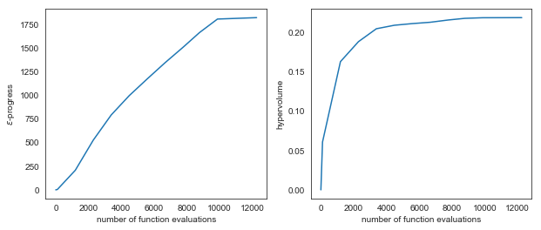

**Figure C.1: Convergence under Problem Formulation 2**

(A) Epsilon progress and (B) Hypervolume metrics

### C.2 Seed Analysis

One should not jump to conclusions after a single simulation run, because the way that the algorithm converges depends on the values initialized by the pseudo-random number generator. Thus, it is important to perform a seed analysis because the behavior of any evolutionary algorithm changes per simulation run depending on the randomly generated start conditions. Problem formulations were checked for the effects of seed conditions (example figure below).

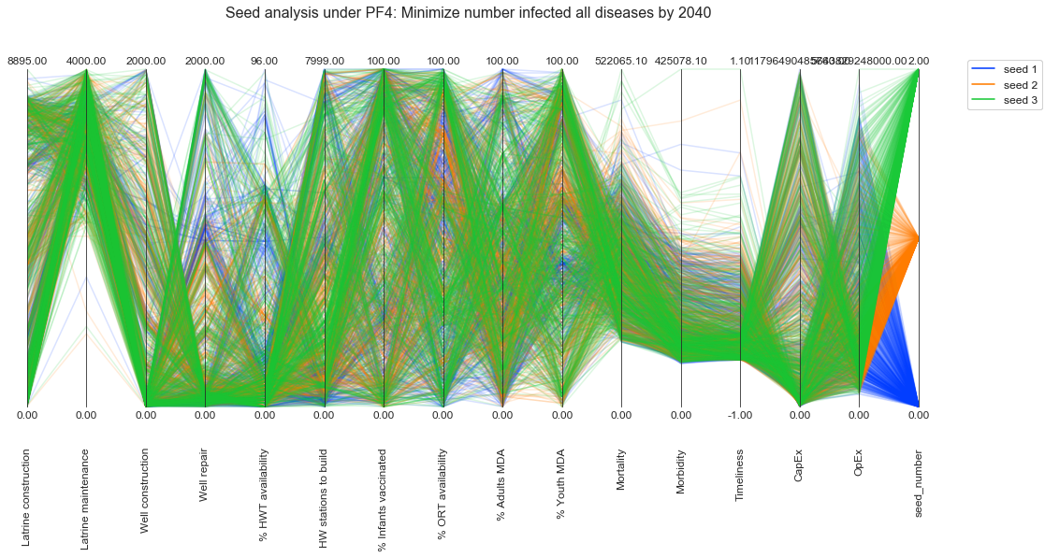

In this case, the best-performing candidates from each seed (lowest quartile *Mortality*) were considered in the robustness evaluation during Problem Formulation 4 stress-testing and regret determination. The particular seed did not seem to have a significant impact on the solution sets ultimately proposed – the impact of the seed was far less than the impact of the problem formulation itself. However, future extensions of this research seeking to find solutions as close to the true Pareto front as possible should consider more extensive seed analysis.

### C.3. Additional Figures: Open Exploration

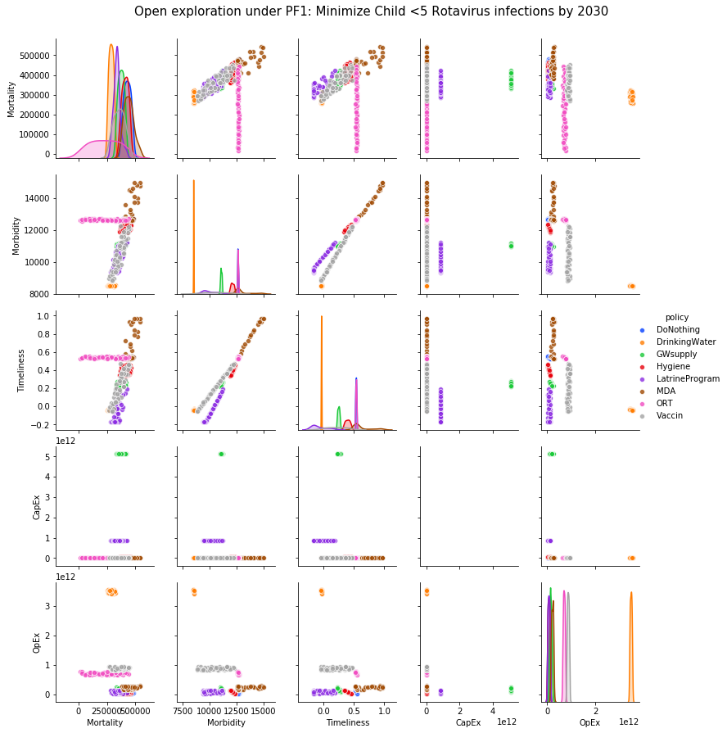

Figure showing how pre-specified policies perform against objectives. Under PF1, ORT is the best way to reduce *Mortality* although it does not affect *Morbidity* or *Timeliness*, indicating that the disease remains prevalent. The high costs of a Ground Water Supply program are apparent.

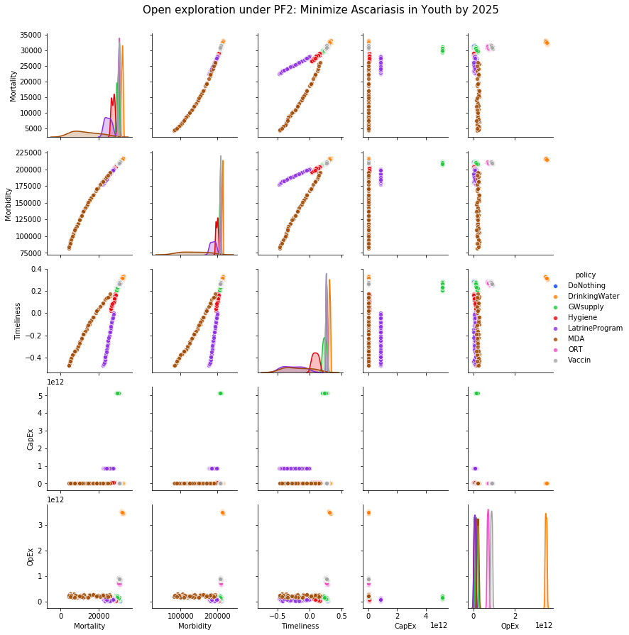

Figure showing how pre-specified policies perform against objectives. Under PF2, MDA is clear option for achieving the objectives, followed by sanitation measures.

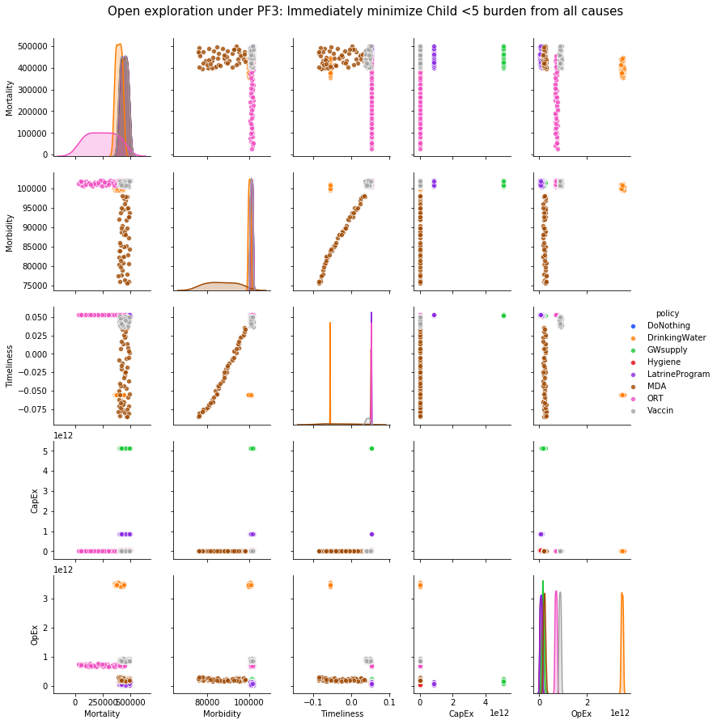

Figure showing how pre-specified policies perform against objectives. Under PF3, some combination of ORT (to reduce mortality) and MDA (to reduce morbidity) is desirable.

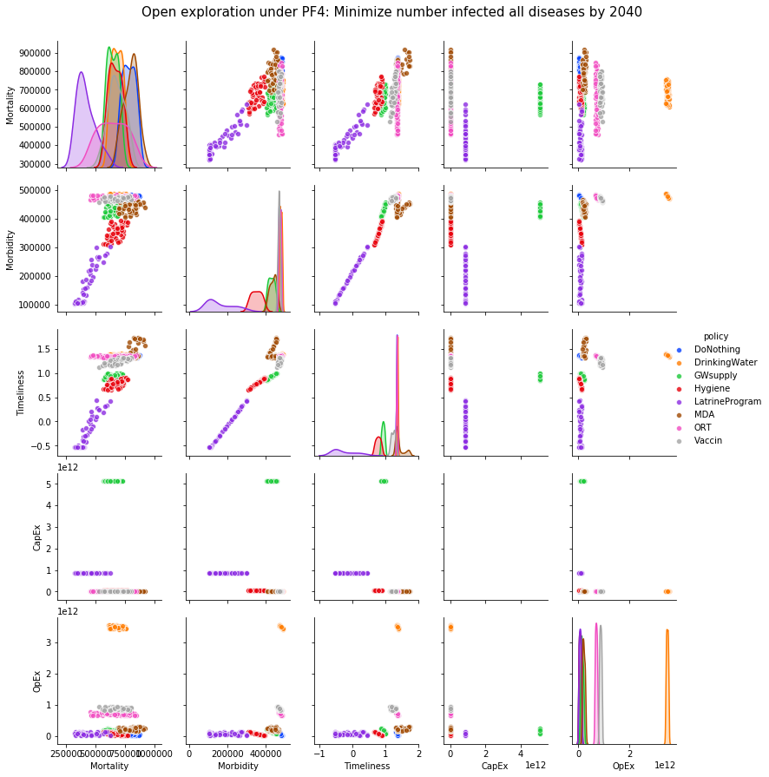

Figure showing how pre-specified policies perform against objectives. Under PF4, measures to improve sanitation are highly favorable.

### C.4. Additional Figures: Directed Search

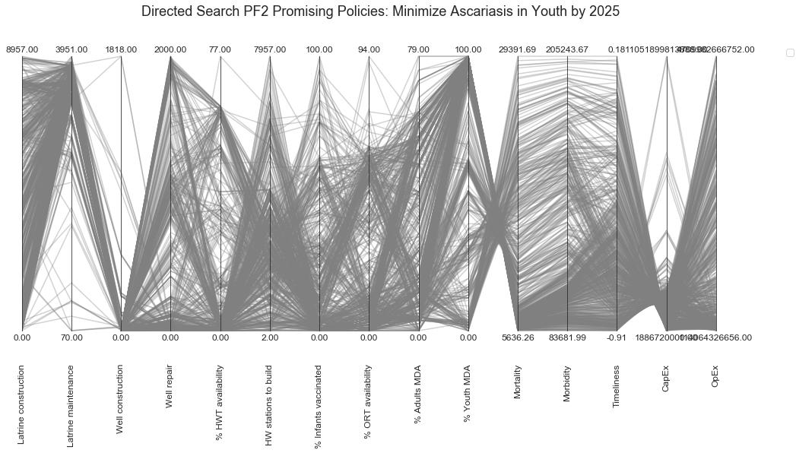

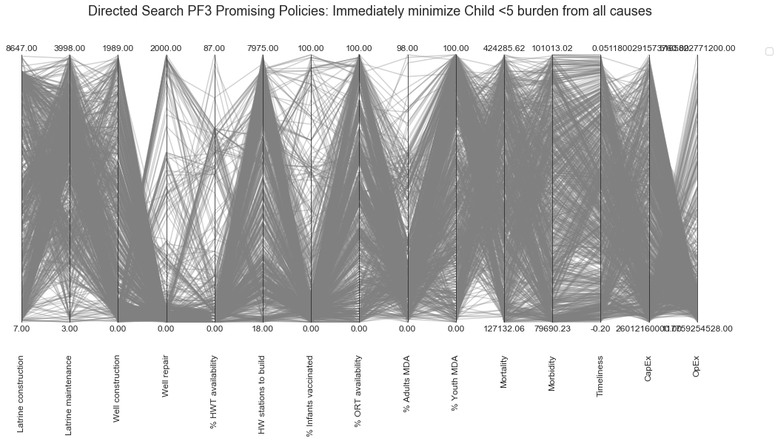

## D. Literature Review Process

The literature review conducted in Chapter 2 sough to find research concerning the use of quantitative models to guide policymakers against multiple health threats . The literature review was conducted by searching Google Scholar and PubMed Central using combinations of these keywords: *multiple disease “multi-disease” intervention decision support model policy.*

The keywords aimed to identify the state of the art for multi-disease decision support models. In-body/clinical models that studied pathogens from an individual or immunological perspective were not considered in the scope of this search. Article abstracts were scanned for relevance, neglecting clinical co-infection studies that were unrelated to the context of public health intervention planning. Relevant articles were selected based on if the model considered multiple diseases or multiple transmission pathways in their evaluation of intervention performance. Table 11 on the next page summarizes the literature search results.

|  |  |  |  |  |
| --- | --- | --- | --- | --- |
|  | **Citation** | **Title** | **Type** | **Author’s critique** |
| 1 | (Heesterbeek et al., 2015) | Modelling infectious disease dynamics in the complex landscape of global health | Systematic review | The authors provide a comprehensive review at the advances of public health modelling over the last 70 years and offer support for the need for more integrated decision support models. The paper is a systematic review and does not include a model itself. |
| 2 | (Homer & Hirsch, 2006) | System Dynamics Modelling for Public Health: Background and Opportunities | Review of approach | Advocates for a more holistic (system dynamics) approach to health modelling. While a specific model is not developed in this paper, the authors argue for the potential of system dynamics models in general to meet rising global health challenges. |
| 3 | (Fischer Walker & Walker, 2014) | Lives Saves Tool (LiST) | Multi-disease model | Used to calculate the impact of maternal, neonatal, and child health interventions. Cost modules have recently be added to help decision makers with resource allocation problems. |
| 4 | (Chen & Preciado, 2014) | Optimal Coinfection Control of Competitive Epidemics in Multi-Layer Networks | Multi-disease model * | The authors extend a standard compartment model for multiple diseases. The paper assumes that the policymakers in charge have a limited budget to choose different vaccines, and aims to fine the best allocation of these fictional antidotes to the population. |
| 5 | (Handel et al., 2007) | What is the best control strategy for multiple infectious disease outbreaks? | Multi-disease model * | The authors create a model with the goal of optimizing the intervention strategy when more than one infectious disease epidemics break out at the same time in a given population. The authors are vague/unclear as to how they define an ‘optimal’ intervention. |
| 6 | (Tien & Earn, 2010) | Multiple Transmission Pathways and Disease Dynamics in a Waterborne Pathogen Model | SWIR model * | The authors develop a SIWR model, which is an extension of the classic Susceptible-Infected-Recovered compartment model to also include an environmental reservoir (W). The model includes multiple transmission pathways (person-to-person and ingestion of water) but is not considered a “multi-disease” model as defined in this thesis. |
| 7 | (Devipriya & Kalaivani, 2012) | Optimal Control of Multiple Transmission of Water-Borne Diseases | SWIR model * | The authors claim to be the first to optimize control against waterborne disease, though (Tien & Earn, 2010) predate them by a few years. Similar to their predecessors, (Devipriya & Kalaivani, 2012) assume that there is a single optimal solution without discussing the implications of how other stakeholders might view an ideal solution. The authors also only use a generic “waterborne disease” and assume that there is a vaccine available for it, which is not true. |
| 8 | (Bershteyn et al., 2018) | Implementation and applications of EMOD, an individual-based multi-disease modelling platform | Generalizable model | EMOD is a powerful agent-based modelling code base that can be customized for a wide range of infectious diseases. The majority of the code is applied to widely-known, diseases with most information available, such as e.g. malaria, HIV, dengue, and polio. |
| 9 | (Erraguntla et al., 2017) | Framework for Infectious Disease Analysis: A comprehensive and integrative multi-modelling approach to disease prediction and management | Modelling framework | FIDA is an approach to ensuring that data and structures used in different models can be shared between different applications. The aim is to promote consistency and validity between different models. |
| 10 | (Eisen et al., 2011) | Multi-Disease Data Management System Platform for Vector-Borne Diseases | Data platform | The authors present a software system for monitoring data about multiple vector-borne diseases. The multi-disease system currently manages data about dengue and malaria, with potential for adding other more vector-borne diseases in future. |

Table 10: Existing multi-disease models and frameworks from literature

*\* = paper uses an group infection classification (e.g. “waterborne disease”), rather than a real pathogen (e.g. rotavirus, ascaris lumbricoides).*

# REFERENCES

A. Coello Coello, C., A. Van Veldhuizen, D., & B. Lamont, G. (2007). *Evolutionary Algorithms for Solving Multi-Objective Problems Second Edition*. https://doi.org/10.1007/978-0-387-36797-2

Adriko, M., Tinkitina, B., Arinaitwe, M., Kabatereine, N. B., Nanyunja, M., & M. Tukahebwa, E. (2018). Impact of a national deworming campaign on the prevalence of soil-transmitted helminthiasis in Uganda (2004-2016): Implications for national control programs. *PLOS Neglected Tropical Diseases*, *12*(7), e0006520. https://doi.org/10.1371/journal.pntd.0006520

Arndt, M. B., & Walson, J. L. (2018). Enteric infection and dysfunction—A new target for PLOS Neglected Tropical Diseases. *PLOS Neglected Tropical Diseases*, *12*(12), e0006906. https://doi.org/10.1371/journal.pntd.0006906

Babji, S., & Kang, G. (2012). Rotavirus vaccination in developing countries. *Current Opinion in Virology*, *2*(4), 443–448. https://doi.org/10.1016/j.coviro.2012.05.005

Baltussen, R., & Niessen, L. (2006). Priority setting of health interventions: The need for multi-criteria decision analysis. *Cost Effectiveness and Resource Allocation*, 9.

Bankes, S., Walker, W. E., & Kwakkel, J. H. (2013). Exploratory Modeling and Analysis. In S. I. Gass & M. C. Fu (Eds.), *Encyclopedia of Operations Research and Management Science* (pp. 532–537). https://doi.org/10.1007/978-1-4419-1153-7_314

Bartram, J., & Hunter, P. (2015). *Bradley Classification of disease transmission routes for water-related hazards*. https://doi.org/10.4324/9781315693606.ch03

Batterman, S., Eisenberg, J., Hardin, R., Kruk, M. E., Lemos, M. C., Michalak, A. M., … Wilson, M. L. (2009). Sustainable Control of Water-Related Infectious Diseases: A Review and Proposal for Interdisciplinary Health-Based Systems Research. *Environmental Health Perspectives*, *117*(7), 1023–1032. https://doi.org/10.1289/ehp.0800423

Bbaale, E. (2013). Factors Influencing Childhood Immunization in Uganda. *Journal of Health, Population, and Nutrition*, *31*(1), 118–129.

Bershteyn, A., Gerardin, J., Bridenbecker, D., Lorton, C. W., Bloedow, J., Baker, R. S., … for the Institute for Disease Modeling. (2018). Implementation and applications of EMOD, an individual-based multi-disease modeling platform. *Pathogens and Disease*, *76*(5). https://doi.org/10.1093/femspd/fty059

Bryant, & Lempert, R. J. (2010). Thinking inside the box: A participatory, computer-assisted approach to scenario discovery | Elsevier Enhanced Reader. https://doi.org/10.1016/j.techfore.2009.08.002

CDC. (2019a, January 28). Rotavirus. Retrieved February 11, 2019, from https://www.cdc.gov/rotavirus/about/transmission.html

CDC. (2019b, April 11). Ascariasis. Retrieved June 5, 2019, from Centers for Disease Control and Prevention website: https://www.cdc.gov/parasites/ascariasis/index.html

Chen, X., & Preciado, V. M. (2014). Optimal coinfection control of competitive epidemics in multi-layer networks. *53rd IEEE Conference on Decision and Control*, 6209–6214. https://doi.org/10.1109/CDC.2014.7040362

Chowell, G., Sattenspiel, L., Bansal, S., & Viboud, C. (2016). Mathematical models to characterize early epidemic growth: A Review. *Physics of Life Reviews*, *18*, 66–97. https://doi.org/10.1016/j.plrev.2016.07.005

Chunga, R. M., Ensink, J. H. J., Jenkins, M. W., & Brown, J. (2016). Adopt or Adapt: Sanitation Technology Choices in Urbanizing Malawi. *PLoS ONE*, *11*(8). https://doi.org/10.1371/journal.pone.0161262

Deb, K. (2001). *Multi-objective optimization using evolutionary algorithms* (Vol. 16). John Wiley & Sons.

Devipriya, G., & Kalaivani, K. (2012). Optimal Control of Multiple Transmission of Water-Borne Diseases [Research article]. https://doi.org/10.1155/2012/421419

Ding, Z., Gong, W., Li, S., & Wu, Z. (2018). System Dynamics versus Agent-Based Modeling: A Review of Complexity Simulation in Construction Waste Management. *Sustainability*, *10*(7), 2484. https://doi.org/10.3390/su10072484

Doucleff, M. (2018, November 1). Merck Pulls Out Of Agreement To Supply Life-Saving Vaccine To Millions Of Kids. Retrieved June 3, 2019, from NPR.org website: https://www.npr.org/sections/goatsandsoda/2018/11/01/655844287/merck-pulls-out-of-agreement-to-supply-life-saving-vaccine-to-millions-of-kids

Duflo, E., Greenstone, M., Guiteras, R., & Clasen, T. (2015). Toilets Can Work: Short and Medium Run Health Impacts of Addressing Complementarities and Externalities in Water and Sanitation. *Working Paper 21521*, 42.

Eisen, L., Coleman, M., Lozano-Fuentes, S., McEachen, N., Orlans, M., & Coleman, M. (2011). Multi-Disease Data Management System Platform for Vector-Borne Diseases. *PLOS Neglected Tropical Diseases*, *5*(3), e1016. https://doi.org/10.1371/journal.pntd.0001016

Eisenberg, J. N. S., Desai, M. A., Levy, K., Bates, S. J., Liang, S., Naumoff, K., & Scott, J. C. (2007). Environmental Determinants of Infectious Disease: A Framework for Tracking Causal Links and Guiding Public Health Research. *Environmental Health Perspectives*, *115*(8), 1216–1223. https://doi.org/10.1289/ehp.9806

Eisenberg, J. N. S., Scott, J. C., & Porco, T. (2007). Integrating Disease Control Strategies: Balancing Water Sanitation and Hygiene Interventions to Reduce Diarrheal Disease Burden. *American Journal of Public Health*, *97*(5), 846–852. https://doi.org/10.2105/AJPH.2006.086207

Eisenberg, J. N. S., Trostle, J., Sorensen, R. J. D., & Shields, K. F. (2012). Toward a Systems Approach to Enteric Pathogen Transmission: From Individual Independence to Community Interdependence. *Annual Review of Public Health*, *33*, 239–257. https://doi.org/10.1146/annurev-publhealth-031811-124530

Enserink, B., Hermans, L., Koppenjan, J., Bots, P., Kwakkel, J., & Thissen, W. (2010). *Policy Analysis of Multi-Actor Systems*. Retrieved from https://books.google.nl/books?id=dlbYSAAACAAJ

Erraguntla, M., Zapletal, J., & Lawley, M. (2017). Framework for Infectious Disease Analysis: A comprehensive and integrative multi-modeling approach to disease prediction and management. *Health Informatics Journal*, 146045821774711. https://doi.org/10.1177/1460458217747112

Fischer Walker, C. L., & Walker, N. (2014). The Lives Saved Tool (LiST) as a model for diarrhea mortality reduction. *BMC Medicine*, *12*, 70. https://doi.org/10.1186/1741-7015-12-70

Freeman, M. C., Garn, J. V., Sclar, G. D., Boisson, S., Medlicott, K., Alexander, K. T., … Clasen, T. F. (2017). The impact of sanitation on infectious disease and nutritional status: A systematic review and meta-analysis. *International Journal of Hygiene and Environmental Health*, *220*(6), 928–949. https://doi.org/10.1016/j.ijheh.2017.05.007

Freeman, M. C., Stocks, M. E., Cumming, O., Jeandron, A., Higgins, J. P. T., Wolf, J., … Curtis, V. (2014). Systematic review: Hygiene and health: systematic review of handwashing practices worldwide and update of health effects. *Tropical Medicine & International Health*, *19*(8), 906–916. https://doi.org/10.1111/tmi.12339

Gall, A. M., Mariñas, B. J., Lu, Y., & Shisler, J. L. (2015). Waterborne Viruses: A Barrier to Safe Drinking Water. *PLoS Pathogens*, *11*(6). https://doi.org/10.1371/journal.ppat.1004867

Gong, M., Lempert, R., Parker, A., Mayer, L. A., Fischbach, J., Sisco, M., … Kunreuther, H. (2017). Testing the scenario hypothesis: An experimental comparison of scenarios and forecasts for decision support in a complex decision environment. *Environmental Modelling & Software*, *91*, 135–155. https://doi.org/10.1016/j.envsoft.2017.02.002

Government of Uganda. (n.d.). *Uganda Vision 2040*. Retrieved from http://npa.go.ug/wp-content/themes/npatheme/documents/vision2040.pdf

Gupta, S. K., Keck, J., Ram, P. K., Crump, J. A., Miller, M. A., & Mintz, E. D. (2008). Part III. Analysis of data gaps pertaining to enterotoxigenic *Escherichia coli* infections in low and medium human development index countries, 1984–2005. *Epidemiology and Infection*, *136*(6), 721–738. https://doi.org/10.1017/S095026880700934X

Handel, A., Longini, I. M., & Antia, R. (2007). What is the best control strategy for multiple infectious disease outbreaks? *Proceedings of the Royal Society B: Biological Sciences*, *274*(1611), 833–837. https://doi.org/10.1098/rspb.2006.0015

Heesterbeek, H., Anderson, R. M., Andreasen, V., Bansal, S., Angelis, D. D., Dye, C., … Collaboration, I. N. I. I. (2015). Modeling infectious disease dynamics in the complex landscape of global health. *Science*, *347*(6227), aaa4339. https://doi.org/10.1126/science.aaa4339

Henriksson, D. K., Peterson, S. S., Waiswa, P., & Fredriksson, M. (2019). Decision-making in district health planning in Uganda: Does use of district-specific evidence matter? *Health Research Policy and Systems*, *17*(1), 57. https://doi.org/10.1186/s12961-019-0458-6

Herman, J. D., Reed, P. M., Zeff, H. B., & Characklis, G. W. (2015). How Should Robustness Be Defined for Water Systems Planning under Change? *Journal of Water Resources Planning and Management*, *141*(10), 04015012. https://doi.org/10.1061/(ASCE)WR.1943-5452.0000509

Hirai, M., Roess, A., Huang, C., & Graham, J. (2016). Exploring geographic distributions of high-risk water, sanitation, and hygiene practices and their association with child diarrhea in Uganda. *Global Health Action*, *9*(1), 32833. https://doi.org/10.3402/gha.v9.32833

Homer, J. B., & Hirsch, G. B. (2006). System Dynamics Modeling for Public Health: Background and Opportunities. *American Journal of Public Health*, *96*(3), 452–458. https://doi.org/10.2105/AJPH.2005.062059

Huston, A., & Moriarty, P. (n.d.). *Understanding the WASH system and its building blocks*. 40.

Kabatereine, N. B., Tukahebwa, E. M., Kazibwe, F., Twa‐Twa, J. M., Barenzi, J. F. Z., Zaramba, S., … Brooker, S. (2005). Short communication: Soil-transmitted helminthiasis in Uganda: epidemiology and cost of control. *Tropical Medicine & International Health*, *10*(11), 1187–1189. https://doi.org/10.1111/j.1365-3156.2005.01509.x

Kasprzyk, J. R., Nataraj, S., Reed, P. M., & Lempert, R. J. (2013). Many objective robust decision making for complex environmental systems undergoing change. *Environmental Modelling & Software*, *42*, 55–71. https://doi.org/10.1016/j.envsoft.2012.12.007

Knight, G. M., Dharan, N. J., Fox, G. J., Stennis, N., Zwerling, A., Khurana, R., & Dowdy, D. W. (2016). Bridging the gap between evidence and policy for infectious diseases: How models can aid public health decision-making. *International Journal of Infectious Diseases*, *42*, 17–23. https://doi.org/10.1016/j.ijid.2015.10.024

Kolaczinski, J. H. (2006). *SITUATION ANALYSIS AND NEEDS ASSESSMENT*. 51.

Kraay, A. N. M., Brouwer, A. F., Lin, N., Collender, P. A., Remais, J. V., & Eisenberg, J. N. S. (2018). Modeling environmentally mediated rotavirus transmission: The role of temperature and hydrologic factors. *Proceedings of the National Academy of Sciences*, *115*(12), E2782–E2790. https://doi.org/10.1073/pnas.1719579115

Krause, M. (2010). *The political economy of water and sanitation*. Routledge.

Kwakkel, J. H. (2017). The Exploratory Modeling Workbench: An open source toolkit for exploratory modeling, scenario discovery, and (multi-objective) robust decision making. *Environmental Modelling & Software*, *96*, 239–250. https://doi.org/10.1016/j.envsoft.2017.06.054

Kwakkel, J. H., Walker, W. E., & Haasnoot, M. (2016). Coping with the Wickedness of Public Policy Problems: Approaches for Decision Making under Deep Uncertainty. *Journal of Water Resources Planning and Management*, *142*(3), 01816001. https://doi.org/10.1061/(ASCE)WR.1943-5452.0000626

Kwakkel, J., & Haasnoot, M. (2018). *Supporting decision making under deep uncertainty: A synthesis of approaches and techniques*.

Lempert, R. J., Groves, D. G., Popper, S. W., & Bankes, S. C. (2006). A General, Analytic Method for Generating Robust Strategies and Narrative Scenarios. *Management Science*, *52*(4), 514–528. https://doi.org/10.1287/mnsc.1050.0472

Loevinsohn, M., Mehta, L., Cuming, K., Nicol, A., Cumming, O., & Ensink, J. H. J. (2015). The cost of a knowledge silo: A systematic re-review of water, sanitation and hygiene interventions. *Health Policy and Planning*, *30*(5), 660–674. https://doi.org/10.1093/heapol/czu039

Löfgren, J., Tao, W., Larsson, E., Kyakulaga, F., & Forsberg, B. C. (2012). Treatment patterns of childhood diarrhoea in rural Uganda: A cross-sectional survey. *BMC International Health and Human Rights*, *12*, 19. https://doi.org/10.1186/1472-698X-12-19

Malande, O. O., Munube, D., Afaayo, R. N., Annet, K., Bodo, B., Bakainaga, A., … Musyoki, A. M. (2019). Barriers to effective uptake and provision of immunization in a rural district in Uganda. *PLOS ONE*, *14*(2), e0212270. https://doi.org/10.1371/journal.pone.0212270

McGinnis, S. M., McKeon, T. J., Desai, R., Ejelonu, A., Laskowski, S., & Murphy, H. M. F. (2017). A Systematic Review: Costing and Financing of Water, Sanitation, and Hygiene (WASH) in Schools. *International Journal of Environmental Research and Public Health*. https://doi.org/10.3390/ijerph14040442

McPhail, C., Maier, H. R., Kwakkel, J. H., Giuliani, M., Castelletti, A., & Westra, S. (2018). Robustness Metrics: How Are They Calculated, When Should They Be Used and Why Do They Give Different Results? *Earth’s Future*, *6*(2), 169–191. https://doi.org/10.1002/2017EF000649

Mills, J. E., & Cumming, O. (2016). The impact of water, sanitation and hygiene on key health and social outcomes. *URL: Https://Www. Lshtm. Ac. Uk/Sites/Default/Files/2017-07/WASHEvidencePaper_HighRes_01*, *23*.

Ministry of Health. (2010, July). *Second National Health Policy 2010.pdf*. The Republic of Uganda.

Ministry of Health. (2018). UGANDA ROLLS OUT ROTAVIRUS VACCINE INTO THE ROUTINE IMMUNIZATION SCHEDULE. Retrieved February 11, 2019, from https://health.go.ug/content/uganda-rolls-out-rotavirus-vaccine-routine-immunization-schedule

Montibeller, G., & Franco, A. (2010). Multi-Criteria Decision Analysis for Strategic Decision Making. In C. Zopounidis & P. M. Pardalos (Eds.), *Handbook of Multicriteria Analysis* (Vol. 103, pp. 25–48). https://doi.org/10.1007/978-3-540-92828-7_2

Mor, S. M., & Tzipori, S. (2008). Cryptosporidiosis in Children in Sub-Saharan Africa: A Lingering Challenge. *Clinical Infectious Diseases : An Official Publication of the Infectious Diseases Society of America*, *47*(7), 915–921. https://doi.org/10.1086/591539

Morecroft, J. D. (2015). *Strategic modelling and business dynamics: A feedback systems approach*. John Wiley & Sons.

Muli, A. N. (2018). *Variables That Impact Incidence of Diarrhea Amongst Under-Five in Uganda* (Dissertation). Walden University.

Mulogo, E. M., Matte, M., Wesuta, A., Bagenda, F., Apecu, R., & Ntaro, M. (2018). Water, Sanitation, and Hygiene Service Availability at Rural Health Care Facilities in Southwestern Uganda [Research article]. https://doi.org/10.1155/2018/5403795

Musoke, D., Ndejjo, R., Halage, A. A., Kasasa, S., Ssempebwa, J. C., & Carpenter, D. O. (2018). Drinking Water Supply, Sanitation, and Hygiene Promotion Interventions in Two Slum Communities in Central Uganda. *Journal of Environmental and Public Health*, *2018*. https://doi.org/10.1155/2018/3710120

Nakawesi, J. S., Wobudeya, E., Ndeezi, G., Mworozi, E. A., & Tumwine, J. K. (2010). Prevalence and factors associated with rotavirus infection among children admitted with acute diarrhea in Uganda. *BMC Pediatrics*, *10*(1). https://doi.org/10.1186/1471-2431-10-69

Namawejje, H., Luboobi, L. S., Kuznetsov, D., & Wobudeya, E. (2014). Modeling optimal control of rotavirus disease with different control strategies. *Journal of Mathematical and Computational Science*, *4*(5), 892-914–914.

Narzisi, G., Mysore, V., & Mishra, B. (2006). Multi-objective evolutionary optimization of agent-based models: An application to emergency response planning. *Computational Intelligence*.

PATH. (2017, November 22). Diarrhea and enteric illnesses. Retrieved February 23, 2019, from DefeatDD website: https://www.defeatdd.org/article/diarrhea-and-enteric-illnesses

Qadri, F., Svennerholm, A.-M., Faruque, A. S. G., & Sack, R. B. (2005). Enterotoxigenic Escherichia coli in Developing Countries: Epidemiology, Microbiology, Clinical Features, Treatment, and Prevention. *Clinical Microbiology Reviews*, *18*(3), 465–483. https://doi.org/10.1128/CMR.18.3.465-483.2005

Rahmandad, H., & Sterman, J. (2008). Heterogeneity and Network Structure in the Dynamics of Diffusion: Comparing Agent-Based and Differential Equation Models. *Management Science*, *54*(5), 998–1014. https://doi.org/10.1287/mnsc.1070.0787

Rietveld, L. C., Siri, J. G., Chakravarty, I., Arsénio, A. M., Biswas, R., & Chatterjee, A. (2016). Improving health in cities through systems approaches for urban water management. *Environmental Health*, *15*(S1). https://doi.org/10.1186/s12940-016-0107-2

Saltelli, A., & Annoni, P. (2010). How to avoid a perfunctory sensitivity analysis. *Environmental Modelling & Software*, *25*(12), 1508–1517. https://doi.org/10.1016/j.envsoft.2010.04.012

Saltelli, A., & Giampietro, M. (2015). *The fallacy of evidence based policy*. 32.

Shim, E., Feng, Z., Martcheva, M., & Castillo-Chavez, C. (2006). An age-structured epidemic model of rotavirus with vaccination. *Journal of Mathematical Biology*, *53*(4), 719–746. https://doi.org/10.1007/s00285-006-0023-0

Shirley, D.-A. T., Moonah, S. N., & Kotloff, K. L. (2012). Burden of disease from Cryptosporidiosis. *Current Opinion in Infectious Diseases*, *25*(5), 555–563. https://doi.org/10.1097/QCO.0b013e328357e569

Shortridge, J. E., & Zaitchik, B. F. (2018). Characterizing climate change risks by linking robust decision frameworks and uncertain probabilistic projections. *Climatic Change*, *151*(3–4), 525–539. https://doi.org/10.1007/s10584-018-2324-x

Squire, S. A., & Ryan, U. (2017). Cryptosporidium and Giardia in Africa: Current and future challenges. *Parasites & Vectors*, *10*(1), 195. https://doi.org/10.1186/s13071-017-2111-y

Stegmuller, A. R., Self, A., Litvin, K., & Roberton, T. (2017). How is the Lives Saved Tool (LiST) used in the global health community? Results of a mixed-methods LiST user study. *BMC Public Health*, *17*(4), 773. https://doi.org/10.1186/s12889-017-4750-5

Tate, J. E., Burton, A. H., Boschi-Pinto, C., & Parashar, U. D. (2016). Global, Regional, and National Estimates of Rotavirus Mortality in Children <5 Years of Age, 2000–2013. *Clinical Infectious Diseases*, *62*(suppl 2), S96–S105. https://doi.org/10.1093/cid/civ1013

Tayler, K., Parkinson, J., & Colin, J. (2003). *Urban Sanitation*. https://doi.org/10.3362/9781780441436

Tchuem Tchuenté, L. A. (2011). Control of soil-transmitted helminths in sub-Saharan Africa: Diagnosis, drug efficacy concerns and challenges. *The Diagnostics and Control of Neglected Tropical Helminth Diseases*, *120*, S4–S11. https://doi.org/10.1016/j.actatropica.2010.07.001

Tien, J. H., & Earn, D. J. D. (2010). Multiple Transmission Pathways and Disease Dynamics in a Waterborne Pathogen Model. *Bulletin of Mathematical Biology*, *72*(6), 1506–1533. https://doi.org/10.1007/s11538-010-9507-6

Tissera, M. S., Cowley, D., Bogdanovic-Sakran, N., Hutton, M. L., Lyras, D., Kirkwood, C. D., & Buttery, J. P. (2016). Options for improving effectiveness of rotavirus vaccines in developing countries. *Human Vaccines & Immunotherapeutics*, *13*(4), 921–927. https://doi.org/10.1080/21645515.2016.1252493

UNPF. (2017, March). *Uganda Population Dynamics*. Retrieved from https://uganda.unfpa.org/sites/default/files/pub-pdf/Issue%20Brief%201%20-%20Population%20dynamics.%20Final.%2010.5.2017.pdf

Valcourt, N., Walters, J., Will, A. J., & Linden, K. (2019). *Understanding complexity in WASH systems*. 11.

Victora, C. G., Habicht, J.-P., & Bryce, J. (2004). Evidence-Based Public Health: Moving Beyond Randomized Trials. *American Journal of Public Health*, *94*(3), 400–405. https://doi.org/10.2105/AJPH.94.3.400

Walker, W. E., Marchau, V. A. W. J., & Kwakkel, J. H. (2013). Uncertainty in the Framework of Policy Analysis. In W. A. H. Thissen & W. E. Walker (Eds.), *Public Policy Analysis* (Vol. 179, pp. 215–261). https://doi.org/10.1007/978-1-4614-4602-6_9

Wilson-Jones, M., Gautam, O. P., & Smith, K. (2018, February 27). WASH and nutrition: Trials and tribulations? Retrieved March 17, 2019, from WASH Matters website: /blog/wash-and-nutrition-trials-and-tribulations

World Bank Group. (2016). *Uganda Poverty Assessment Report 2016* [ACS18391]. Retrieved from http://pubdocs.worldbank.org/en/381951474255092375/pdf/Uganda-Poverty-Assessment-Report-2016.pdf

Xia, S., Zhou, X.-N., & Liu, J. (2017). Systems thinking in combating infectious diseases. *Infectious Diseases of Poverty*, *6*. https://doi.org/10.1186/s40249-017-0339-6

Yates, T., Vujcic, J. A., Joseph, M. L., Gallandat, K., & Lantagne, D. (2018). Efficacy and effectiveness of water, sanitation, and hygiene interventions in emergencies in low- and middle-income countries: A systematic review. *Waterlines*, *37*(1), 31–65. https://doi.org/10.3362/1756-3488.17-00016